This is the peer reviewed accepted manuscript of the following article: Utsi, E., and M.Penman. 2025. “Combining Ground Penetrating Radar Data With Historical Research: The Scottish Royal Benedictine Abbey of Dunfermline.” Archaeological Prospection32, no. 3: 676–706. https://doi.org/10.1002/arp.1988.
This article may be used for non-commercial purposes in accordance with Wiley Terms and Conditions for Use of Self-Archived Versions.

Combining Ground Penetrating Radar data with Historical Research: the Scottish Royal Benedictine Abbey of Dunfermline
Erica Carrick Utsi¹ and Michael Penman²
¹ EMC Radar Consulting, 13 West End, Haddenham, Ely, Cambs, CB6 3TD, UK
² Dept of History, University of Stirling, Stirling, FK9 4LA, UK
Abstract
Like many buildings of historical importance, Scotland’s royal abbey of Dunfermline, Fife, has undergone frequent changes in its structure from its initial establishment through its growth under royal favour, partial destruction inspired by religious reformation followed by a period of use as a relatively open access site up until the construction of the present Georgian Abbey Church over the footings of the destroyed medieval choir. As a result of the site’s chequered history over ten centuries, it was initially thought that Ground Penetrating Radar (GPR) survey would not prove useful in providing an insight into the wealth of missing information from its medieval past. From the perspective of the Abbey’s curators, the lack of visible evidence of its rich past could be explained but not illustrated to researchers or other visitors.
Further considerations included that it would be impossible to excavate in order to confirm the survey data as the current Abbey Church is in use as a parish church, that space available for survey was limited due to areas of fixed pews, and the possible effects of groundwater and pitch on transmission velocity and signal attenuation.
This project used close line spacing and two frequencies of antenna to optimise target definition and detection depth of the extant remains using GPR. These data were then compared with a wide range of historical sources and the known layout of comparable Benedictine abbey choirs. It has proved possible to establish the outline and extent of the medieval choir, to retrieve evidence of some of the elite burials, parts of the interior layout and to partially define which subsurface anomalies are potentially of medieval date. Not every interpretation carries the same degree of certainty, but future historical research may assist with this. The Abbey Church and partner Historic Environment Scotland are making use of the GPR data for illustration of the site’s historical importance to its many visitors.
Keywords
Ground Penetrating Radar, GPR, Historical Heritage, Multi-Frequency Antennas, Dunfermline Abbey, Lost royal tombs.

Introduction
It is now common practice to use Ground Penetrating Radar (GPR) to assist in assessing the structural condition of historical buildings as well as to search for buried historical features (e.g. Utsi E, 2006, 2012, Bavusi et al, 2010, Imposa & Mele, 2011, Webber H, 2017, Gracia VP et al, 2000, Santos--‐Assunçao et al 2015, Persico R et al, 2018, Pieraccini M, 2020 Leucci et al, 2021). Historic buildings and places of worship in particular are subject to reworking of their structure throughout their lives as they adapt to change of use. Such change reflects the cultural and political forces which they both serve and represent, and the adaptations vary from fabric repairs or minor changes of layout to more major building extensions but also often include destruction with or without rebuilding. This complicates investigation by GPR but does not normally prevent it (e.g. Leucci et al, 2021, Paul et al, 2011, Udphuay et al 2010, Ramirez-Blanco et al, 2008, Gracia et al, 2000,). Few such religious establishments have been subjected to as great a degree of destruction, rebuilding, and reuse as the church of the Benedictine abbey of Dunfermline in Fife, Scotland (Figures 1 and 2).
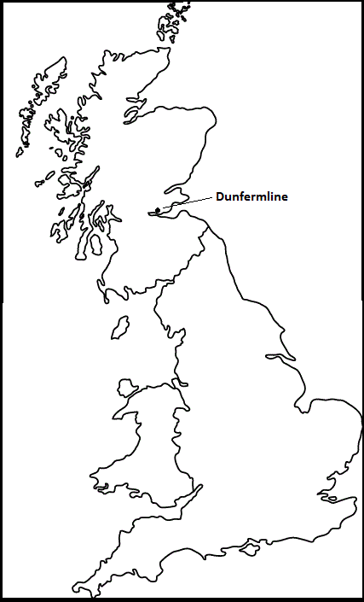
Figure 1: Location of Dunfermline Royal Abbey
This paper reports on a series of pilot GPR studies in and around the current Abbey Church in order to detect any extant remains of the medieval church choir. The aim is to concentrate on the peak period of the medieval abbey’s national and international importance between 1250 and 1560 CE when the abbey took the lead in developing the cult of St Margaret of Scotland across Britain as well as being significant politically within and beyond the Scottish kingdom. The medieval abbey also served as the primary burial place of subsequent Scottish royalty and their elite followers into the later 14th century.
The results include the detection of several medieval burials including at least one royal double tomb, the outline of the medieval transepts and other features, not all of which are securely identifiable, but which provide material for further historical research.
Historical Background
The original monastic church occupied the site of an earlier religious building, an 11th century priory, a feature common to other religious foundations (cf Gracia et al, 2000, Panisova et al, 2013). This church was converted by King David I in 1128 to an abbey, for which he brought in additional monks from the established Benedictine foundation at Canterbury Cathedral Priory. The Abbey in Dunfermline underwent considerable expansion between 1128 and 1150 including, crucially, eastwards expansion with a full choir. From the 11th century onwards, the medieval abbey became both the burial place for Scottish royalty and related aristocracy and also the focus of the cult of Queen (later Saint) Margaret of Scotland (d. 1093), the priory founder. When Margaret was canonised by the papacy in 1249 her remains were translated to a new east-end feretory shrine-chapel. This was an embellishment which saw the choir further enlarged, as did the addition of a late 13th-/early-14th century Lady Chapel to the north (Fawcett, 2005).
The Scottish religious Reformation of 1560 resulted in the progressive sacking of the east end of the medieval church including the choir and the Lady Chapel, the two principal areas of royal burial. The nave continued to serve c.1560 to 1821 as the parish church of the town of Dunfermline although this also resulted in a process of clearing out all traces of the former Catholic worship in order to respect the more austere Presbyterian religious practice. A long period of neglect followed during which the site became a source of stone for the town and surrounding area before becoming, c.1700 to 1816, a recognised burial ground, the ‘Psalter churchyard’. It is probable that neglect implies the removal of more than merely stone from the site and investigation of structural and human remains cannot be ruled out (Baine, 1790 pp 461-2; Dalyell, 1809 p 465; Henderson, 1879, pp 561-2).
Between 1818 and 1821 the modern Presbyterian ‘Abbey Church’ was built on top of what remained of the medieval choir’s ruins, positioned directly adjoining the nave (Penman & Utsi, 2024, pp 46-52). This inevitably resulted in further rearrangement of the site surface. The architect, William Burn, and subsequent custodians are known to have used pitch to guard against subsurface water. The ground on which Dunfermline Abbey stands is unusually water retentive for such a politically important building and there is evidence of historic flooding (Dunfermline Kirk Session, 1660; Dalyell, 1809; Penman & Utsi, 2024, p 51). It will also have been necessary for the ground to be levelled. From a small number of access points in the church floor a gap between the current floor and extant archaeological material including the top of walls and the levelled historical surface can be seen.
More modern adaptations carried out include the installation of an organ with its associated crawl through access, heating pipes, shop fittings, and the addition of the Tiffany window (Church of Scotland, 2019).
Although these post-medieval modifications present a number of problems for investigation by GPR, the changes of use, including that of religious worship, have also impacted upon the historical evidence, in terms both of its survival and the ambiguity of interpretation between different sources. In 2016, a project was therefore initiated by the University of Stirling, working with EMC Radar Consulting and OJT Heritage, to explore the possibility of using GPR to identify what remained of the medieval building. For the purposes of this investigation, medieval is defined as the years between 1250/51 and c.1560. The former date defines the establishment of a new East end shrine for the mortal remains of St (Queen) Margaret and the further expansion of the medieval choir. The latter date, as noted above, relates to the religious reformation in Scotland. The GPR data has been used to assess what remains of the medieval structure, by comparison with the various sources of historical evidence.
The historical resources include medieval documents (e.g. charters), 19th century resources (e.g. Burn’s plans, sketches & other antiquarian documentation) and also the ground plans of existing Benedictine establishments such as those at St Dénis, Canterbury, and Durham.
Figure 2: Dunfermline Abbey and Abbey Church. To the left/west the medieval nave and former parish church; to the right/east the Abbey Church (1818-21) built
atop the ruined medieval choir. Crown Copyright: HES, DP250775.

The important religious and political role that Dunfermline Abbey played in medieval Scotland meant that the proposed study was not only of archaeological interest but also wider public interest since it was no longer possible to view the medieval choir in either outline or interior nor to identify the location of any of the major tombs known to have existed within this space. Currently the extant medieval abbey consists of a partially stripped medieval nave attached to a Georgian church with a single grave of potential (but uncertain) royal significance (Figure 2). The east end of the medieval abbey, in so far as it remains, lies underground, partially covered by its successor, the Abbey Church. The contrast with other royal abbeys such as St Dénis in Paris or the collegiate Church of St Peter, Westminster, could not be starker.
Methodology
All radar signals are the result of electromagnetic change and therefore the product of two or more materials, lending some ambiguity to any definitive identification. Where excavation is possible, it is common practice to carry out at least a trial excavation in order to validate the archaeological interpretation of the GPR data (Schmidt et al, 2015). However, it is often not possible to disturb the ground within a building of historical importance which is also in current use. This is the case for the current Abbey Church which is still in daily use for worship and other community activities. From the outset it was known that excavation inside this building was not an option. Given the number of marked post-1560 graves in the immediate vicinity of the church, excavation outside is also not a realistic option.
Under this constraint, it is usual to refer to any available documentary evidence (eg Panisova J et al, 2013, Persico R et al, 2018, Persico & Muci, 2023). For this Dunfermline project, we have continued this process so that the GPR results are not only compared with the evidence from known historical documents but then provide a focus and comparison for future historical research (Penman & Carrick Utsi, 2024).
In spite of the many historical modifications, GPR survey of the subsurface of churches is not unusual. Many early surveys made use of strategically placed series of investigative lines, particularly where structural problems were known (e.g. Gracia et al, 2000, Leucci et al, 2007). Where resources permit, it has become the custom to use complete area surveys rather than confining investigation to a selected number of individual lines as the resulting data yields better target definition and potentially improves interpretation of the data (Leucci et al, 2021, Carrick Utsi, 2019, Seren et al, 2015 Santos-Assunçao et al, 2015). Given the potential complexity of any extant targets beneath the Abbey Church of Dunfermline and the likelihood that these might be scarce or post-depositionally damaged features, it was essential to carry out area surveys rather than a series of test profiles as the latter would be very difficult to interpret and relating the results from one area to any other challenging at the very least.
Since the current Abbey Church is in regular use and contains fixed pews occupying much of the floor space, the areas available for trial scanning, particularly those in 2016 and 2017, were relatively small. Other intrusive features included the east end organ, pillars, radiators, shop fittings, a sloping dais around the present communion table (just west of the area atop the medieval altar), a pulpit and shop fittings in the North Transept entrance. In order to maximise the survey results, a single channel GroundVue 3 (GV3) was used in preference to a multi-channel as this allowed closer working around the church furniture and hence more complete imaging in the horizontal plane. GV3 is an impulse radar with twin arrayed screened antennas for which encoder wheels can be attached for either hand towing or on a trolley (https://pipehawk.uk/road-inspection/gv3-single/). Hand towing was used on all indoor spaces and a trolley on the outdoor areas.
The notes and plans of the architect of the current Abbey Church, William Burn, indicated depths of c.7ft to 10ft (c.2m to 3m) for the planned foundation raft to be placed above the medieval ruins for the construction of the current Abbey Church (HES CANMORE, FID 89/3-22). They also noted that pitch had been poured over this foundation raft in order to protect against groundwater. However, these depths were only indicative since no comprehensive “as built” plan currently exists. It was anticipated that groundwater might be an issue for the GPR survey as the sloping site which the medieval choir occupied had been prone to a high-water table, possibly fed by a water source running East/West along the south side of the abbey. Flooding on the south side has been recorded during the construction and subsequent lifetime of the Abbey Church and perhaps throughout its history (NRS GB234/HR159/3, 28 Nov 1818-7 Jan 1819).

It is likely that the reduced depths of the extant remains relative to Burn’s initial plans reflect his concerns in relation to groundwater and that adjustments had to be made during actual construction. It should be noted that the depths of the features in the GPR data collected within the Abbey Church are also effectively understated by c.55cm relative to the data collected externally. A relatively consistent air gap of c.55cm exists beneath the modern floor. However, this can only be checked in certain locations and depths have not been amended.

The antenna frequencies chosen were 400MHz and 250MHz for their depth capabilities although a 1GHz was also briefly trialled in 2016 from North to South across the church. Unsurprisingly this demonstrated insufficient depth capability beyond the more recent historical structures but also confirmed an increasing moisture content from north to south. The 250MHz antenna was chosen to maximise depth capability since soil attenuation, full probing depth and the effect of both pitch and groundwater on signal attenuation were unknown. The 400MHz antenna was used in order to optimise target definition. The time settings selected for the lower frequency antennas were 80ns and 100ns respectively.

Survey lines were carried out along a North/South orientation with a spacing of 25cm between adjacent lines for both frequencies in line with practice previously established at Westminster Abbey and current European guidance (Utsi, 2006; Schmidt et al, 2015). The chosen orientation recognises the likelihood of multiple burials in the subsurface. The sampling intervals along the survey lines were 23mm to 31.6mm. The radar equipment did not vary but the encoder wheels available each year were slightly different. This has no material effect on the comparative data.

In all indoor areas the antennas were mounted on a hand towed skid to minimise offset from the church furniture. Outdoors a traditional trolley was used on the south side of the building to cope with ground conditions.

The recent formation of a multi-agency collaboration which includes the three custodial bodies responsible for the Dunfermline site (Dunfermline Abbey Church Kirk Session of the Church of Scotland, Historic Environment Scotland, and Fife Council), now working together in the Dunfermline Heritage Partnership, has led to a number of interesting heritage development projects in Fife as well as interest in trying to obtain a more coherent understanding of the medieval royal abbey’s role, function and location. As far as this project is concerned, this has allowed us access to the area directly south of the current Abbey Church and also resulted in the progressive removal of some of the fixed pews so that four additional small areas became available for survey in 2022.
In order to maintain a scientific approach to this study, given that it is potentially easy to prove a theory decided on in advance and difficult to prove a negative with GPR, the information given in advance of survey is kept to a minimum and the data initially analysed independently. A review is then carried out by both Penman and Utsi, frequently leading to either re-examination of the GPR data or further historical research or both.
Data Processing
Transmission velocity calibration was carried out by curve fitting. The 2d data for both the 250MHz and 400MHz surveys in all areas has been processed by correction for Tzero, constant background removal, the addition of gain to compensate for diminishing signal strength with depth and the application of Bandpass Butterworth to remove any spurious signals. A 3-d data block was generated for each survey set, and time slices extracted at levels of potentially significant patterning. These were compared with each other and with known historical sources.

Results

The initial trial
Two small areas free of pews were investigated in the initial trial, a short section of the North Aisle together with extensions into the centre of the North Transept and the Crossing (area 1), and the Vestry (area 2) at the East end of the church (Figure 3). The primary aims of this first trial were to establish:
- Whether it was possible to use GPR successfully to investigate the historical subsurface of the present church, in particular the remains, if any, of its medieval predecessor;
- Which frequencies of radar antenna were suitable survey tools;
- Whether it was possible to detect any graves or other structures, potentially of the medieval period, in the two areas selected;
- Whether it was possible to detect any graves located in the subsurface below the Vestry in the east end of the current church, given its proximity to the former shrine dedicated to St Margaret (Figures 3 and 45).

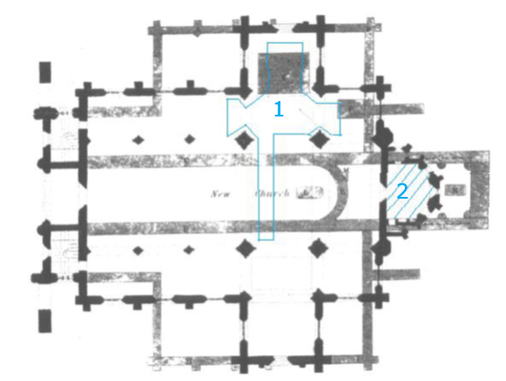
N
Figure 3: Initial 2016 Survey areas delineated in blue (1 - North Transept/Aisle and 2 - Vestry) within William Burn’s 1818 groundplan of the current Abbey Church (in black), overlying the possible position of the choir of the medieval church (in grey). The choir of the medieval abbey extends further than the area of the current Abbey Church.

Area 1 covers a section of the north aisle of the Abbey Church, with extensions northwards into the centre of its north transept (at the time a gift shop with immovable furniture) and a small extension to the south towards but not into the current south transept. As can be seen from Figure 3, this area lies above the medieval north transept, the Lady Chapel. Elite interments are recorded in both the medieval Lady Chapel and its north aisle. Primarily these were members of the Scottish royal family, including immediate family members and descendants of King Robert 1 (1306-29, known colloquially as Robert the Bruce), and other aristocrats.

The North Aisle and Transept of the Abbey Church with an extension into the crossing (Area 1 Figure 3)
The unusual shape of this area was dictated by the space available. Although it has 3 subdivisions, from north to south the North Transept, the North Aisle and the Crossing (Figures 6 & 7, cf Figure 3), the whole area was surveyed as one unit, working systematically along N/S lines as close to the church fixtures and fittings as possible.
Both low frequency antennas gave good results in area 1 with indications of anomalies close to the current floor (not relevant to this paper) but also deeper anomalies including potential subsurface burials and architectural features (Figure 4). Similar evidence was visible also in the more restricted parts of the survey area (Figure 5a, 5b).
Figure 4: 250MHz data illustrating the existence of buried archaeological remains potentially of the medieval period, as well as the complexity of the near surface (depth axis to 100ns).
The time slices generated by the two frequencies are generally coherent with each other, allowing for the differences in wavelength which affects both the target definition and depth measurement (Figures 6, 7).

These two time slices reveal three distinct areas of potential archaeological interest aligned with each other along an East/West axis. Comparison with Figure 3 shows that this alignment corresponds to the choir north aisle of the medieval church, an area known to have contained a considerable number of aristocratic burials in the medieval period.

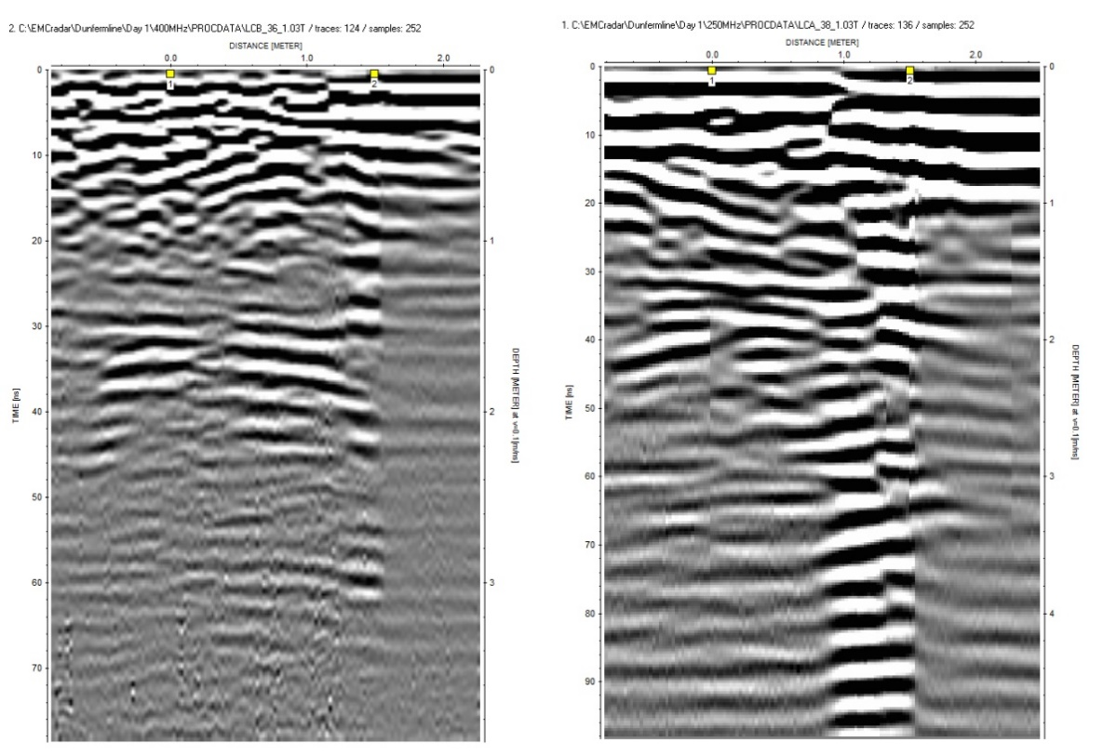
Figure 5b: 250MHz data showing subsurface features with ringing (echo effects) beneath from a depth of c.70ns.

Figure 5a: 400MHz data showing similar evidence from the more restricted part of area 1, potentially a double burial (30ns to 40ns depth).

Each of these three subdivisions has a roughly rectangular outline in at least one of the time slices, suggesting areas of organised use. Those at the top (east) and bottom (west) of the figures are the most clearly

Figure 6: Time Slice of Area 1 (cf Figure 3) at c.1.5m depth showing 4 possible burial areas within the North Aisle (250MHz).
Figure 7: Time Slice of Area 1 (cf Figure 3) at c.2.2m indicating an additional area of interest within the Crossing (to the South), potentially structural remains (250MHz).

defined and also contain pairs of smaller rectangles which could represent the air gaps within paired burials, in whole or in part (1 to 4 in Figure 6, 1 to 5 in Figure 7).

Viewed in the 2-dimensional (2-d) vertical perspective, the data confirms the pairing of these smaller areas of strong signal return is unlikely to be random. There are paired anomalies at c.1.5m depth (Figure 5). Directly below these features a double column of ringing is frequently observable. This suggests the presence of two sets of short metallic surfaces which would be consistent with the use of aristocratic coffins of the medieval period in which the deceased has been wrapped in a lead shroud or, possibly, a lead-lined coffin (e.g. Figure 5b).

The central section of the three subdivisions, to the north of the crossing, is best defined in Figure 7. Although it is obviously an area of disturbance, perhaps that investigated by antiquarian John Dalyell and locals in 1807 (Dalyell, 1809), it also contains fewer indications of discrete potential burials within the area. It does, however, show as being a potentially coherent entity, albeit one which has been greatly disturbed. The 2-d data from this area does contain similar evidence of potential medieval burials to that of the areas to the east and west but at a deeper level. (Figure 8). A linear feature, L, possibly part of a larger structure is visible in this area and there is at least part of one feature adjacent to the west of the marked pillar (‘?’ in Figure 7). Although this is a partial view, it is potentially of significance as the position is one where the remains of an altar might be expected.

Figure 8: Double columns of ringing from the central section of area 1, evidence consistent with that of the paired burials to the east and west in the North Aisle (400MHz data).

The three sections along the north aisle of the Abbey Church coincide with the area thought, from historical records, to be the site of the medieval northern Lady aisle in which sources record numerous aristocratic burials of the 13th and 14th centuries (Chron. Fordun, 1872, ii, pp 354-5 Andrew Moray, 360 Matilda Bruce, 366 Christian Bruce; Chron. Bower, vi, pp 65 Thomas Randolph, and vii 37 Queen Annabella Drummond, 135 Robert Stewart Duke of Albany). The GPR data not only confirm that it is possible to locate what remains of the medieval abbey choir but also correlate with the relevant historical accounts.

It is noticeable that the outlines of the possible graves are not undamaged. Rather they are consistent with burials which may either have been investigated post-deposition, are otherwise affected by subsequent building alterations in the same area or reflect the current (as opposed to the original) distribution of the material being detected, most likely air. Given the site’s history and its reduction to rubble in advance of the building of the Abbey Church, this is unsurprising.

There is a tradition that a group of six large slabs covering royal graves were found in the Abbey Church north transept (and therefore within the medieval Lady Chapel) during the site clearance prior to building the Abbey Church. This tradition was recorded by William Burn, the architect of the Abbey Church. Although it was not possible to include most of this area in the survey due to the position of the shop furniture, there was room to carry out six long and one shorter survey lines into this area (cf Figures 6 & 7). No clear evidence for these graves was found in the limited area available for investigation.

There is a fourth area of interest which develops with depth close to the centre of the current Abbey Church, within the crossing (Figure 7). The outline is suggestive of a central linear symmetrical feature such as steps leading up to the area of the medieval altar, a common feature of Benedictine choirs. It is planned to test this hypothesis by comparing the alignment of the features within an accurate up to date plan of the Abbey Church once one becomes available. The 250MHz data suggests another smaller discrete central feature below this linear one at c.65ns depth (Figure 4, x = 9m).

Area 2: The Vestry

In area 2, the Vestry, the picture was rather different. The vestry lies at the east end of the Abbey Church (Figure3). In terms of the medieval church, it lies to the east of the choir and would have formed part of the medieval shrine of St Margaret, the remains of which now stand outside the east end of the Abbey Church in the eastern exterior graveyard (Figure45). It therefore forms part of the area dedicated to St Margaret, a pilgrimage site associated with childbirth and various cures, which would have formed an important focus within the church, and which may have been the final burial site of the saint and her husband King Malcolm III. In the interim years between the destruction of the east end of the abbey and the building of the Abbey Church, it would have been easily accessible and formed part of the Psalter burial ground. The same survey strategy as for Area 1 was applied to this area.

The results show a crowded subsurface with a high density of graves, some of which may have intercut others. The evidence from both frequencies suggests more than one level of burial (Figure 9). It is difficult to resolve the outlines of the burials for those closer than 40ns (c.2m) to the surface which suggests a simple form of burial but also the possibility of intercutting given that there needs to be a separation of c.1 wavelength between similar features for separate detection (Figure 10). The degree of separation required would be 25cm for the 400MHz antenna and 40cm for the 250MHz (Carrick Utsi, 2017).

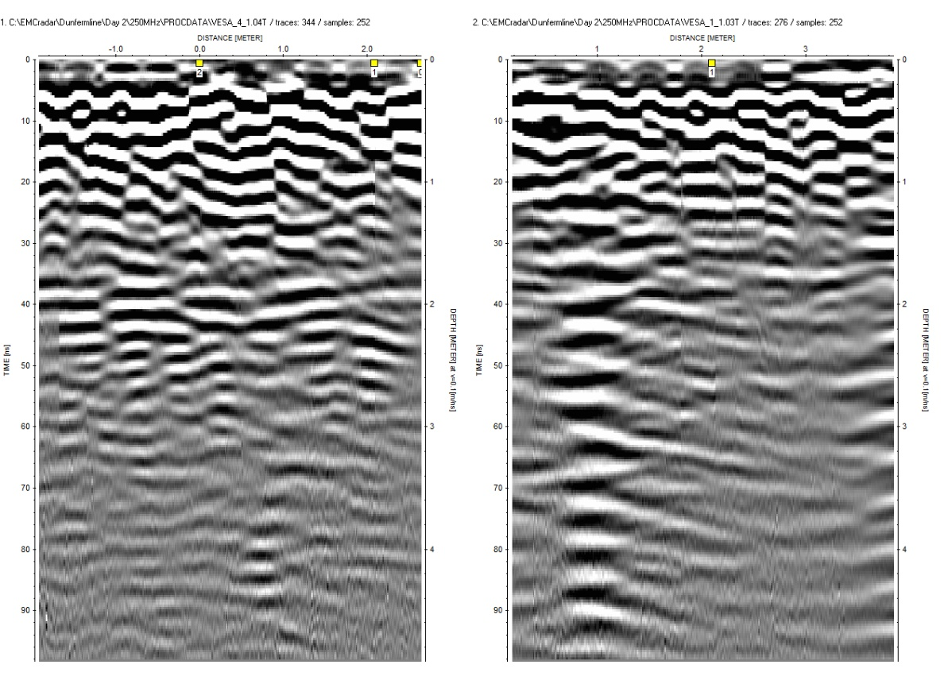
Figure 9: Vestry data showing the crowding of a variety of potential burial evidence.

Figure 10: Time Slice at 40ns (c.2m) showing the crowding of possible grave outlines beneath the floor of the Vestry (400MHz data).
The spatial order accorded to the graves in the north aisle is not replicated here and there is also considerably less subsurface ringing in this data set. This suggests that the majority of the persons buried here were not interred in the same manner as those in area 1. They may not have been viewed as being of the same social importance (for example clergy or burgesses rather than nobility), or the change of religion might have resulted in different criteria for the allocation of sought after burial spaces post-1560. Given the building destruction, there is also the possibility of less control over the use of the site which, in turn, would suggest that many of these graves are of post-medieval date.

The Presbytery (central internal area between the crossing and the vestry) and the medieval Lady Chapel

The second exploratory season gave the opportunity to survey three areas, the central internal area directly to the west of the Vestry (2a) and two external areas (2b, 2c) thought to cover the area of the medieval Lady Chapel which extended beyond the walls of the Abbey Church (Figures 3, 11). One aim of the survey was to try and locate any remnants of the external walls of the medieval Lady Chapel (proofing Burns’ 1818 plan).
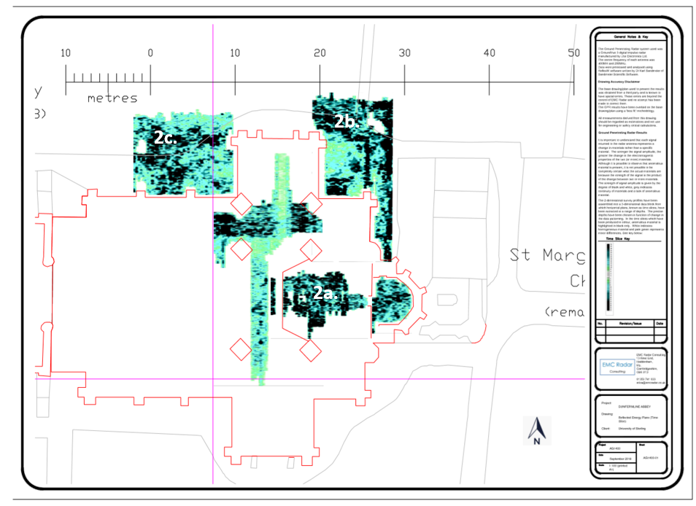
Figure 11: Plan of the Abbey Church showing the three areas of investigation in 2017 (2a, b and c) together with the two areas investigated in 2016.
The internal area was restricted by fixed pews still in place, by other church furniture including the organ and the communion table, and by a large wooden pulpit overlying the surface of a grave discovered and reinstated in 1818-19 then marked with a brass plaque in 1889, as it is currently widely believed to be the burial place of Robert I. The attribution of this grave is by no means definitive (Penman & Utsi, 2024, pp 60-6, 159-69). It proved possible to place a thin cover over parts of the grave in order to survey a part of the surface without damage.

The Presbytery (Area 2a, Figure 11)
The data from area 2a revealed very lossy soil in places, and ringing from the near surface, for example emanating from the modern organ fittings. This made the data more difficult to interpret than those of the previous season. The results were broadly similar from both antennas and consisted primarily of large rectangular features (Figure 12).
Figure 12: Time slice of Area 2a c.1.3m depth showing 7 of the 8 large features.
Although these could potentially be large graves, the 2-d data do not entirely support this hypothesis. In theory the two features closest to the Vestry (and therefore to the former shrine to St Margaret) could reasonably be expected to be graves (‘1’ and ‘2’ in Figure 12). However, this is one of the areas affected by a combination of near surface ringing and lossy soil beneath (Figure 13). Although the same conditions prevail across features 3 to 5 and features 6 and 7, there is also real material and a little associated ringing visible lower down (Figure 13). The only subsurface signals which resemble the potential graves in the north aisle of the medieval abbey are visible on the right hand edge of Figure 13, corresponding to feature 7 in Figures 12 and 14.
Figure 13: Survey line 67 showing the subsurface beneath features 6 and 7, and the lossy soil beneath.
Although the interpretation is not definitive, it seems likely that the near surface ringing may be due to a built-in void between the dais floor and the original floor of the Abbey Church and that features 3 to 6 may be related to what remains of the medieval altar settings beneath. Figure 7 could potentially form part of a grave lying partially under a later chancel screen internal wall. These hypotheses are under investigation.
The last of the eight features is visible only in the 400MHz data set (Figure 14). Its outline is irregular, and the most likely explanation is that it represents soil deposits from the excavation of the known 1818 Bruce grave immediately to the north of it in which case it is of post-medieval date.

Figure 14: Time Slice at c.1.25m depth showing position of possible eighth feature, marked ‘??’.
The East End of the Lady Chapel (Area 2b, Figure 11)
The second area chosen for investigation was the eastern end of the medieval north transept, the Lady Chapel, known to lie outside the Abbey Church north transept from the architect’s plans in which the buttresses of the Abbey Church were shown placed aligned with the outer walls of the original medieval north transept. The objective was to identify the line of the outer walls of the medieval north transept and to investigate the possibility of extant archaeological remains. The ground in this area lies approximately 1m below the floor level of the Abbey Church. Much of the ground outside the Abbey Church has been used as a graveyard and the survey had to be worked around external lights as well as gravestones and railings placed around them.
Confirmation of the location of the east end of the Lady Chapel came from both frequencies of antenna from c.1m depth downwards in the form of damaged wall foundations (Figures 15 and 16). There is also evidence
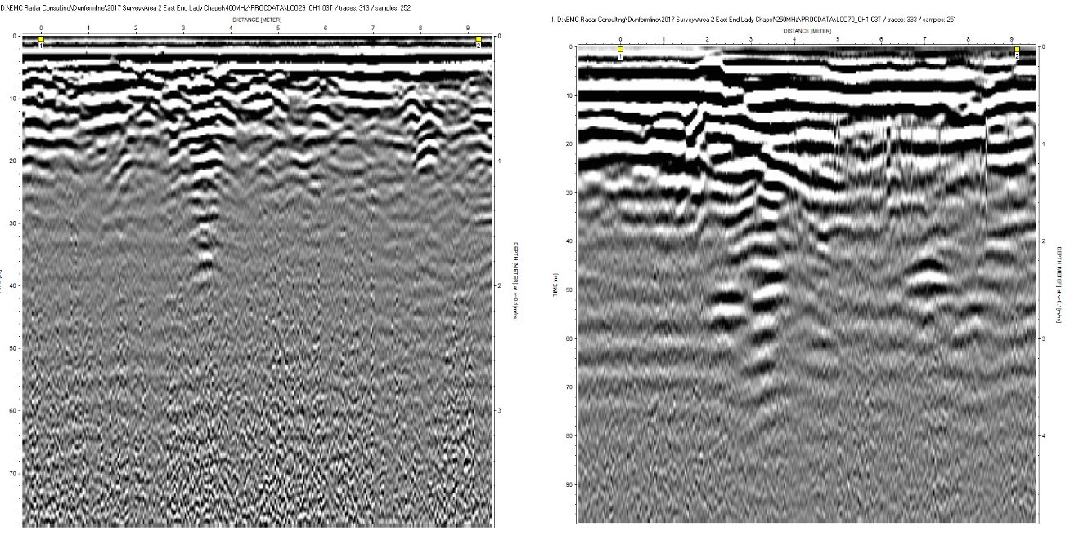
Figure 15: 400MHz data (lhs) and250MHz (rhs) showing evidence of wall footings and other archaeological material.

of extant archaeological material within the outer edge of the wall including probable burial sites. The number and extent increase with depth (Figures 17, 18). Along the edge of the Lady Chapel this may indicate that the substantial wall widens with depth, or it may indicate other material. Although the patterning suggests the former, this is 250MHz
Figure 16: Time Slice at c.1m depth (400MHz data) showing upper level of medieval wall foundations.
data so that the target definition is not as fine as that of the 400MHz.
Figure 17: Time Slice at c.1.4m depth (400MHz data) showing the outline of medieval wall foundations along the north (N) and east (E) edges of and extant archaeological remains (?A) within the Lady Chapel.
Figure 18: Time Slice at c.2.1m depth (250MHz data) showing the outline of medieval wall foundations and extant archaeological remains.
The GPR plan is a good match for that drawn up c.1818 by William Burn, the architect of the Abbey Church (cf Figure 3). It also seems to confirm his ground-plan’s recording of a flat east-end choir aisle wall, joining at a right angle with the eastern extension of the rectangular St Margaret feretory shrine (a point of difference with several conjectural 20th century heritage ground plans).
Above the level of the medieval walls, at a depth of c.40cm, the 400MHz data shows a different outline along the northern wall (Figure 19). There are two possible explanations for this. There is historical evidence that the northern and north-east corner walls of the medieval Lady Chapel stood at c.8m height, complete with four arched Gothic windows, at the time when the site was cleared for the construction of the Abbey Church foundations in 1817-18, so it is possible that the shallower remains are from what was left of the broken remains of these walls, covered over during the construction of the current church. Alternatively, historical sources including the 1854 Ordnance Survey map of Dunfermline show both the lines of thick medieval walls around the Abbey Church but also a thinner wall inserted at an angle of c.100 degrees, presumably outlining space for post-1822 burial lairs. The apparent ‘dog leg’ may therefore be a combination of the remains of the medieval wall with the 19th century wall remains.
Figure 19: Time Slice at c.40cm depth (400MHz data) showing a "dog leg" along the northern wall in Area 2b.
Within the boundary of the ruined Lady Chapel walls there are other features which may be burials or burial-related structures either of the medieval period or possibly later burials from the period between the Reformation and the construction of the Abbey Church (Figures 17 to 19). The (post-medieval) Kirk Session burial registers indicate that the Earls of Elgin, descendants of the Bruce family, were interred within the north-east corner of the ruined choir. The only potential method of differentiating the two time periods is the depth at which these burials were placed although this is not necessarily a definitive indicator. One potential for the later period is the substantial grave in the south-west corner of the survey area, the upper level of which is visible at c.40cm depth (Figure 19) in an area which presumably lay in front of a dedicated Lady altar.

The West End of the Lady Chapel (Area 2c, Figure 11)
In order to test the full extent of the former Lady Chapel, the area directly to the west of the Abbey Church north transept was also surveyed (Figure 11). As with the eastern end, the survey had to be worked around external lights, an ash pathway as well as gravestones from post-medieval interments. The combined effects of historic destruction, disturbance and re-use had a greater impact in this area, particularly on the use of the lower frequency antenna. The better performance from the 400MHz is a reflection of the destruction level applied in this area and the associated crowding of the mixed materials in the subsurface as this has a lesser effect on target definition for this antenna (Figure 20).
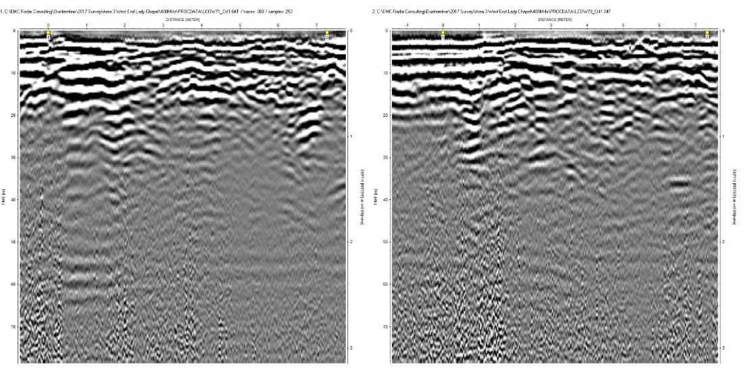
Figure 20: 400MHz data from the West end of the Lady Chapel.
Remains of the outer north wall of the Lady Chapel become visible at around 80cm below current ground level followed by confirmation of the west wall approximately a further 20cm lower down (Figure 21). The outlines given correspond, as was the case in the east end of the Lady Chapel, with the later placement of the Abbey Church. In the lower time slice, potential archaeological features are also visible. The degree of post-depositional disturbance makes it difficult to be prescriptive about the nature of these features although both structural elements and burials remain a possibility. Scottish medieval chronicles briefly note several possible burials in this area (Chron. Fordun, i, 354, 363, 369, 377 and ii, 354-5, 360, 366-7; Chron. Bower, vi, 73, 305; Boardman, 2005, p 150). However, it is difficult to allocate any of these features to the medieval or post-medieval period. Unlike the pattern of graves beneath the north aisle of the Abbey Church, there is no regularity in their relative location which suggests that post-medieval is more likely.
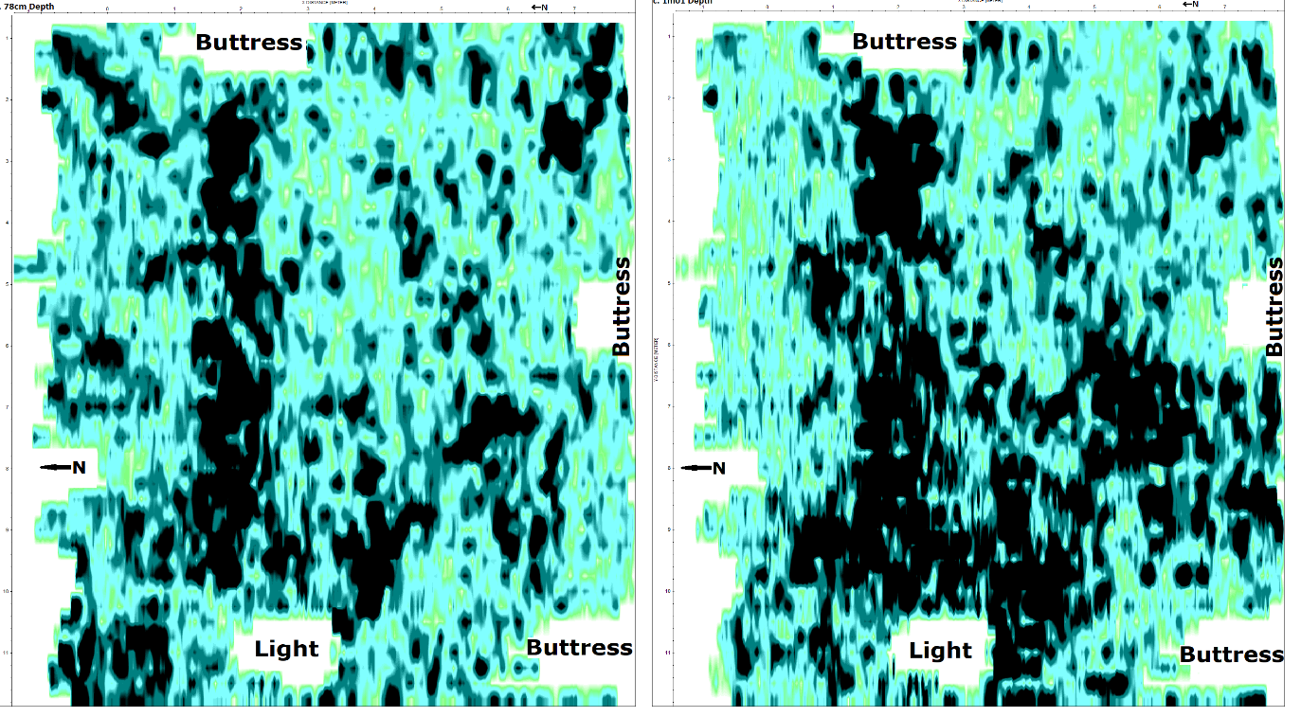
Figure 21: Time slice at c.80cm depth (left) showing the extant remains of the north wall of the Lady Chapel and at c.1m (right) where the west wall becomes visible(400MHz data).

A further 30cm lower down the patterning persists although the outlines of the various features, some of which appear related and all of which have irregular outlines suggestive of damage are less easy to categorise (Figure 22). This may not be as irregular as it appears since this data was generated using the 250MHz antenna so that the irregularities could be the result of two or more features being within a wavelength’s distance from each other, in this area c.32cm, so that they are not separately distinguishable.
One feature towards the west end of the area, marked as ‘2?’ in Figure 22, does appear to have a coherent structure with a curved upper surface. It is not possible to be certain whether this is a medieval or post-medieval feature although the depth is greater than would normally apply, for example, for modern utilities.

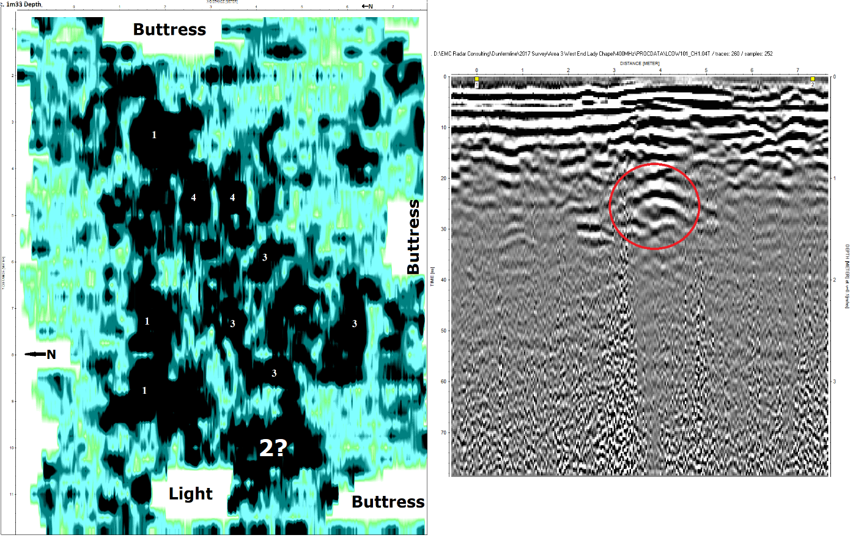
Figure 22: Time slice at c.1.3m depth (250MHz data) showing a number of internal features some of which may be related. The 2-d data to the right shows the outline of the area marked ‘2?’ in the time slice.

The Question of a South Transept
In August 2019 it was decided to tackle another external area, to the south of the Abbey Church in order to test for the possible (and disputed) existence of a chapel, dedicated to St John the Baptist, in the South Transept, mirroring the Lady Chapel to the north. William Burn’s 1818 ground plan drawing of the medieval walls still standing when he was planning the building of the current Abbey Church shows a symmetrical cruciform shaped church which implies the existence of an aisled chapel in this vicinity (Figure 3). The balancing of the Lady Chapel in the south with that of St John in the north in addition to the main altar to the east would also be expected in a Benedictine abbey with a high altar dedicated to the Trinity and where thus importance is placed on triplicated features and the Holy Family. The dedication to St John is confirmed by early 16th century burgh records which refer to the altar and south aisle under this name (Burgh Records of Dunfermline, 1488-1584, nos 24, 26, 31, 120, 121, 125, 131, 140, 142, 151, 154, 208, 357, 365).
This was a challenging area to survey as the ground conditions were unfavourable. Not only was there a slope to the south side and a considerable density of marked graves and some external lights, it was unclear just what purpose(s) this area had served since the destruction of the medieval church although late 18th-century sketches of the ruins suggest no new structures were placed here and it was likely to have been open-air burial ground (Figure 23). References to wet ground and flooding, mentioned above, were related primarily to the south side where an underground watercourse had been suspected. This did not prevent the survey from being carried out in a systematic and accurate manner. A trolley with large wheels was used to minimise the disturbance in crossing the ground. However small blank areas remain within the horizontal data where above ground obstacles prevented the antennas from having contact with the ground.
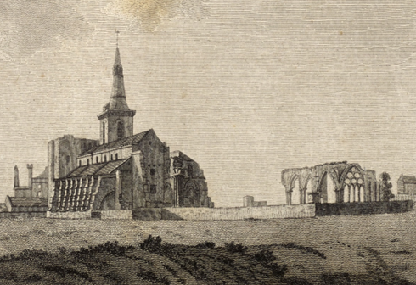
Figure 23: General view of Dunfermline Abbey ruins from the south-east, 1791: note the four standing Lady Chapel windows and, to the west, centre frame, a single truncated medieval choir pillar.
Unfortunately, in the weeks before the survey took place (August 2019), it had rained heavily with the result that the ground was too wet for the 400MHz antenna to give sufficient depth penetration to reach any medieval remains. The survey was therefore restricted to the 250MHz antenna. Calibration of the data was carried out by curve fitting which gave a transmission velocity of 0.08m/ns for depths up to c.1m and 0.065m/ns lower down.
The 2-d data showed subsurface packing of this area, not only connected with relatively modern features such as paths and graves but also around 1m depth, often accompanied by echo effects (Figure 24). Although there is some material lower down, notably between 40ns and 50ns, this is sparse. No remains of walls still in situ were observed in the 2-d data. Nor were there any clear indications of potential burials.
Figure 24: Survey lines 18 and 25 showing packing of the near surface on the south side of the Abbey Church as well as material at c.1m depth and subsurface ringing below.
Figure 25: Time Slice at c.1m depth. The rectangular feature is outlined in red.
Examination of the time slices extracted from the 3-d data block confirmed the destruction and re-use of this area but also revealed
a layer formed by disparate blocks of material forming a rectangular outline (Figure 25). This looks as though it could be material from the original medieval south chapel and aisle which has been broken up and used to level the site for the construction of the current Abbey Church. It may have originally been larger than the feature outlined in red but, if so, subsequent use of the ground has reduced its visibility. The depth of this feature is consistent with the upper level of potential medieval features from the north side, in particular in area 2c. Although it is unlikely that little if any of the original material lies in situ, it appears that there has been an attempt to level ground defined by a pre-existing feature using the broken elements of that feature, namely the medieval south transept. This fits not only Burn’s drawing but also his concerns re groundwater along the south side of the Abbey Church.
The South Aisle, Memorial Chapel, North Transept and NE Dais
In August 2022 it became possible, with the removal of additional pews and the relocation of the shop, to investigate a further four small areas, namely the South Aisle of the Abbey Church, the Memorial chapel, the North Transept (with an extension towards the south) and the North-East dais (Figure 26). The first two were new territory, the latter two partially overlapped a small part of the North Aisle, investigated in 2016.
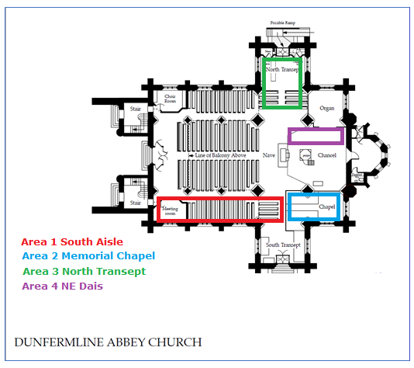
Figure 26: Survey areas in 2022. Plan based on that drawn up by Tod and Taylor, Architects, Edinburgh in January 2005.

The South Aisle
The survey of this area revealed a number of recent near surface interior constructions which relate to the Abbey Church rather than the medieval one, for example, the installation of the Tiffany window in 2019. Echo effects suggest that there are air gaps present and possibly some related metal (Figure 27). Extant remains of the medieval church were few. As was the case for the survey of the external South Transept, adjacent to this area, the ground appears to have been comprehensively reworked prior to the building of the Abbey Church.
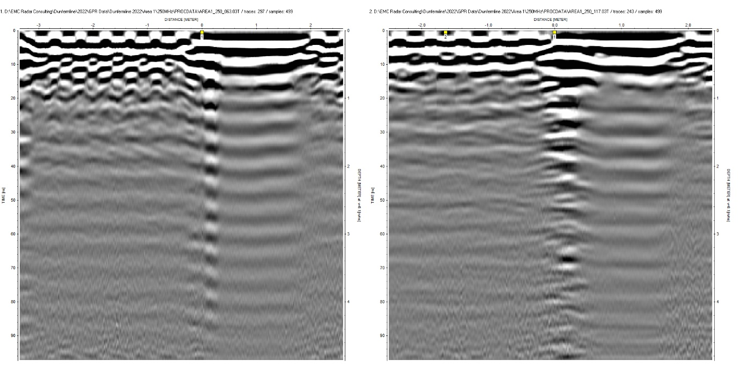
Figure 27: Typical 2D data from the South Aisle of the Abbey Church. The ringing visible in the left hand radargram is from metallic edging to a carpet (250MHz data).
Both antennas detected a series of anomalies in the SW corner which are potential medieval remains (Figure 28). Their depth, at c.2m, is consistent with the depth results of the other surveys. Although the outlines of these features are irregular and apparently discontinuous, it is noticeable that they form points on 3 potential North/South lines which run parallel to each other at nearly identical spacings of c.1.5m. The orientation, at 90 degrees to the axis of the church, suggests the remains of a related structure. The 2-d data suggests that there is a faint layer change or series of slightly irregular layer changes at this depth, implying at least a minimal degree of continuity of structure. Given that the radar is travelling in precisely the same direction, the implication is that this could be the remains of three short stretches of wall, differentially damaged.

The irregularity in the outlines from both frequencies in both the 2d and 3d data sets imply considerable destruction of these features and their
immediate surroundings. The overall pattern, although it is incomplete, therefore suggests a form of partitioning of this area in the medieval period.

Figure 28: Time Slice at c.2m depth (Abbey Church south aisle) showing potential medieval remains in the SW corner (400MHz data). The line of central West/East signals are ringing from the near surface.

The Memorial Chapel
The memorial chapel is essentially a continuation of the south aisle towards the east (Figure 26). The results of the surveys in this area were broadly similar to those in both the south aisle and the external south transept in terms of the predominance of relatively modern features within the near surface, the apparent levels of destruction in the process of rebuilding and the very limited survival of potential medieval remains, primarily in the SW corner of the area (Figure 29).

Taking areas 1 and 2 together with the results of the 2019 investigation into the possibility of a medieval south transept, suggests that not only did this southern chapel exist but that there were monuments, potentially funerary monuments and their associated burials within the south aisle of the medieval church. Although the extant remains are limited as a result of the degree of demolition and the reuse of building material as stabilisation for the Abbey Church, this is sufficient to give an insight into the medieval south transept and aisle.

Figure 29: Time Slice at c.2.15m depth showing potential medieval remains in the SW corner of the Memorial chapel (400MHz data). The remaining signals are ringing from the near surface.
The North Transept with an Extension towards the South
The investigation of the north aisle of the Abbey Church revealed the position of pairs of graves in the medieval north aisle along an East/West axis and the position of the external walls of the medieval Lady Chapel were identified by an external survey. There were also other potential internal features. The small central area of the current north transept that had been surveyed in 2016 did not appear to contain extant medieval remains (cf Figures 6 & 7) although it was known from historical records that this had been an important burial place for medieval royalty and related nobility. Only Figure 7, the time slice at 2.2m depth, the same depth as the possible steps up to the medieval altar, shows a potential but very partial area of interest at the eastern edge of the accessible area. With the clearance of the Abbey Church north transept, it became possible to survey the full area including an extension towards the south (Figure 26).

The 2-d data from both frequencies shows a mixture of archaeological features directly below the modern floor construction mostly lying within the first 20ns depth (Figure 30). There are traces of further material directly below as well as at greater depth, for example around 30ns and below 60ns in the left radargram. There are some other curiosities such as the near surface feature visible in figure 30 below in which, after a very small gap, only ringing is visible. This is the feature labelled ‘3’ in Figure 32. The apparent depth of the near surface signal at this position suggests the existence of a near surface air gap sufficiently small for the upper and lower levels to be independently undetected. From its depth it is likely to be of (relatively) modern date.

Figure 30: Survey lines along y=1.15m and 3.9m in the North Transept showing archaeological features below the near surface as well as at greater depth. The feature of the near surface which has resulted in strong ringing lies between 0m and 2m The adjacent signal pattern centred on 3m resembles archaeological material (250MHz data).
It is not currently known what this near surface feature represents nor whether the dominance of the echo effects is due to uniformity of the material below or the substitution of lossy soil for whatever originally lay below. The proximity to archaeological material raises the possibility of earlier investigation of medieval remains in this vicinity before the building of the Georgian Abbey Church,F for which there is historical evidence (Dalyell, 1809).

Below the 20ns depth, this column of echo effects lies adjacent to and south of buried material (Figure 30). This location corresponds to the potential grave signalled by a linear West/East feature placed between the western (upper) edge and y = 4m, centred around x =c.2m, partially visible in Figure 31 and marked as ‘2’ in Figure 32.

Figure 31: Time Slice from the North Transept at c.1.5m depth showing at least one possible grave ('1') and a heavily disturbed area along both the western (top) and eastern (bottom) edges of the North Transept (400MHz data).
Figure 32: Time Slice from the North Transept at c.2m depth showing grave 1, possible grave 2 and feature 3 (250MHz data).
The time slice at 1.5m depth resolves these features into one linear east/west feature accompanied by disturbed ground along the western edge and at least one major grave, possibly with the remains of others in the east section of the area (Figure 31). At this depth, the 2-d data suggest that the features along the eastern edge are similar to the remains of the large grave, marked ‘1’ (cf Figure 31, with Figures 30 and 33). This main grave appears to be one, and the best preserved, of a series of graves in a north/south line. It is possible that this may correspond to the location of one of the 6 royal graves which local tradition were marked in this area by six surviving slabs, the longest 6’ long, and which Burn depicted on his groundplan record of extant medieval remains beneath the new proposed Abbey Church walls (CANMORE, FID 89/3 to 22, and SC 1573934).

As suggested above, the linear feature, marked “2” in Figure 32, at the western end of the survey area, potentially truncated along its southern edge, may represent part of another grave. Its position, directly opposite
grave 1 also suggests this.

The density of strong signal returns along the western edge to the north of this position also suggests possible burial remains, potentially either partially destroyed, disturbed or destroyed in the period between the destruction of the medieval choir and the building of the Abbey Church. Whether these are connected to spoil from an excavation or to the preparation for the construction of the later church cannot currently be determined.

By c.2m depth, the remains of grave 1 are still visible, the material in the south-west corner discussed above has expanded to suggest a full grave space (‘2’) and the material along both east and west edges still suggests that there may have been more burials in this area towards the north although re-distribution of archaeological material from investigations cannot be ruled out (Figure 32). There are no recognisable burial space outlines which suggests that this material has possibly been post-depositionally disturbed or that the actual burial material detected by the radar (eg air, asphalt or other) may have become partial in extent due to the passage of time. The corresponding 2-d data shows archaeological material and the faint outline of an undulating layer change at c.2m depth (Figure 33).

Figure 33: Survey lines from the North Transept at y = 5.4m and 4.9m showing archaeological material within and below the 2m depth in which the faint outline of an undulating layer is visible (250MHz data).
The near surface features relate to the construction of the 19th century wooden floor and are not relevant to this project. The area by the Abbey Church north entrance can also be ignored as this is the result of recent modern adaptation.

Figure 34: Time Slice from the North Transept at c.2.9m depth showing potential burial locations beneath the Abbey Church north transept extending into the north aisle (250MHz data).
A further 90cm down, the areas covered by potential graves 1 and 2 are larger and their outlines more coherent (Figure 34). Grave 1 and the smaller dark rectangle lying to the north of it contain material consistent with burial in soil (cf Figure 30, lhs) and it is possible, even likely, that this was originally a double interment. Both areas show a considerable degree of disturbance above this depth which could result either from repeat burials in the same location or by post-interment investigation of the grave(s) in the post-Reformation period. The size of the grave(s) does suggest elite burial. The extent of the material to the south of this area, also lying on the eastern edge, is insufficient to determine whether or not it is a similar feature although John Dalyell and subsequent antiquarians did record the discovery of an apparent row of six stone coffins beneath the debris-strewn surface of the north aisle c.1802-9 (Dalyell, 1809; Chalmers, 1844, i, 151-5; Henderson, 1879, 549).

Potential grave 2 is more complicated. As Figure 33 shows, only part of the feature is visible. There is a large modern feature near the surface but the strong signals below, although truncated, are not unequivocally direct reflections, in whole or in part, of the material above as would be expected in echo effects. The depth and its position relative to grave 1 suggests a medieval feature but the possibility of post-medieval intrusion or that this feature is of post-medieval date remains.

The North-East Dais
The dais is a feature of the current Abbey Church (Figure 26). Unsurprisingly the near surface data mostly correspond to the floor construction. This area is almost devoid of deep anomalies as the deeper subsurface is mostly disguised by echo effects from features in the near surface. However, there are a small number of real features to the East end of the survey area visible as anomalous signals from a depth of c.1.1m depth. The best definition of their outlines is visible by c.1.95m depth which is consistent with medieval remains in the other surveys. Although the survey area is limited by the position of current church walls to the east and north, a short line of potential burials including the partial outline of a lead coffin is visible (Figure 35).
Figure 35: Time Slice from the North-East Dais at c.1.9m depth showing a number of possible graves at the East end. The red arrow indicates the possible lead coffin.

Discussion

The history of this site makes this a challenging project not just from
various changes of use but also the nature of the ground on which the buildings were constructed and the impact of modern weather patterns, notably the very wet summer of 2019. The limited access originally thought to be an obstacle has proved not to be as difficult to work around as expected and the church authorities have been keenly supportive of the survey work carried out.

Potentially it could have been contentious to use GPR survey without recourse to verification by physical investigation. Incompleteness of remains makes it difficult to determine the overall form and the relative date of former structures. However, the abbey’s initial royal status and the continuing interest in its history from the 16th century onwards have given rise to a range of documents containing relevant information about the layout and use of the medieval choir. There are also physical parallels in other Benedictine establishments reflecting their common liturgical practices. Although we cannot expect to provide a complete inventory of all extant remains, we do have sufficient comparative material to identify some of the medieval features and to link others to different phases of the site’s history.

The GPR data have been used to distinguish between disputed texts and will remain as an independent comparison to further historical research as well as enabling a reassessment of the various phases of the building’s history. Although the process may be imperfect, particularly as regards dating of the GPR evidence, it has nonetheless given valuable information of the medieval past of the modern Abbey Church.

The evidence uncovered includes the following:
- Wall footings delineating the outline of the medieval Lady Chapel, lying to the north of the Abbey Church north transept;
- Confirmation of William Burn’s groundplan of c.1818 that the outline of the Abbey Church was tied into the framework of the medieval choir;
- Structures within the medieval Lady Chapel, a mixture of graves and other features within a pattern of destruction;
- Multiple potential elite burials in the North Transept and Lady Chapel area of the medieval choir;
- Potential elite burials in pairs along the East/West axis of the north aisle, adjacent to the Lady Chapel;
- Archaeological remains oriented north-south lying below the current presbytery (medieval chancel or sanctuary) which are likely candidates for structures associated with the high altar of the medieval abbey rather than graves;
- Parallel remains lying directly to the west which may indicate the position of the sanctuary steps;
- Multiple burials below the vestry of the Abbey Church, in the east end, possibly related to the position of the shrine of St Margaret but more likely from their distribution to date to the post-Reformation ‘Psalter’ churchyard (c.1560 to 1818);
- Evidence for a chapel in a southern transept, in part from the external southern survey but also from the finds of potential elite burials in the areas of the memorial chapel and south aisle of the Abbey Church;
- Understanding and identification of some of the post-Reformation history of the site; and
- Proof that medieval remains can be mapped beneath the current construction across the majority of the site in spite of variable subsurface conditions and post-depositional damage.

The series of trial surveys has prompted further historical research into additional historical sources either previously unknown or overlooked. The result of combining this evidence with the GPR data has led to revised understanding of the layout, use and history of Scotland’s royal abbey and the pilgrimage cult of St Margaret. This includes a better understanding of the location of the royal and aristocratic burials, the possibility of a southern chapel dedicated to St John the Baptist, a reassessment of the cruciform layout and spacing of the medieval church, the possible layout of the high altar and eastern sanctuary of the choir and Dunfermline’s relationship to its English and French counterparts at Westminster and St Dénis.

Interestingly the combined data also impacts on the burial history of two Scottish kings, Alexander III and Robert I (known colloquially as Robert the Bruce). For the former, it provides a potential explanation for an unusual burial location, confirmed as a possibility by the GPR data. For the latter, it provides an alternative burial location consistent with paired burial alongside his Queen (unlike the currently marked grave) and also conforms more clearly to witness evidence. A full account of the historical evidence is available online (Penman and Utsi, 2024).

Future Work
The small scale of these surveys has not prevented the detection of interpretable patterning of the subsurface. Completing the overall pattern beneath the Abbey Church does, however, require further work, in particular investigation of the central western area (cf Figures 11 and 26).
There is also a need for the creation of a more accurate floor plan of the Abbey Church in order to place all of the survey evidence within context and to enable testing of some of our preliminary conclusions. The obvious example of this is the alignment of the possible altar steps with the range of features potentially marking the position of the high altar. It is also hoped to obtain funding for a digital recreation of the project results.
As mentioned above, it was not possible to use the 400MHz antenna on the southern exterior of the Abbey Church due to the moisture content of the soil. It has been useful in other areas to compare the evidence of the two frequencies of antenna and, if weather conditions and timing permit, this area should be tackled with a 400MHz antenna.
The medieval nave is still standing, immediately adjacent to the Abbey Church. There has been at least one excavation in this area, but it would be instructive to include the nave in a future survey.
The current shrine to St Margaret lies outside of the Abbey Church at the East end and is marked by two central levels of fossiliferous stonework and surrounded by a low wall on two sides with the vestry and the boundary of a grave on the other two (Figure 36). The area available for survey is extremely limited. It may not be possible to survey in this area although it would be interesting to do so in view of the results obtained within the adjacent vestry.
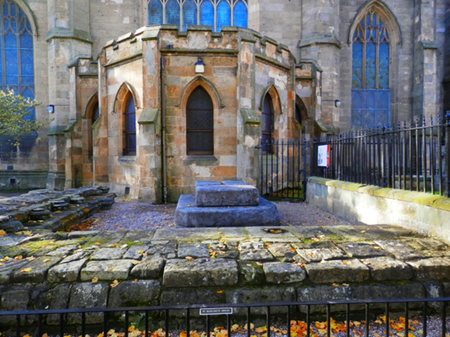
Figure 36: St Margaret’s Shrine to the East of the Abbey Church (Dunfermline Historical Society).
Conclusions
Although the modifications made to the medieval abbey church presented a challenge for GPR survey both in terms of detection and data interpretation, it has been possible to glean a range of interesting information and to corroborate this with historical sources and contemporary equivalent buildings. Even though access in any one survey was limited, using close area survey and dual frequencies has allowed the generation of a considerable volume of data and to identify meaningful patterning within the data set.
The first trial surveys proved that it was possible to use GPR meaningfully on the site and identified organised elite burials within the medieval north aisle and crowded, relatively disorganised, simpler interments within the vicinity of St Margaret’s shrine. The former are of medieval date, but the latter may date to the post-Reformation, pre-reconstruction phase.
A second set of surveys revealed assorted structures within the central presbytery which may represent the high altar and the screened chancel fittings around it and a parallel linear feature further to the west, possibly the remains of the altar steps. This theory will be tested once an accurate modern plan of the floor can be produced. The external surveys revealed the line of the wall footings from the medieval Lady Chapel to the north of the Abbey Church and, as per William Burn’s groundplan, confirmed that the newer Abbey Church had been placed symmetrically within the outline of the medieval choir and transepts (as well as, perhaps, siting modern pillar bases atop medieval pillar remains). There are structures including potential graves, within this area of the North Transept of medieval and post-medieval date.
In spite of the widespread destruction along the south side of the Abbey Church during and after the religious Reformation of 1560, a plausible location for the ruins of a South Transept whose existence had previously been uncertain were identified in 2019. The latest survey (2022) of the south interior of the Abbey Church has produced further evidence of groups of graves and other structures, potentially partitioning which, in spite of the level of destruction, confirm the existence and likely location of this south chapel, placed symmetrically with the Lady Chapel to the north.
Acknowledgements
The authors would like to thank the following charitable funding bodies for their generosity in supporting us through the four preliminary stages of our pilot scans: the G.W.S. Barrow Award (2016), the Strathmartine Trust (2016), the Royal Society of Edinburgh (2017 and 2022), the Hunter Archaeological & Historical Trust (2019); and the Faculty of Arts & Humanities of the University of Stirling (2019).

We are also grateful for the initiation of this project and the continuing enthusiastic support of the Abbey Church through the persons of Rev. MaryAnn Rennie and her husband, Keith; former Kirk Session Clerk, Ken Richards; current Joint Session Clerks David Williams and Frances McCafferty; former Keeper of Fabric, Arnott Wilson; former Beadle Mary Walsh; and custodians Elaine Pirrie and Willie Donaldson.

On Fife Council, we have also had advice, support and encouragement from: former Community Manager for the City of Dunfermline, Joe McGuiness, former Community Manager for the City of Dunfermline, and his successor, Gillian Taylor (now of Carnegie Dunfermline Trust); Bereavement Services Manager, Liz Murphy; Local Authority Archaeologist, Douglas Spiers; Chair of the Dunfermline Abbey Burial Ground Project, Cllr Jean Muir; and the Convenor of the City of Dunfermline Area Committee, Cllr Helen Law.

From Historic Environment Scotland [HES], we have received invaluable support for our field-work and research from Sally Gall, Interpretation Officer (Access and Audiences), HES’s representative on the Dunfermline Heritage Partnership, along with her colleague, Joyce Kitching. We are also grateful to: Anne Marie O’Reilly as District Visitor and Communities Manager, Central East; Doreen Waller, HES Senior Operations Manager; Lyn Wilson, Digital Documentation Manager; Stephen Duncan, Director of Commercial and Tourism; Dr Nicki Scott, Senior Cultural Resources Advisor; Dr Richard Strachan, Senior Archaeologist; Dr Kirsty Owen, Deputy Head of Archaeology; Ben Thomas, Research Manager; Philip Brooks, Public Services Officer; Veronica Fraser, Accessions Programme Manager; and the great team of on-site Dunfermline Abbey Nave and Palace custodians.

Local Studies Officer, Sara Ann Kelly, and her colleagues in the archive-library of Dunfermline Carnegie Library & Gallery have helped us locate and understand many important manuscript sources in their care, not least the works of local historians of the nineteenth century.

The Abbey Church, Fife Council, HES and DCL&G have been strong contributors to the collaborative energy of the Dunfermline Heritage Partnership since 2017 and that body, following the Abbey Church’s ambitious lead, have embraced and further aided our research. Thus we would like to thank, too, its many other members and in particular: Chair Derek Bottom; Grant Williams and Haley Muir, respectively Project Manager and Officer for Dunfermline’s Great Place Scheme; Mark Macleod, Project Manager of Dunfermline Digital Tours for Fife Cultural Trust; Rev. Christopher Heenan of St Margaret’s Memorial Church, Dunfermline (for discussions about St Margaret relics and images); Ann Camus, Tourism Partnership Manager for Fife Council, working with John Murray and Miranda Lorraine on the Fife Pilgrim Way project (completed in summer 2019) for Fife Coast & Countryside Trust; and Nora Rundell of the Carnegie Dunfermline Trust.

We have also been fortunate to undertake our project in parallel with several other research initiatives, benefitting from exchange and debate with their work. We would like to thank: Sue Mowat of Dunfermline Community Heritage Projects and Mark Seaborne of the Dunfermline Youth Archaeology Society, for their joint Abbey Graveyard project and insights into the archaeology and history of the burial grounds; Dr Susan Buckham of Kirkyard Consulting (and a research associate of the University of Stirling) for her 2020 scoping report for the Dunfermline Abbey Burial Ground project; Dr Iain Fraser, Archives Manager for HES and his collaborators at the Centre for Digital Documentation and Visualisation (Glasgow School of Art) for their Lost Tomb of Robert Bruce project (2014-), now housed within the Abbey Church; and Dr Martin MacGregor and his Glasgow and Liverpool colleagues and their inter-disciplinary work ‘in search of the face’ of Robert Bruce (2014-19).

We also owe a collegiate debt to a number of other researchers: the late Professor Emeritus Richard Fawcett, formerly of Historic Scotland and the University of St Andrews, for exchanges on ecclesiastical architecture and lead coffins; Peter Yeoman, former Fife County Archaeologist, for his kind notice of the carved lion footrest fragment found in Abbot’s House excavations in the 1990s; and fulsome feedback after having used our research to update the HES Statement of Significance for the Abbey-Palace; Dr David Caldwell, formerly of National Museums Scotland, for material on elite burials; Dr Paul Adderley, of Biological and Environmental Sciences at the University of Stirling, for the initial suggestion of applying GPR to Dunfermline Abbey; Stirling colleagues Professor Richard Oram, Dr Tom Turpie and the late Dr Alasdair Ross for numerous suggestions and discussions about Dunfermline, pilgrimage, shrines and relics; Rod Eley and Sally Foster, both formerly of Historic Scotland for exchanges on DNA, leprosy and burial archaeology; Professor Roberta Gilchrist of the University of Reading for a brief exchange relating to lead coffins; Professor Lindy Grant of the University of Reading and the Reading Abbey Revealed community project, for her support of our development of a project to digitally recreate Dunfermline Abbey choir; Dr Duncan Pirrie, Associate Professor of Geology at the University of South Wales, for raising questions about the source of the abbey’s fossiliferous marble; Peter Richmond of Hexham Abbey Heritage for advice about sources and ground-plans; Frank Connelly and Charles Bruce for a fascinating conversation about the choir relics potentially deposited in the south-side Abbey Church crypt of the Bruce Earls of Elgin; and Professor Frederique Lachaud and Professor Emeritus Elizabeth A.R. Brown of the Sorbonne, Paris, for exchanges on royal choir burial and St Dénis Abbey.

The authors also wish to express thanks to the late Dr Oliver O’Grady of OJT Heritage and Mr Alex Birtwistle and Ms Sarah Birtwisle Newson of Atlas Geophysical for their enthusiasm and hard work in assisting with the field work of 2016-17 and 2019-22 respectively when Atlas Geophysical took over from OJT Heritage.

References
Arts.st-andrews.ac.uk, accessed November 2023. Corpus of Scottish medieval parish churches: Dunblane and Dunkeld dioceses (st-andrews.ac.uk).
Baine, John, Sketches to illustrate the Ruins of Dunfermline, being a supplement to the Fourteen large views of these ruins taken in May and June 1790 – Dunfermline Carnegie Library & Gallery D/VIEWS manuscript.
Bavusi M, Soldovieri F, Piscitelli S, Loperte A, Vallianatos F, & Soupios P, 2010. Ground-Penetrating Radar and Microwave tomography to evaluate the crack and joint geometry in historical buildings: some examples from Chania, Crete, Greece in Near Surface Geophysics, Vol 8, no 5, pp377-387.
Boardman S, 2005. ‘Dunfermline as a Royal Mausoleum’ in R. Fawcett ed., Royal Dunfermline: Society of Antiquaries of Scotland, 139-54.
Bower, Walter, Scotichronicon, eds. D.E.R. Watt et al (9 vols, Aberdeen, 1987-99)
The Burgh Records of Dunfermline, 1488-1584, ed. E. Beveridge (Edinburgh, 1917)
CANMORE, Historic Environment Scotland (HES) database, FID 89/3-22, William Burn’s architectural tender plans for Dunfermline Abbey Church (1816-17)
CANMORE, Historic Environment Scotland (HES) database, SC 1573934, William Burns’s architectural plan for Dunfermline Abbey Church foundations, horizontal (1816-17)
Carrick Utsi, E, 2017. Ground Penetrating Radar Theory and Practice, Chapter 2, Elsevier. ISBN 978-0-08-102216-0
Carrick Utsi, E, 2019. Surveying, Analyzing and Evaluating the Sanctuary and High Altar Pavements: Ground Penetrating Radar Surveys 2004-05 in the Cosmatesque Mosaics of Westminster Abbey Vol 1, Rodwell W & Neal D S (eds), Chap 5 pp147-156, Oxbow Books, 978-1-78925-234-7 & 978-1-78925-234 (epub)
Chalmers, P., Historical and Statistical Account of Dunfermline (2 vols, Edinburgh, 1844-59)
Church of Scotland, 2019. https://churchofscotland.org.uk/news-and-events/news/2019/articles/stunning-tiffany-window-dedicated-in-dunfermline
Dalyell, J.G., A Tract, chiefly Relative to Monastic Antiquities: with some account of a recent search for the remains of the Scottish King interred in the Abbey of Dunfermline (Edinburgh, 1809).
Dunfermline Kirk Session 17th April 1660 in Henderson, Annals of Dunfermline, p. 332 (Dunfermline, 1879).
Fawcett R, 2005. Dunfermline Abbey Church, in R. Fawcett ed. Royal Dunfermline: Society of Antiquaries of Scotland, 25-67.
Fordun, John de, Chronicle of the Scottish Nation, ed. and trans. W.F. Skene (2 vols, Edinburgh, 1872)
Gracia VP, Canas JA, Pujades LG, Clapés J, Caselles O, Garcia F, & Osorio R, 2000. GPR survey to confirm the location of ancient structures under the Valencian Cathedral (Spain), Journal of Applied Geophysics, 43, pp 167-174.
Henderson, Ebenezer, The Annals of Dunfermline and vicinity, from the earliest authentic period to the present day, A.D. 1069-1878 (Dunfermline, 1879)
Imposa S & Mele, G, 2011. Ground Penetrating Radar Survey inside the S. Agata Cathedral of Catania (Eastern Sicily) in International Journal of Architectural Heritage 5, pp188-197.
Leucci G, Persico R, Soldovieri F, 2007. Detection of fractures from GPR data: the case history of the Cathedral of Otranto. Journal of Geophysics and Engineering, Volume 4, Issue 4, December 2007, Pp452-461. DOI/10.1088/1742-2132/4/4/011
Leucci G, De Georgi L, Ditaranto I, Miccoli I, & Scardozzi G, 2021. Ground-Penetrating Prospections in Lecce Cathedral: New Data about the Crypt and the Structures under the Church, Remote Sensing.
National Records of Scotland (NRS), GB234/HR159/3, Dunfermline Parish Heritors’ Records 1815-37.
Panisova J, Fraštia M, Wunderlich T, Pašteka R, & Kušnirák, 2013. Microgravity and Ground-Penetrating Radar Investigations of Subsurface Features at the St Catherine’s Monastery, Slovakia, Archaeological Prospection 20 pp163-174.
Paul V, Udphuay S, Everett M, & Warden R, 2011. Ground-Penetrating Radar at Valmagne, France, in Bork, R, Clark, WW & McGehee, A New Approaches to Medieval Architecture, Ashgate Publishing, Farnham, UK. ISBN 9781409422280. Pp171-178.
Penman, M & Utsi, EC, 2024. In Search of the Scottish Royal Mausoleum at the Benedictine Abbey of Dunfermline, Fife: Medieval Liturgy, Antiquarianism, and a Ground-Penetrating Radar Pilot Survey, 2016-22, Dunfermline Abbey GPR Project, 2016-19-22 | Ecclesiastical Heritage - In Search of Scotland's Lost Medieval Royal Mausoleum at Dunfermline Abbey, c.1250-c.1560, and other projects... (stir.ac.uk) or Records from Dunfermline Abbey Ground Penetrating Radar (GPR) Project, 2016-2022 | Canmore
Persico R, D’Amico S, Matera, L, Colica E, De Georgio, C, Alescio A, Sammut C, Pauline G, 2018. GPR Prospecting in the chapel of Aragon within the Co-Cathedral of St John (Valletta, Malta) in Proceedings of the 17th International Conference on Ground Penetrating Radar, Rapperswil, Switzerland, Institute of Electrical and Electronic Engineers, DOI:10. 1109/GPR43935.2018.
Persico R & Muci, G, 2023. Ground penetrating radar investigation and georeferencing without global satellite navigation systems: the case history of the amphitheatre of Lecce, Italy in Geophysical Prospecting. DOI:10.1111/1365-2478.13356.
Pieraccini M, Miccinesi L, Conti A, Fiorini L, Tucci G, Pieri I & Corazzini, S, 2020. Integration of GPR and TLS for Investigating the Floor of the ‘Salone dei Cinquecento’ in Palazzo Vecchio, Florence, Italy, Archaeological Prospection.
Ramirez-Blanco M, Garcia-Garcia F, Rodriguez-Abad I, Martinez-Sala, R & Benlloch, J, 2008. Ground-Penetrating Radar Survey for Subfloor Mapping and Analysis of Structural Damage in the Sagrado Corazón de Jesús Church, Spain, Archaeological Prospection 15. Pp285-292.
Santos-Assunçao S, Perez-Gracia V, Gonzalez-Drigo R, Valdebenito G, Vasquez V, Pedret J, Alvarado D, Muñoz J, Aguilar P V, Aburto P, 2015. Multi-purpose GPR Applications to Heritage Structures In Chile. The Case Study Of the Museum Of Contemporary Art In Valdivia in Proceedings of the 8th International Workshop on Advanced Ground Penetrating Radar, Florence, Italy. ISBN 8469226614, 9788469226612.
Schmidt A, Linford P, Linford N, David A, Gaffney C, Sarris A, Fassbinder J, 2015. EAC Guidelines for the Use of Geophysics in Archaeology, Questions to Ask and Points to Consider, Europae Archaeologiae Consilium Guidelines 2, ISBN 978-963-9911-73-4.
Seren A, Öğretmen Z, Babacan A E, Sadiklar T, Banu İkizler S, 2015. GPR
Investigation of structure’s bases at Hagios Georgios Church, Old Gumushane, Turkey in Proceedings of the 8th International Workshop on Advanced Ground Penetrating Radar, Florence, Italy. ISBN 8469226614, 9788469226612.

Udphuay S, Paul VL, Everett ME, Warden, RB, 2010. Ground-Penetrating Imaging of Twelfth Century Romanesque Foundations Beneath the Thirteenth Century Abbey Church of Valmagne, France, Archaeological Prospection 17. Pp199-212.
Utsi E, 2006. Improving Definition: GPR Investigations at Westminster Abbey in Daniels J, Chen CC (eds) Proceedings of the 11th International Conference on Ground Penetrating Radar, Columbus, OH.
Utsi E, 2012. The Shrine of Edward the Confessor: a study in multi-frequency GPR investigation, Near Surface Geophysics pp65-75, Vol 10, No1.
Webber H, 2017. Geophysical Survey at St Mary’s Deerhurst, University of Bristol, UK.

