This is the Author Accepted Manuscript of Lee, A., Lis, O., & Panagiotakou, S. (2026). A four component model for the social perception of first names. Social Cognition. Advance online publication.

The manuscript has been accepted for publication following peer review but has not undergone the publisher’s copyediting or typesetting.

© 2026 . All rights reserved.

The published version of record is available at https://doi.org/10.1521/soco.2026.44.5.1

RESEARCH ARTICLE

A four component model for the social perception of first names.

Authors:
Anthony J. Lee, Odette Lis, and Sofia Panagiotakou

Author affiliations:
Faculty of Natural Sciences, Division of Psychology, University of Stirling, Stirling, Scotland, FK9 4LA.

Corresponding author:
Anthony J. Lee: anthony.lee@stir.ac.uk

Word Count:
7471 words total (4637 excluding abstract, reference list, tables and figures)

Keywords:
Given Names, Person Perception, Stereotypes, Bias, Valence-Dominance Model, Stereotype Content Model

Abstract

First (given) names are subject to stereotypes and can be a source of bias when making many important decisions. However, previous research on name bias is fragmented and informed by disjointed theories. Here, we investigate the underlying structure of name biases to provide a unifying theory of the social perception of names. Across two samples collected in separate European countries (UK and Germany; N = 1083 and 972 respectively), male and female names were rated on multiple social traits, with mean trait ratings for each name then being entered into a Principal Components Analysis. In both samples, and for both male and female names, the same four component structure was found: these included components corresponding with valence/competence, dominance/warmth, youth/attractiveness, and familiarity. We propose that this four component model could provide an overarching theoretical framework that could help unite research on name bias and generate new testable hypotheses.

Keywords: Given Names, Person Perception, Stereotypes, Bias, Valence-Dominance Model, Stereotype Content Model

Introduction

First (given) names are ubiquitous and play a significant role in everyday life. It is a fundamental human right for every child to be given name (Convention on the rights of the child, 1989). Not only are names a means of differentiating between people, but also provide important social information, such as gender, age, and race. However, even though the primary role of a name is to identify an individual, each name comes with social history and cultural context (e.g., names can be perceived differently depending on who has used the name previously, Rymes, 1999). When hearing a name, we implicitly build a mental representation of the type of person who would have that name (Zwebner et al., 2017). As such, names not only provide people with a label, but can be a source of stereotyping and bias.
Previous research has found that names can impact many real-world outcomes. For instance, name bias can influence academic appraisals in an education setting (Anderson-Clark et al., 2008; Busse & Seraydarian, 1978; Garwood, 1976; Harari & McDavid, 1973; Moss-Racusin et al., 2012; Steinpreis et al., 1999; Zhao & Biernat, 2017), hiring and promotion decisions (Bao et al., 2023; Bertrand & Mullainathan, 2004; Coffey & McLaughlin, 2009; Cotton et al., 2008; Gaddis, 2015; Kang et al., 2020; Watson et al., 2011), healthcare decisions (Anderson & Schmitt, 1990; Bhat et al., 2021), voting behaviour in leadership elections (Laham et al., 2012), crime participation and punishment decisions (Bao et al., Pre-print; Bodenhausen & Wyer, 1985; Garwood et al., 1983; Kalist & Lee, 2009), as well as judgements of attractiveness and date-ability (Erwin, 1993; Garwood et al., 1980; Gebauer et al., 2012; Hensley & Spencer, 1985). Names are also associated with trustworthiness judgements (Newman et al., 2014) and general like-ability/approachability (Dinur et al., 1995; Greitemeyer & Kunz, 2013; Lee, 2015; Topolinski et al., 2014; West & Shults, 1976). Given the wide-ranging outcomes, it is important to understand the mechanisms that may impact the social perception of names.
To date, research on the social perception of names is fragmented and informed by disjointed theories. For example, several studies have found that names that are recognised as being from a different culture or group from the majority are judged harsher in numerous contexts (Anderson-Clark et al., 2008; Bertrand & Mullainathan, 2004; Bodenhausen & Wyer, 1985; Cotton et al., 2008; Dinur et al., 1995; Gaddis, 2015; Watson et al., 2011; Zhao & Biernat, 2017); this research is predominantly informed by theories of racial stereotypes and prejudice. Similarly, research on sex bias of gendered names is informed by theories of gender stereotypes (Dorrough et al., 2017; Kasof, 1993; Moss-Racusin et al., 2012; Speckmann & Wingen, 2023; Steinpreis et al., 1999) and the Stereotype Content Model (discussed in more detail below; Nett et al., 2020; Newman et al., 2018). On the other hand, other studies have found that individuals with names that are hard to pronounce are disadvantaged (Laham et al., 2012; Lee, 2015; Newman et al., 2014; Speckmann & Wingen, 2023; Topolinski et al., 2014); these studies are based on literature on perceptual fluency. Other studies still lack any theoretical foundation, simply assessing the influence of the “desirability” or “popularity” of names without elaborating on any potential underlying social/cognitive mechanisms (Garwood et al., 1980; Young et al., 1993). Overall, there is no unifying theoretical framework for research investigating the social perception of given names.
For over a decade, the Valence-Dominance Model (Oosterhof & Todorov, 2008) has become an influential theoretical framework for assessing the social perception of faces. This model proposes that social judgements are underpinned by two dimensions. The first dimension is valence, which is characterised by trustworthiness and defined as the extent to which a target is perceived as having the intention to harm. The second dimension is dominance, which encapsulates both physical and social dominance and is defined as the extent to which a target is perceived as having the ability to inflict harm. This model was initially developed using data-driven approach to assess the social judgements of faces (Oosterhof & Todorov, 2008) and has since replicated numerous times, including cross-nationally (Jones et al., 2021), as well as in other stimuli types, such as voices (McAleer et al., 2014; Shiramizu et al., 2023) and bodies (Morrison et al., 2017; Tzschaschel et al., 2022).
Similarly, the Stereotype Content Model (Cuddy et al., 2008) has provided a unifying theory for research on stereotypes and the social perception of groups. Like the Valence-Dominance Model, the Stereotype Content Model proposes that social biases are underpinned by two dimensions. The first dimension is ‘warmth’ characterised by friendliness, and sincerity. The second dimension is ‘competence’ and is characterised by capability, intelligence, and confidence. While the Stereotype Content Model is typically used to describe the social perception of groups and the Valence-Dominance Model typically used to describe the social perception of individuals, there is arguably conceptual overlap between the two models. While previous research has applied the Stereotype Content Model to the social perception of names (Bin et al., 2021; Nett et al., 2020; Newman et al., 2018), this application is top-down and has focused on the influence of gender stereotypes on gendered names; as such, it is unclear how well the model explains overall variance in social judgements of names, or if the social perception of names is influenced by other dimensions.
Both the Valence-Dominance Model and the Stereotype Content Model have provided a unifying framework for their respective fields. For instance, people with faces that score high on the valence dimension are more likely to occupy higher positions in corporate hierarchies (Linke et al., 2016), and less likely to receive the death penalty (Wilson & Rule, 2015). Conversely, facial dominance has been associated with election outcomes (Laustsen & Petersen, 2017), and more likely to win a physical contest (Třebický et al., 2013). Similarly, the warmth and competence dimensions has helped explain shared variation in attitudes in perceived social structures, including outgroup members and immigrants (Lee & Fiske, 2006), between social classes (Durante et al., 2017), or between genders (Eckes, 2002). Correspondingly, identifying the underlying structure for the social perception of names (i.e., whether it follows the Valence-Dominance Model, the Stereotype Content Model, or a different structure) would provide a theoretical framework to help unifying previous research on name bias, as well as help generate new hypotheses for future research.
Here, we aim to assess the underlying structure of social judgements of names across two European sample following methods used in Oosterhof and Todorov (2008). This involved having a large number of names rated on several social traits and entering these ratings into a Principal Components Analysis (PCA). In Sample 1, we collected trait ratings of 187 male and 218 female names commonly used in the United Kingdom (UK). For Sample 2, we re-analyse publicly available data on social judgements of 1000 male and 1000 female German names published in Nett et al. (2020).

Sample 1

In Sample 1, we assess the underlying structure of social judgements in names commonly used in the UK. We also assess the consistency of social judgements of names between people, as we would expect that different individuals would judge different names the same way should a consensus structure exist.

Methods

Participants
Participants were either online volunteers or recruited via the [institution]’s participant pool. A total of 1150 participants completed the study with data collection occurring between 2022 and 2024. We aimed to recruit a minimum of 30 participants per trait assessed based on findings from Hehman et al. (Pre-print). Following Jones et al. (2021), participants who did not show sufficient variation in trait ratings (i.e., 75% of ratings given were of the same value) were removed (n = 67); however, note that retaining these participants did not change the results. The final sample included in the analysis was 1083 participants (274 males, 781 females, 28 non-binary/prefer not to say, M = 24.83 years, SD = 10.11 years). Participants were predominantly living in the UK (85.96%) with the following breakdown: Scotland (n = 736), England (n = 176), Northern Ireland (n = 14) and Wales (n = 5). The remaining participants (n = 150) lived outside the UK.

Names
Names were taken from national databases that record the usage of names given to babies born in the UK each year. This includes the National Records of Scotland , the Northern Ireland Statistics and Research Agency , and Office of National Statistics for names used in England and Wales. These databases were accessed through the R package ukbabynames (Çetinkaya-Rundel et al., 2022). All names that appeared in the top 50 most selected names for any given year in any of the three databases were included in the study. Data for all available years were included; this included the years 1974 to 2019 for baby names used in Scotland, 1997 to 2019 for baby names used in Northern Ireland, and 1996 to 2019 for baby names used in England and Wales. This resulted in 187 male names and 218 female names, which is a larger number of stimuli to other social perception research that use a similar technique (e.g., Jones et al., 2021). Given that our analysis includes 18 items (traits listed below), this number of names adheres to the commonly used guideline of 10 observations (names) per item (Osborne & Costello, 2004). The full list of names included in the study is available on the OSF at https://osf.io/9dvtm/.

Procedure
Participants were randomly assigned to rate the names on one of 18 traits. These included the 13 traits included in Oosterhof and Todorov (2008), which includes aggressive, attractive, caring, confident, dominant, emotionally stable, intelligent, mean, responsible, sociable, trustworthy, unhappy, and weird. We also include the additional traits of masculine, feminine, old, young, and competent following previous research that suggest that these are also important dimensions when making social judgements regarding non-face stimuli (McAleer et al., 2014; Sutherland et al., 2013) and could conceivably have an impact on name evaluations. Participants were asked to rate names on their assigned trait on a 9-point scale (1 = very low in the trait, 9 = very high in the trait) and were given a short definition of the trait they were rating (e.g., for participants rating names on aggressiveness, they were given the definition “inclined to behave in a hostile fashion”). Definitions for the 13 traits included in Oosterhof and Todorov (2008) were taken from Jones et al. (2021), while dictionary definitions were used for the remaining traits. Masculine and feminine were defined as “having qualities or appearance traditionally associated with men/women” respectively, while young and old were defined as “having lower/greater age, or not being old/young” respectively. Definitions were provided to ensure variation was due to differences in social perceptions rather than participants interpretation of trait labels. Each participant was shown 100 male and 100 female names. For each participant, names were randomly chosen from the larger set of names and presented in a random order blocked by sex. Participants were randomly shown either the male or female names first.

Results

All analyses were conducted in the R Statistical Software (R Core Team, 2013).

Consistency Between Raters
To assess the consistency of trait ratings, first we calculated a Cronbach’s alpha for each trait to assess the inter-rater agreement. Cronbach’s alphas are reported in Table 1. Generally, inter-rater agreement was acceptable, with 10 traits for both male and female names being above .70. Notably, inter-rater agreement for some traits were low, including Unhappy ratings for both male and female names, and Mean ratings for male names. Removing any single name did not substantially improve consistency.

Table 1. The consistency of trait ratings across names, measured via Cronbach’s alphas and the proportion of variance in ratings attributed to names and raters.
 |  |  | Male Names |  |  | Female Names
Trait | n | Cronbach’s Alpha | Prop. Variance Attributed to Name | Prop. Variance Attributed to Rater | Cronbach’s Alpha | Prop. Variance Attributed to Name | Prop. Variance Attributed to Rater
Aggressive | 60 | .74 | 15.63% | 23.93% | .74 | 15.97% | 25.06%
Attractive | 61 | .63 | 14.07% | 30.35% | .75 | 17.60% | 26.89%
Caring | 58 | .53 | 11.22% | 26.87% | .54 | 11.89% | 29.52%
Competent | 67 | .81 | 17.99% | 22.33% | .71 | 14.27% | 26.09%
Confident | 60 | .72 | 14.04% | 27.99% | .58 | 11.78% | 27.95%
Dominant | 58 | .64 | 13.85% | 27.87% | .40 | 12.72% | 24.70%
Emotionally Stable | 62 | .72 | 13.17% | 24.05% | .51 | 11.10% | 22.44%
Feminine | 65 | .88 | 18.73% | 36.19% | .88 | 18.93% | 36.76%
Intelligent | 55 | .78 | 18.02% | 25.77% | .75 | 16.03% | 25.00%
Masculine | 64 | .88 | 18.97% | 36.94% | .84 | 15.92% | 40.60%
Mean | 57 | .39 | 9.04% | 29.44% | .56 | 12.17% | 29.34%
Old | 67 | .92 | 26.22% | 19.84% | .90 | 25.44% | 19.52%
Responsible | 55 | .79 | 17.16% | 22.65% | .79 | 17.48% | 22.38%
Sociable | 57 | .75 | 15.31% | 24.67% | .74 | 15.15% | 25.70%
Trustworthy | 55 | .50 | 10.86% | 29.02% | .58 | 10.54% | 29.74%
Unhappy | 61 | .24 | 4.25% | 25.90% | .25 | 7.23% | 26.17%
Weird | 58 | .82 | 19.24% | 32.09% | .80 | 16.07% | 33.42%
Young | 63 | .86 | 23.31% | 18.26% | .84 | 24.65% | 16.76%

Second, we assess consistency between raters by calculating intraclass correlations (ICC) following procedures in Hehman et al. (2017). This allows us to attribute sources of variance to either raters or to names with the remainder being attributed to residual variance (which includes error variance and variance unique to each rater-name pair). If social judgements of names are consistent between raters, then we would expect a greater proportion of the variance in trait ratings to be attributed to names. If social judgements of names are more idiosyncratic between raters, then we would expect a greater proportion of the variance to be attributed to the individual rater or a larger residual variance. For male names, across all traits, the mean ICC was .1561, while the mean ICC for female names was .1527. While this is comparable with what has been found with face stimuli (Hehman et al., 2017; Hester et al., 2021), other research has reported between 30-50% consensus for stereotypes about groups (Koch et al., 2020). In nearly all cases, the variance attributed to raters was greater than that of names; this would indicate that while raters shared some agreement about the traits associated with names, individual differences in rating style or interpretation also played a substantial role. Across all traits, correlation between Cronbach’s alpha and variability attributed to names was high (r = .94). Together, this suggests that while there is moderate agreement in how names are perceived between raters, a large degree of individual variation still exists.
As a robustness check, the PCAs reported below were also run with only traits that had reasonable reliability (Cronbach’s alphas > .60). The resulting structures were identical to that reported below with the exception that for female names Component 2 only captured ‘Competence’ rather than both ‘Valence / Competence’. We also reanalysed our data excluding participants living outside the UK. Again, the resulting structures were identical to that reported below with the exception that only three components were identified for male names, with the ‘Familiarity’ component being excluded. Here, we report the original PCA analyses with all traits and participants included. For full results of these additional analyses, please see the supporting materials (https://osf.io/9dvtm/).

Principal Components Analysis
We calculated mean trait ratings for each name and entered them into a Principal Components Analysis (PCA) with a varimax rotation. We retained components with eigenvalues greater than 1. For both male and female names this produced a four-factor solution with similar structures. Factor loadings of individual traits on each PC for male names are shown in Table 2. Component 1 appeared to capture ‘Valence/Competence’ and explained 24.84% of the total variance in trait ratings. Component 2 appeared to capture ‘Youth/Attractiveness’ and explained 17.62% of the variance in trait ratings. Component 3 appeared to capture ‘Dominance’ and explained 16.90% of the total variance. Finally, component 4 was labelled as ‘Familiarity’ due to the high loading of ‘weird’ and explained 11.61% of the total variance.

Table 2. Factor loadings of individual traits on each component for male names in the UK sample.
Trait | PC1: Valence / Competence | PC2: Youth / Attractiveness | PC3: Dominance | PC4: Familiarity
Aggressive | -.67 | .01 | .52 | .09
Caring | .57 | .05 | -.06 | .40
Competent | .82 | -.20 | .21 | .12
Emotionally Stable | .75 | .27 | .09 | .05
Intelligent | .86 | -.09 | .17 | -.01
Responsible | .68 | -.55 | .13 | .01
Trustworthy | .71 | -.03 | .07 | .14
Attractive | .20 | .68 | .31 | .38
Feminine | -.05 | .64 | -.57 | -.05
Old | .31 | -.88 | .10 | -.13
Young | -.26 | .86 | -.02 | .20
Confident | .33 | .24 | .63 | .40
Dominant | .39 | .02 | .77 | -.02
Masculine | .20 | -.41 | .73 | .25
Mean | -.39 | -.01 | .58 | -.06
Sociable | -.12 | .24 | .29 | .72
Unhappy | -.17 | -.22 | .18 | -.68
Weird | -.22 | .14 | -.50 | -.66
Factor loadings with absolute values greater than .50 are bolded.

Factor loadings of individual traits on each PC for female names are reported in Table 3. Component 1 appeared to capture ‘Youth/Attractiveness’ and explained 21.69% of the total variance in trait ratings. Component 2 appeared to capture ‘Valence/Competence’ and explained 20.10% of the variance in trait ratings. Component 3 appeared to capture ‘Familiarity’ and explained 14.69% of the total variance. Finally, component 4 appeared to capture ‘Dominance’ and explained 11.57% of the total variance.

Table 3. Factor loadings of individual traits on each component for female names in the UK sample.
Trait | PC1: Youth / Attractiveness | PC2: Valence / Competence | PC3: Familiarity | PC4: Dominance
Attractive | .79 | .18 | .29 | .01
Old | -.88 | .17 | -.06 | .21
Sociable | .64 | -.09 | .39 | .27
Unhappy | -.62 | -.17 | -.14 | .22
Young | .88 | -.10 | .05 | -.19
Caring | .23 | .60 | .18 | -.22
Competent | -.25 | .75 | .22 | .01
Emotionally Stable | -.34 | .52 | .34 | -.16
Intelligent | .05 | .82 | .15 | .11
Responsible | -.51 | .67 | .24 | .13
Trustworthy | .16 | .72 | .03 | -.14
Confident | .43 | .20 | .51 | .38
Feminine | .36 | .19 | .79 | -.09
Masculine | -.12 | -.12 | -.84 | .24
Weird | -.06 | -.25 | -.72 | -24
Aggressive | -.17 | -.51 | -.09 | .69
Dominant | .18 | .23 | .03 | .75
Mean | -.09 | -.41 | .08 | .68
Factor loadings with absolute values greater than .50 are bolded.

Visualisations of the component structure for both male and female names are shown in Figure 1. Component scores for each name are available on the OSF at https://osf.io/9dvtm/.

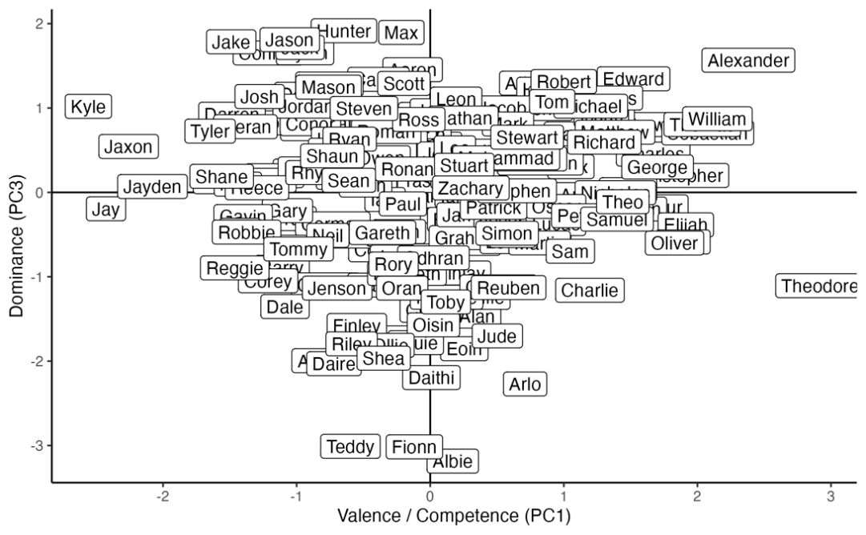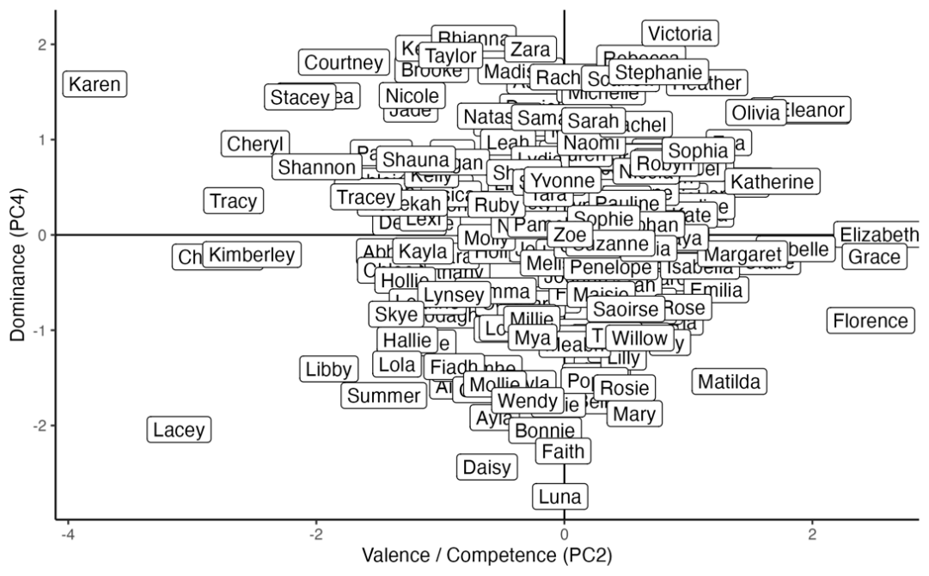
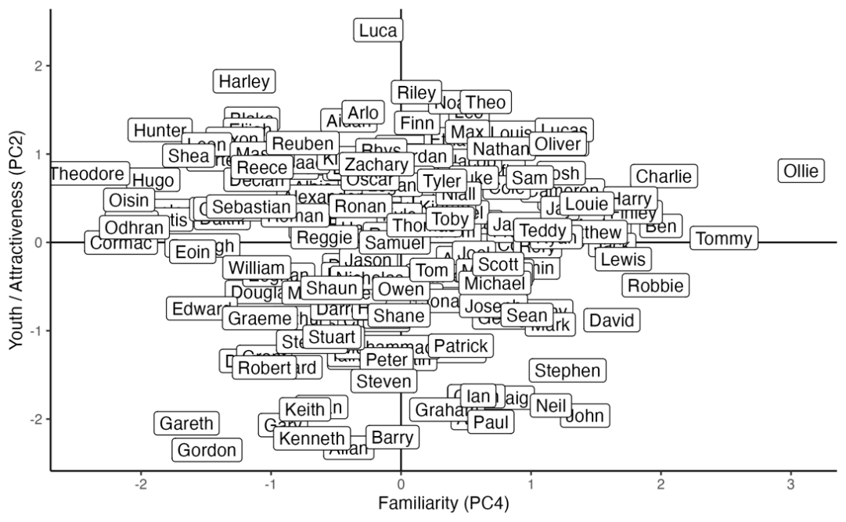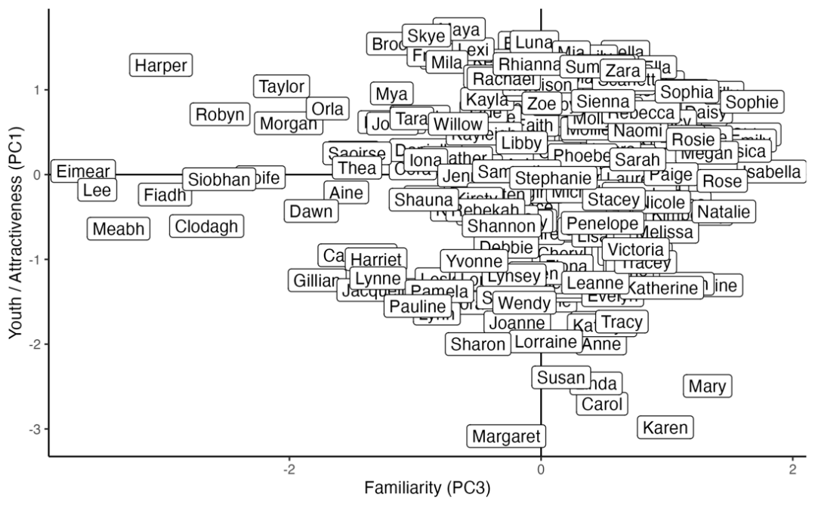
Figure 1. Visualisations of the four components from the PCAs for male (right) and female (left) names. This includes the Valence/Competence and Dominance (top), and the Familiarity and Youth/Attractiveness (bottom) components.

Sample 2

With Sample 2, we attempt to replicate our model using a publicly available dataset of trait ratings of 2000 German names collected in Nett et al. (2020). While Nett et al. (2020) also investigated the underlying structure of name trait ratings via a PCA, our analysis differs in two ways. First, Nett et al. (2020) aim to apply the Stereotype Content Model to the social perceptions of names, and thus only include trait ratings that measure warmth and competence in the PCA. Here, since we aim to capture variation across multiple domains, we include all trait ratings available in the dataset (an additional 6 traits). Second, in Nett et al. (2020), both male and female names are included in the same analysis; therefore, the resulting structure would be influenced by gender stereotypes. Here, we conduct separate PCAs for male and female names. This data is publicly available and was accessed from https://osf.io/jepzp/.

Method

Participants
For full participant details, see Nett et al. (2020). In short, the sample included 972 participants who were either recruited from a university participant pool or were paid volunteers. The sample included 711 females, 258 males, and 3 non-binary (M = 34.24 years, SD = 10.69 years). All participants were fluent in German.

Names
For full details of the name selection process, see Nett et al. (2020). In short, names were taken from a larger database of German names and names were removed if 1) they were similar with a more common version of the name, 2) if the name was uncommon, and 3) if the name appeared in both the male and female name dictionary (i.e., sex ambiguous names were removed). The final set included 1000 male names and 1000 female names.

Procedure
For full details on the name rating procedure, see Nett et al. (2020). In short, name ratings were collected using an online survey. Participants were asked to rate a subset of 75 names on numerous traits. We include in our analyses all available trait ratings that were measured on a 7-point scale. This included traits that measure perceived warmth and competence that were included in the original Nett et al. (2020) analysis (competent, competitive, independent, likable, warm, and good natured). However, we also included the additional traits of educated, age, attractiveness, intelligence, religiousness, and familiarity. We did not include traits where participants made a categorical response (e.g., is the name German or foreign). In total, ratings for 12 separate traits were included in our analysis.

Results

The analysis strategy was identical to that with Sample 1. For both male and female names the PCAs produced four-factor solutions. Factor loadings of individual traits on each PC for male names are shown in Table 4. Component 1 appeared to capture ‘competence’ and explained 38.24% of the total variance in trait ratings. Factor 2 appeared to capture ‘Warmth’ and explained 23.85% of the variance in trait ratings. Component 3 appeared to capture ‘Youth/Attractiveness’ (reversed) and explained 15.04% of the total variance. Finally, component 4 appeared to capture ‘Familiarity’ (reversed) and explained 8.81% of the total variance.

Table 4. Factor loadings of individual traits on each component for male names in the German sample.
Trait | PC1: Competence | PC2: Warmth | PC3: Youth / Attractiveness (reversed) | PC4: Familiarity (reversed)
Education | .90 | .21 | .08 | -.07
Intelligence | .93 | .21 | .03 | .01
Competent | .92 | .28 | .06 | .02
Competitive | .90 | .17 | -.12 | -.02
Independent | .88 | .19 | .04 | -.01
Likable | .40 | .79 | -.31 | -.13
Warm | .24 | .92 | -.11 | .07
Good Natured | .22 | .91 | .05 | -.01
Age | .37 | -.02 | .86 | .11
Attractiveness | .35 | .38 | -.77 | -.04
Familiarity | .13 | .40 | .42 | -.64
Religiousness | .04 | .18 | .40 | .78
Factor loadings with absolute values greater than .50 are bolded.

Factor loadings of individual traits on each PC for female names are reported in Table 5. Similar with the male names, component 1 appeared to capture ‘competence’ and explained 38.30% of the total variance in trait ratings. Factor 2 appeared to capture ‘warmth’ and explained 23.19% of the variance in trait ratings. Component 3 appeared to capture ‘Youth/Attractiveness’ (reversed) and explained 17.33% of the total variance. Finally, component 4 appeared to capture ‘familiarity’ and explained 8.83% of the total variance.

Table 5. Factor loadings of individual traits on each component for female names in the German sample.
Trait | PC1: Competence | PC2: Warmth | PC3: Youth / Attractiveness (reversed) | PC4: Familiarity
Education | .91 | .17 | -.02 | .14
Intelligence | .92 | .24 | .01 | .03
Competent | .92 | .26 | .07 | .02
Competitive | .91 | .08 | -.19 | -.02
Independent | .87 | .22 | .05 | .11
Likable | .44 | .81 | -.19 | .10
Warm | .22 | .93 | .09 | .12
Good Natured | .14 | .92 | .15 | .14
Age | .03 | .09 | .90 | .22
Attractiveness | .43 | .30 | -.75 | -.11
Religiousness | .15 | .22 | .78 | -.32
Familiarity | .15 | .27 | .06 | .90
Factor loadings with absolute values greater than .50 are bolded.

Discussion

In both samples, for both male and female names, variation in trait ratings could predominantly be explained by four components. These dimensions appear to represent valence/competence, dominance/warmth, youth/attractiveness, and familiarity. While the relative proportions explained by each of the four components differs across analyses (e.g., the valence/competence and dominance/warmth components are not consistently the first and second components that explain the most variance), the fact that the same four components are found across each sample/sex provides some convergent evidence. We propose that this four component model could provide an overarching theoretical framework that could help unite research on name bias.
Across each of our analyses, we identified a dimension that represents valence and/or competence, and a dimension that represents dominance or warmth. These dimensions are consistent with the predominant theoretical models of social perception, being the Valence-Dominance Model (Oosterhof & Todorov, 2008) and the Stereotype Content Model (Cuddy et al., 2008). Variation in these dimensions could help explain previous name bias findings. For example, names that vary on dominance/warmth could explain name bias in courtroom decisions of guilt (Bao et al., Pre-print; Bodenhausen & Wyer, 1985; Garwood et al., 1983; Kalist & Lee, 2009); this would be consistent with face perception research that has found a courtroom bias according to perceptions of trustworthiness (Wilson & Rule, 2015). Similarly, variation in valence/competence may explain previously identified name biases in leadership elections (Laham et al., 2012), or hiring decisions (Bertrand & Mullainathan, 2004; Coffey & McLaughlin, 2009; Cotton et al., 2008; Gaddis, 2015; Kang et al., 2020; Watson et al., 2011); again, these explanations would be analogous to findings from the face perception literature (Laustsen & Petersen, 2017; Todorov et al., 2005).
In our interpretation above, we acknowledge that we conflate valence and dominance from the Valence-Dominance Model with competence and warmth from the Stereotype Content Model. While the two dimensions from each model on the surface appear to be conceptually similar, conflating these constructs may not be valid, and indeed recent research suggests that these dimensions may be separate constructs (Hong et al., 2023). Theoretically, previous research on person perception has implied that variation in valence/dominance is a property of the stimuli (e.g., corresponds with a visual component of faces). However, given that names do not have an inherent visual component, our study could suggest that judgements of valence and dominance may in part be imposed onto stimuli by perceivers’ shared cognition; this is consistent with recent work which has suggested that a shared conceptual trait space informs social perceptions (Stolier et al., 2020). Future research should explore whether both models could be integrated into a united theoretical framework of social perception (e.g., Abele et al., 2021).
Across all analyses, we identified an additional dimension that appeared to represent perceptions of youth/attractiveness. This is consistent with some findings in face perception research that has found an additional youth/attractiveness dimension when the facial stimuli have a diverse age range (Sutherland et al., 2013). This dimension may help explain findings in name research, such as studies that have found that old-fashion names are perceived less favourably compared to modern names (Christopher, 1998; Speckmann & Wingen, 2023; Young et al., 1993), or research which suggests that names convey age information (Johfre, 2020).
Finally, our analyses also identified a fourth component which we labelled ‘Familiarity’. This dimension represents names that are more conventional, or names perceivers may have had more exposure with. For example, in the UK sample, traditional Irish names that may have been less familiar to the majority of the sample (e.g., Odhran, Eimear, Fiadh), scored low on this component. This is consistent with previous research that has found a ‘weirdness’ component in social perceptions of faces and bodies (Morrison et al., 2017). In the UK sample, traits that loaded onto this factor included ‘confident’ and ‘sociable’, indicating that this factor may also represent a sociability factor, which is a key dimension in a recent meta-theory of social evaluation (Abele et al., 2021). Again, this dimension may help explain previous findings in name perception research. For instance, this familiarity component may capture how difficult a name is to pronounce, which has been associated with negative perceptions (Laham et al., 2012; Lee, 2015; Newman et al., 2014; Speckmann & Wingen, 2023; Topolinski et al., 2014). In addition, the familiarity component may capture the negative effect that names from a different group or culture on social judgements (Anderson-Clark et al., 2008; Bertrand & Mullainathan, 2004; Bodenhausen & Wyer, 1985; Cotton et al., 2008; Dinur et al., 1995; Gaddis, 2015; Watson et al., 2011; Zhao & Biernat, 2017).
The emergence of a valence/competence and dominance/warmth dimensions in our analyses suggests that the underlying structure of social judgements for names may, at least in part, be shared with that for faces, social groups, or other types of stimuli. This would be consistent with existing unified frameworks of social perception (e.g., Abele et al., 2021) and suggests that perceivers may rely on a common cognitive architecture to evaluate social stimuli, regardless of whether the stimulus is visual (e.g., faces) or lexical (e.g., names). However, the emergence of additional distinct components (for youth/attractiveness and familiarity) indicate that names may elicit evaluations along social dimensions not fully captured by these existing models. This could reflect stimuli-specific cues or associations that are unique to names. As such, while unified models of social perception provide a useful starting point, the social perception of names may also involve distinct mechanisms that warrant separate theoretical consideration.
Note that our analyses were conducted separately by gender of the names; this was done because we were interested in the social perception of names separate from gender stereotypes. Undoubtedly, perceptions of gender garnered from names influences social evaluations (see Dorrough et al., 2017; Kasof, 1993; Moss-Racusin et al., 2012; Steinpreis et al., 1999); however, comparing results from male and female names separately can still be insightful. While our analyses reveals that the four component models produced by male and female names across the two studies are largely consistent, we note there are some differences in specific trait loadings between genders. For instance, in the UK sample, gender typicality judgements (i.e., judgements of masculinity and femininity) for male names was associated with the dominance dimension (i.e., more masculine names were perceived as more dominant), while gender typicality was more associated with the familiarity component for female names (i.e., more feminine names were perceived as more conventional). This variation could come about for several reasons: 1) it reflects genuine differences in how male and female names are evaluated, or 2) differences are due to a lack of robustness in our results, and increasing either the number of participants or names included in the study would produce more consistent results.

Limitations
There are several limitations to consider when interpreting these results. First, the development of our model relies on single statistical technique, being PCA using a varimax rotation. A major limitation of PCA is that the underlying structure identified depends on the initial items included. While the traits included have been identified as being important for the social perception of non-name stimuli (e.g., Oosterhof & Todorov, 2008; Jones et al. 2021), it is unclear whether they equally apply to names. If the initial traits are sub-optimal (e.g., they do not encompass all possible social evaluations, or are irrelevant), then the structure produced by the PCA will also be sub-optimal. Indeed, recent analyses using data-driven techniques to identify dimensions from naturalistic profile pictures suggest impression formation could be highly dimensional, and include dimensions such as adventurousness, conservatism, fitness, and stylishness (Connor et al., 2024); dimensions that would not be identified in our analyses. Using different analytic techniques (such as hierarchical clustering, network analyses, or identifying underlying dimensions through natural language models of open-ended responses) would help verify our proposed model. Also, this analytic strategy inherently ignores variation in trait ratings due to perceivers. More recent studies on face perception and group stereotypes have considered variation due to perceiver (Hehman et al., 2017; Hester et al., 2021; Koch et al., 2020), and indeed, the analysis of ICCs in Sample 1 indicate that a good proportion of variance in trait ratings are attributed to the individual raters and consensus between raters explains a comparatively smaller proportion.
Second, our analyses only focus on names/raters from two countries, being the UK and Germany. As such, it is unclear whether this four component model would generalise well to other names, particularly non-European, or non-Western names. In addition, in both samples, raters were predominantly female and familiar with the names (e.g., in Sample 1, most participants resided in the UK). While this is important as raters require some familiarity of names in order to be influenced by cultural biases, this again limits the generalisability of the model. Further research should investigate whether this structure is consistent with names and raters from other cultures, or with raters who are unfamiliar with the names.
Third, in the UK sample, given the method that names were selected, only more common or popular names were included in the study. It is plausible that more unique or uncommon name would illicit stronger social judgements (Anderson & Schmitt, 1990; Bao et al., 2023; West & Shults, 1976), which would not be fully captured in this sample. This could also extend to uncommon variation/spelling of more common names (Mehrabian & Piercy, 1993). However, this concern is mitigated somewhat in the UK sample by country-specific popular names (e.g., the names Harris and Saoirse are popular in Scotland and Northern Ireland respectively, but are uncommon in other countries in the UK), suggesting that raters would have viewed some name they were less familiar with. This is perhaps confirmed by a component representing name familiarity in each analysis.
Finally, our study provides a snapshot of perception of names at the current time, but stereotypes regarding names are likely to be fluid and ever-changing over time (Etaugh & Geraghty, 2018). These shifts in perceptions could be comparably rapid in response to the rise and fall in popularity of names (Etaugh & Geraghty, 2018) or prominent cultural events (e.g., hurricane names; Berger et al., 2012). While we expect the underlying structure would remain constant, future research could investigate social perceptions of names across different temporal contexts, or how perceptions may change over time.

Conclusion
Overall, while the proposed four component model can provide an overarching framework to help unite previous research on name bias, the model can also help generate new hypotheses that could be tested in future research. For instance, could variation in the four components explain potential name biases in previously unidentified domains; for example, is the dominance component related to judgements of fighting ability and formidability (Třebický et al., 2013)? Or are perceptions of warmth and competence of someone’s name associated with people’s willingness to deceive them (Azevedo et al., 2017)? Our four-factor model complements more unifying frameworks of social perception such as the Vertical-Horizontal dimensions described in Abele et al. (2021) as it can help generate and explain hypotheses specific to names. In particular, the proposed model includes an additional two dimensions important to name perception (youth/age and familiarity) that are not included in this integrated model. Furthermore, the proposed model could extend previous research by investigating how the four components may interact or combine to influence social judgements. While our research investigates the social perception of first names, we highlight that it does not speak to accuracy of those judgements. However, if name judgements were accurate, establishing agreement in judgements between people, as demonstrated here, would be the initial step (Bjornsdottir et al., 2022).

Data Availability Statement

All data, analysis scripts, and supporting materials are available at https://osf.io/9dvtm/.

Ethics Approval

This research complies with the Declaration of Helsinki (2023) and received approval from the University of Stirling’s General University Ethics Panel (GUEP 2022 7025 5770). Informed consent was obtained from all participants.

Declaration of Conflicting Interest

All authors declare no conflicts of interest.

Funding

This research was not supported by external funding.

References
Abele, A. E., Ellemers, N., Fiske, S. T., Koch, A., & Yzerbyt, V. (2021). Navigating the social world: Toward an integrated framework for evaluating self, individuals, and groups. Psychological Review, 128(2), 290-314.
Anderson, T., & Schmitt, P. R. (1990). Unique first names in male and female psychiatric inpatients. The Journal of Social Psychology, 130(6), 835-837.
Anderson-Clark, T. N., Green, R. J., & Henley, T. B. (2008). The relationship between first names and teacher expectations for achievement motivation. Journal of Language and Social Psychology, 27(1), 94-99.
Azevedo, R. T., Panasiti, M. S., Maglio, R., & Aglioti, S. M. (2017). Perceived warmth and competence of others shape voluntary deceptive behaviour in a morally relevant setting. British Journal of Psychology, 109(1), 25-44.
Bao, H., Lu, H., & Luo, Y. L. (2023). Do unique names fit people for creative work? Implications for job recruitment, name change, and product evaluation. European Journal of Social Psychology, 53(7), 1524-1541.
Bao, H., Wang, J., & Cai, H. (Pre-print). Blame crime on name? People with bad names are more likely to commit crime. PsyArXiv. doi:10.31234/osf.io/txhqg
Berger, J., Bradlow, E. T., Braunstein, A., & Zhang, Y. (2012). From Karen to Katie: Using baby names to understand cultural evolution. Psychological Science, 23(10), 1067-1073.
Bertrand, M., & Mullainathan, S. (2004). Are Emily and Greg more employable than Lakisha and Jamal? A field experiment of labor market discrimination. American Economic Review, 94(4), 991-1013.
Bhat, D., Kollu, T., Ricci, J. A., & Patel, A. (2021). What’s in a name? Implicit bias affects patient perception of surgeon skill. Plastic and Reconstructive Surgery, 147(6), 948e-956e.
Bin, Z., Chen, L., Fangfang, W., & Zhijie, X. (2021). The impact of gender orientation of names on individuals’ evaluation of impressions and interpersonal interaction. Acta Psychologica Sinica, 53(4), 387-399.
Bjornsdottir, R. T., Hehman, E., & Human, L. J. (2022). Consensus enables accurate social judgments. Social Psychological and Personality Science, 13(6), 1010-1021.
Bodenhausen, G. V., & Wyer, R. S. (1985). Effects of stereotypes in decision making and information-processing strategies. Journal of Personality and Social Psychology, 48(2), 267-282.
Busse, T. V., & Seraydarian, L. (1978). The relationship between first name desirability and school readiness, IQ, and school achievement. Psychology in the Schools, 15(2), 297-302.
Çetinkaya-Rundel, M., Leeper, T. J., Goguen-Compagnoni, N., & Lemus, S. (2022). ukbabynames: UK Baby Name Data. Retrieved from https://cran.r-project.org/web/packages/ukbabynames/index.html
Christopher, A. N. (1998). The psychology of names: An empirical reexamination. Journal of Applied Social Psychology, 28(13), 1173-1195.
Coffey, B., & McLaughlin, P. A. (2009). Do masculine names help female lawyers become judges? Evidence from South Carolina. American Law and Economics Review, 11(1), 112-133.
Connor, P., Nicolas, G., Antonoplis, S., & Koch, A. (2024). Unconstrained descriptions of Facebook profile pictures support high-dimensional models of impression formation. Personality and Social Psychology Bulletin, 1-7.
Convention on the rights of the child. (1989). Treaty no. 27531. United Nations Treaty Series, 1577, 3-178. Retrieved from https://treaties.un.org/doc/Treaties/1990/09/19900902%2003-14%20AM/Ch_IV_11p.pdf
Cotton, J. L., O’neill, B. S., & Griffin, A. (2008). The “name game”: Affective and hiring reactions to first names. Journal of Managerial Psychology, 23(1), 18-39.
Cuddy, A. J., Fiske, S. T., & Glick, P. (2008). Warmth and competence as universal dimensions of social perception: The stereotype content model and the BIAS map. Advances in Experimental Social Psychology, 40, 61-149.
Dinur, R., Beit-Hallahmi, B., & Hofman, J. E. (1995). First names as identity stereotypes. The Journal of Social Psychology, 136(2), 191-200.
Dorrough, A. R., Glöckner, A., Betsch, T., & Wille, A. (2017). When knowledge activated from memory intrudes on porbabilistic inferences from description-the case of stereotypes. Acta Psychologica, 180, 64-78.
Durante, F., Tablante, C. B., & Fiske, S. T. (2017). Poor but warm, rich but cold (and competent): Social classes in the stereotype content model. Journal of Social Issues, 73(1), 138-157.
Eckes, T. (2002). Paternalistic and envious gender stereotypes: Testing predictions from the stereotype content model. Sex Roles, 47, 99-114.
Erwin, P. G. (1993). First names and perceptions of physical attractiveness. The Journal of Psychology, 127(6), 625-631.
Etaugh, C., & Geraghty, C. (2018). Both gender and cohort affect perceptions of forenames, but are 25-year-old standards still valid? Sex Roles, 79, 728-737.
Gaddis, S. M. (2015). Discrimination in the credential society: An audit study of race and college selectivity in the labor market. Social Forces, 93(4), 1451-1479.
Garwood, S. G. (1976). First-name stereotypes as a factor in self-concept and school achievement. Journal of Educational Psychology, 68(4), 482-487.
Garwood, S. G., Cox, L., Kaplan, V., Wasserman, N., & Sulzer, J. L. (1980). Beauty is only “name” deep: The effect of first-name on ratings of physical attraction. Journal of Applied Social Psychology, 10(5), 431-435.
Garwood, S. G., Sulzer, J. L., Levine, D. W., Cox, L., & Kaplan, V. (1983). Should Herietta be punished or rewarded? The effects of name desirability on responsibility attribution and sanction assignment. Names, 31(4), 318-333.
Gebauer, J. E., Leary, M. R., & Neberich, W. (2012). Unfortunate first names: Effects of name-based relational devaluation and interpersonal neglect. Social Psychological and Personality Science, 3(5), 590-596.
Greitemeyer, T., & Kunz, I. (2013). Name-valence and physical attractiveness in Facebook: Their compensatory effects on friendship acceptance. The Journal of Social Psychology, 153(3), 257-260.
Harari, H., & McDavid, J. W. (1973). Name stereotypes and teachers’ expectations. Journal of Educational Psychology, 65(2), 222.
Hehman, E., Sutherland, C. A. M., Flake, J. K., & Slepian, M. L. (2017). The unique contributions of perceiver and target characteristics in person perception. Journal of Personality and Social Psychology, 113(4), 513-529.
Hehman, E., Xie, S. Y., Ofosu, E. K., & Nespoli, G. A. (Pre-print). Assessing the point at which averages are stable: A tool illustrated in the context of person perception. PsyArXiv. doi:https://doi.org/10.31234/osf.io/2n6jq
Hensley, W. E., & Spencer, B. A. (1985). The effect of first names on perceptions of female attractiveness. Sex Roles, 12, 723-729.
Hester, N., Xie, S. Y., & Hehman, E. (2021). Little between-region and between-country variance when peopple form impressions of others. Psychological Science, 32(12), 1907-1917.
Hong, Y., Reed, M., & Ratner, K. G. (2023). Facial stereotypes of competence (not trustworthiness or dominance) most resemble facial stereotypes of group membership. Social Cognition, 41(6), 562-578.
Johfre, S. S. (2020). What age is in a name? Sociological Science, 7, 367-390.
Jones, B. C., DeBruine, L. M., Flake, J. K., Liuzza, M. T., Antfolk, J., Arinze, N. C., . . . Coles, N. A. (2021). To which world regions does the valence–dominance model of social perception apply? Nature Human Behaviour, 5(1), 159-169. doi:10.1038/s41562-020-01007-2
Kalist, D., & Lee, D. Y. (2009). First name and crime: Does unpopularity spell trouble? Social Science Quarterly, 90(1), 39-49.
Kang, Y., Zhu, D. H., & Zhang, Y. A. (2020). Being extraordinary: How CEOS’ uncommon names explain strategic distinctiveness. Strategic Management Journal, 42(2), 462-488.
Kasof, J. (1993). Sex bias in the naming of stimulus persons. Psychological Bulletin, 113(1), 140-163.
Koch, A., Imhoff, R., Unkelbach, C., Nicolas, G., Fiske, S. T., Terache, J., . . . Yzebyt, V. (2020). Groups’ warmth is a personal matter: Understanding consensus on stereotype dimensions reconciles adversarial models of social evaluation. Journal of Experimental Social Psychology, 89, 103995.
Laham, S. M., Koval, P., & Alter, A. L. (2012). The name-pronunciation effect: Why people like Mr. Smith more than Mr. Colquhoun. Journal of Experimental Social Psychology, 48(3), 752-756.
Laustsen, L., & Petersen, M. B. (2017). Perceived conflict and leader dominance: Individual and contextual factors behind preferences for dominant leaders. Political Psychology, 38(6), 1083-1101.
Lee, T. L., & Fiske, S. T. (2006). Not an outgroup, not yet an ingroup: Immigrants in the stereotype content model. International Journal of Intercultural Relations, 30(6), 751-768.
Lee, Y. S. (2015). The name-pronunciation effect: Further evidence from Chinese. The Journal of General Psychology, 142(3), 182-193.
Linke, L., Saribay, S. A., & Kleisner, K. (2016). Perceived trustworthiness is associated with position in a corporate hierarchy. Personality and Individual Differences, 99, 22-27.
McAleer, P., Todorov, A., & Belin, P. (2014). How do you say ‘Hello’? Personality impressions from brief novel voices. PLoS ONE, 9(3), e90779.
Mehrabian, A., & Piercy, M. (1993). Positive or negative connotations of unconventionally and conventionally spelled names. The Journal of Social Psychology, 133(4), 445.
Morrison, D., Wang, H., Hahn, A. C., Jones, B. C., & DeBruine, L. M. (2017). Predicting the reward value of faces and bodies from social perception. PLoS ONE, 12(9), e0185093.
Moss-Racusin, C. A., Dovidio, J. F., Brescoll, V. L., Graham, M. J., & Handelsman, J. (2012). Science faculty’s subtle gender biases favor male students. Proceedings of the National Academy of Sciences, 109(41), 1674-16479.
National Records of Scotland. Retrieved from https://www.nrscotland.gov.uk/
Nett, T., Dorrough, A., Jekel, M., & Glöckner, A. (2020). Perceived biological and social characteristics of a representative set of German first names. Social Psychology, 51(1), 17-34.
Newman, E. J., Sanson, M., Miller, E. K., Quigley-McBride, A., Foster, J. L., Bernstein, D. M., & Garry, M. (2014). People with easier to pronounce names promote truthiness of claims. PLoS ONE, 9(2), e88671.
Newman, L. S., Tan, M., Caldwell, T. L., Duff, K. J., & Winer, E. S. (2018). Name norms: A guide to casting your next experiment. Personality and Social Psychology Bulletin, 44(10), 1435-1448.
Northern Ireland Statistics and Research Agency. Retrieved from https://www.nisra.gov.uk/
Office of National Statistics. Retrieved from https://www.ons.gov.uk/
Oosterhof, N. N., & Todorov, A. (2008). The functional basis of face evaluation. Proceedings of the National Academy of Sciences, 105(32), 11087-11092.
Osborne, J. W., & Costello, A. B. (2004). Sample size and subject to item ratio in principal components anlaysis. Practical Assessment, Research, and Evaluation, 9(1).
R Core Team. (2013). A language and environmental for statistical computing. Vienna, Austria: R Foundation for Statistical Computing.
Rymes, B. (1999). Names. Journal of Linguistic Anthropology, 9(1/2), 163-166.
Shiramizu, V. K. M., Lee, A. J., Altenburg, D., Feinberg, D. R., & Jones, B. C. (2023). The role of valence, dominance, and pitch in perceptions of artificial intelligence (AI) conversational agents’ voices. Scientific Reports, 12(1), 22479.
Speckmann, F., & Wingen, T. (2023). Same question, difference answers?: An emprical comparison of web data and traditional data. Zeitschrift Für Psychologie, 231(1), 30-38.
Steinpreis, R. E., Anders, K. A., & Ritzke, D. (1999). The impact of gender on the review of curricula vitae of job applicants and tenure candidates: A national emprical study. Sex Roles, 41(7-8), 509-528.
Stolier, R. M., Hehman, E., & Freeman, J. B. (2020). Trait knowledge forms a common structure across social cognition. Nature Human Behaviour, 4(4), 361-371.
Sutherland, C. A. M., Oldmeadow, J. A., Santos, I. M., Towler, J., Burt, D. M., & Young, A. W. (2013). Social inferences from faces: Ambient images generate a three-dimensional model. Cognition, 127, 105-118.
Todorov, A., Mandisodza, A. N., Goren, A., & Hall, C. C. (2005). Inferences of competence from faces predict election outcomes. Science, 308(5728), 1623-1626.
Topolinski, S., Maschmann, I. T., Pecher, D., & Winkielman, P. (2014). Oral approach-avoidance: Affective consequences of muscular articulation dynamics. Journal of Personality and Social Psychology, 106(6), 885-896.
Třebický, V., Havlíček, J., Roberts, S. C., Little, A. C., & Kleisner, K. (2013). Perceived aggressiveness predicts fighting performance in mixed-martial-arts fighters. Psychological Science, 24(9), 1664-1672.
Tzschaschel, E., Brooks, K. R., & Stephen, I. D. (2022). The valence-dominance model applies to body perception. Royal Society Open Science, 9, 220594.
Watson, S., Appiah, O., & Thornton, C. G. (2011). The effect of name on pre-interview impressions and occupational stereotypes: The case of black sales job applicants. Journal of Applied Social Psychology, 41(10), 2405-2420.
West, S. G., & Shults, T. (1976). Liking for common and uncommon first names. Personality and Social Psychology Bulletin, 2(3), 299-302.
Wilson, J. P., & Rule, N. O. (2015). Facial trustworthiness predicts extreme criminal-sentencing outcomes. Psychological Science, 26(8), 1325-1331.
Young, R. K., Kennedy, A. H., Newhouse, A., Browne, P., & Thiessen, D. (1993). The effects of names on perception of intelligence, popularity, and competence. Journal of Applied Social Psychology, 23(21), 1770-1788.
Zhao, X., & Biernat, M. (2017). “Welcome to the US” but “change your name”? Adopting Anglo names and discrimination. Journal of Experimental Social Psychology, 70, 59-68.
Zwebner, Y., Sellier, A., Rosenfeld, N., Goldenberg, J., & Mayo, R. (2017). We look like our names: The manifestation of name stereotypes in facial apperance. Journal of Personality and Social Psychology, 112(4), 527-554.

