Title
Which training intensity distribution intervention model will produce the greatest improvements in maximal oxygen uptake and time-trial performance? A systematic review and network meta-analysis of individual participant data

Author Information
Michael A. Rosenblat, PT, PhD^{1*} Jennifer A. Watt, MD, PhD^{2,3,4}, Jem I. Arnold, PT, PhD(c)⁵, Gunnar Treff, PhD⁶, Øyvind B. Sandbakk, PhD⁷, Jonathan Esteve-Lanao, PhD⁷, Luca Festa, PhD⁸, Luca Filipas, PhD^{9,10}, Stuart Galloway, PhD¹¹, Iker Muñoz, PhD¹², Domingo J. Ramos-Campo, PhD^{13,} Patrick Schneeweiss, PhD^{14,15}, Sergio Sellés-Pérez, PhD¹⁶, Thomas Stöggl, PhD¹⁷, Rune K. Talsnes, PhD⁷, Christoph Zinner, PhD¹⁸, Stephen Seiler, PhD¹⁹

Contact Details
¹Evidence-Based Coaching, www.evidencebasedcoaching.ca, Toronto, Ontario, Canada
²Knowledge Translation Program, Li Ka Shing Knowledge Institute, St Michael’s Hospital, Toronto, Ontario, Canada
³Division of Geriatric Medicine, Department of Medicine, University of Toronto, Toronto, Ontario, Canada
⁴Institute of Health Policy, Management and Evaluation, Dalla Lana School of Public Health, University of Toronto, Toronto, Ontario, Canada
⁵School of Kinesiology, University of British Columbia, British Columbia, Canada
⁶Paracelsus Medical University, Institute for Molecular Sports and Rehabilitation Medicine, Salzburg, Austria
⁷Centre for Elite Sports Research, Department of Neuromedicine and Movement Science, Norwegian University of Science and Technology, 7491 Trondheim, Norway
⁸Italian Cycling Federation FCI, Italy
⁹Department of Biomedical Sciences for Health, Università degli Studi di Milano, Milan, Italy
¹⁰TotalEnergies Pro Cycling Team, Essarts-en-Bocage, France
¹¹Physiology, Exercise and Nutrition Research Group, Faculty of Health Sciences and Sport, University of Stirling, Scotland, United Kingdom
¹²Department of Physical Activity and Sports, Faculty of Education and Sports, University of Deusto, Bilbao, Spain
¹³LFE Research Group, Department of Health and Human Performance, Faculty of Physical Activity and Sport Science-INEF, Universidad Politécnica de Madrid, Madrid, Spain
¹⁴Medical Clinic, Department of Sports Medicine, University of Tübingen, 72076 Tübingen, Germany
¹⁵Interfaculty Research Institute for Sports and Physical Activity, University of Tübingen, 72074 Tübingen, Germany
¹⁶General Didactic and Specific Didactics Department, Faculty of education, University of Alicante, Spain
¹⁷Red Bull Athlete Performance Center, Salzburg, Austria
¹⁸Department of Sport, University of Applied Sciences for Police and Administration of Hesse, Wiesbaden, Germany
¹⁹Department of Sport Science and Physical Education, Faculty of Health and Sport Sciences, University of Agder, Kristiansand, Norway

*Corresponding Author
Michael A. Rosenblat, PT, PhD
Evidence-Based Coaching,
www.evidencebasedcoaching.ca
Toronto, Ontario, Canada
ORCID: 0000-0002-3045-2177

Equations

Equation 1: $\log_{10}\left(\frac{Z1}{Z2}×Z3×100\right)$

Equations 2: $\log_{10}\left(\left(\left(\frac{Z1}{0.01}×Z3\right)-0.01\right)×100\right)$

A B
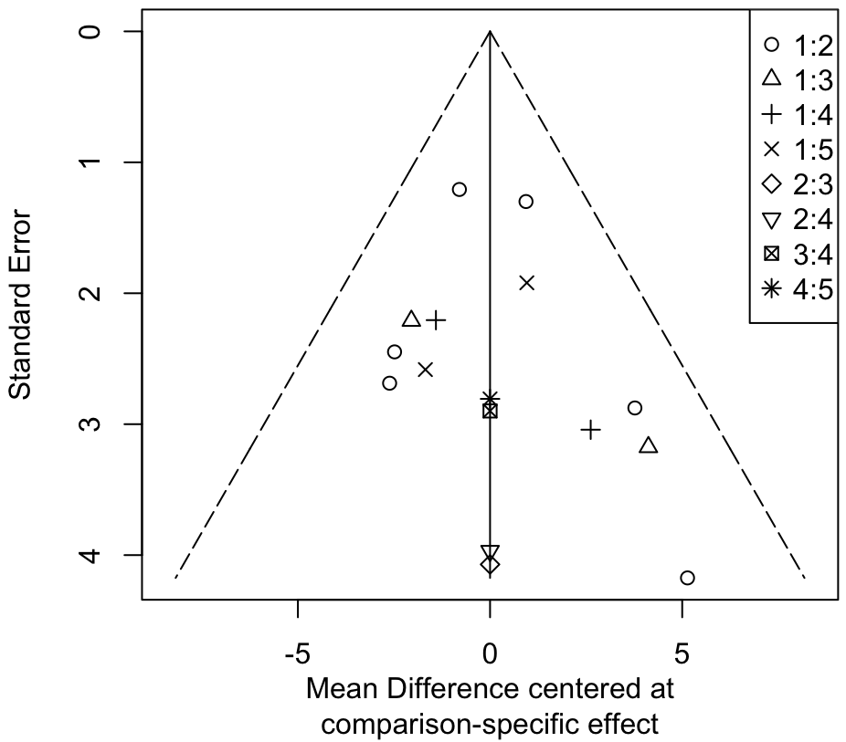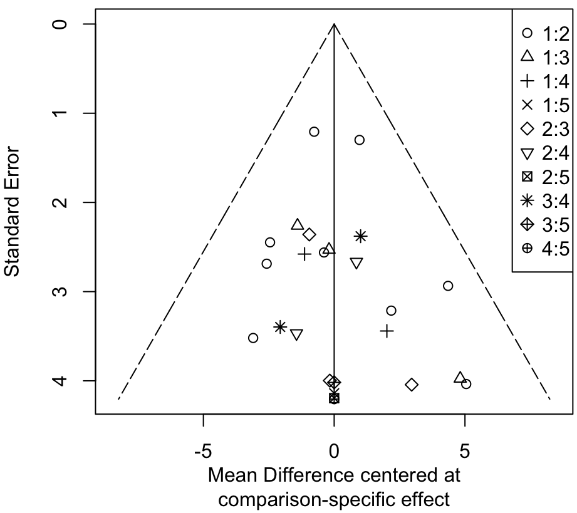
C D
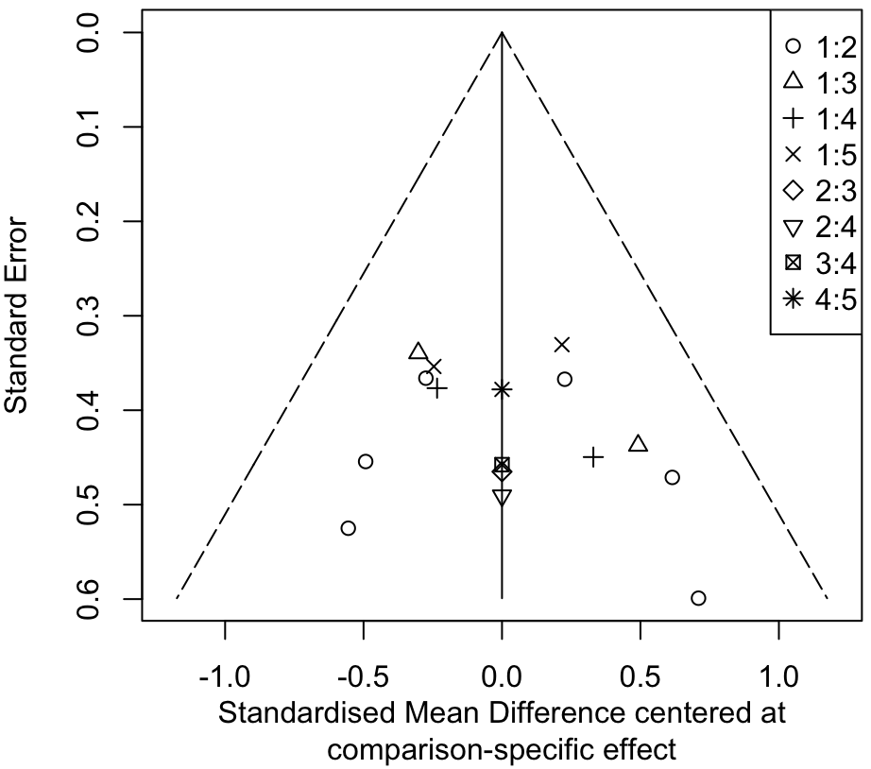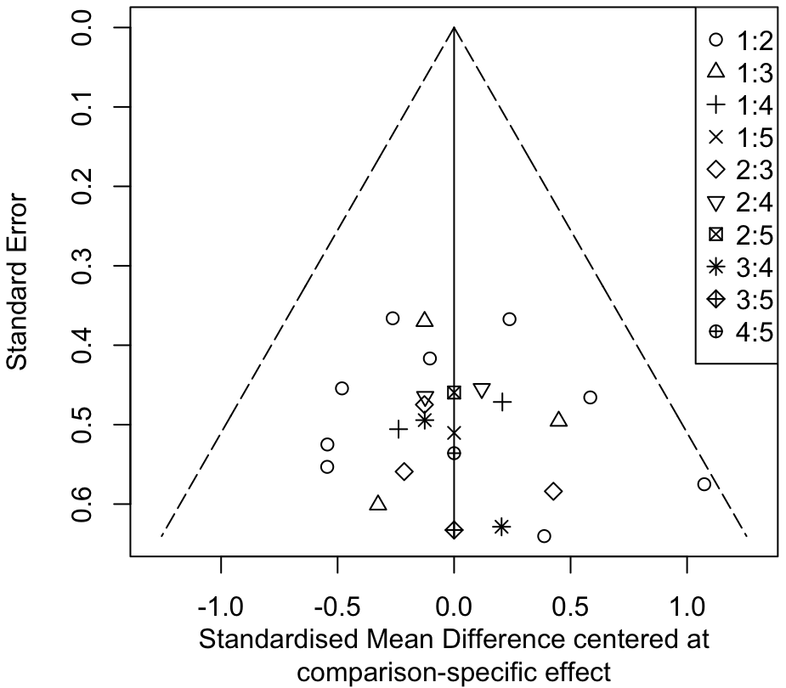
E F
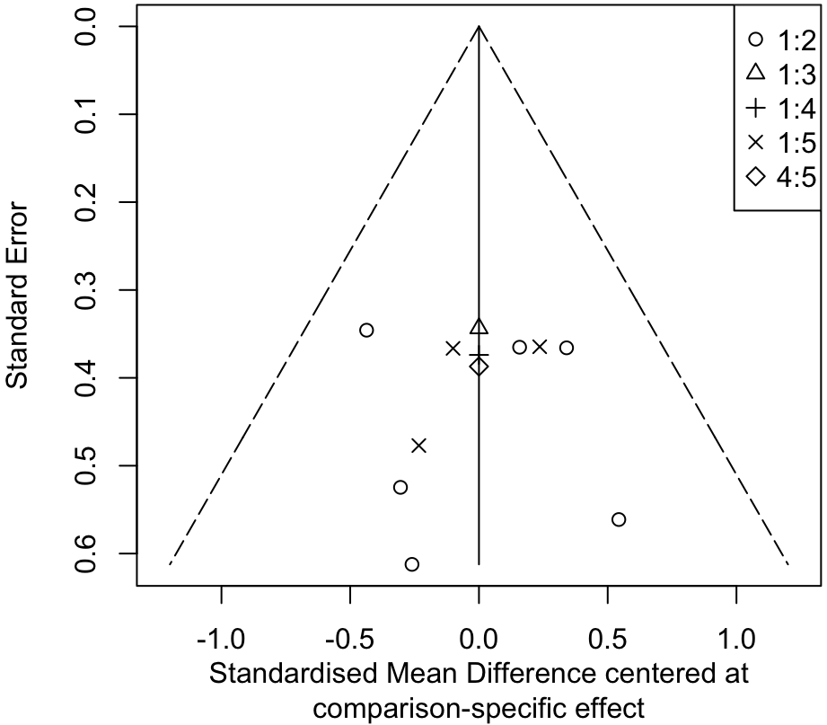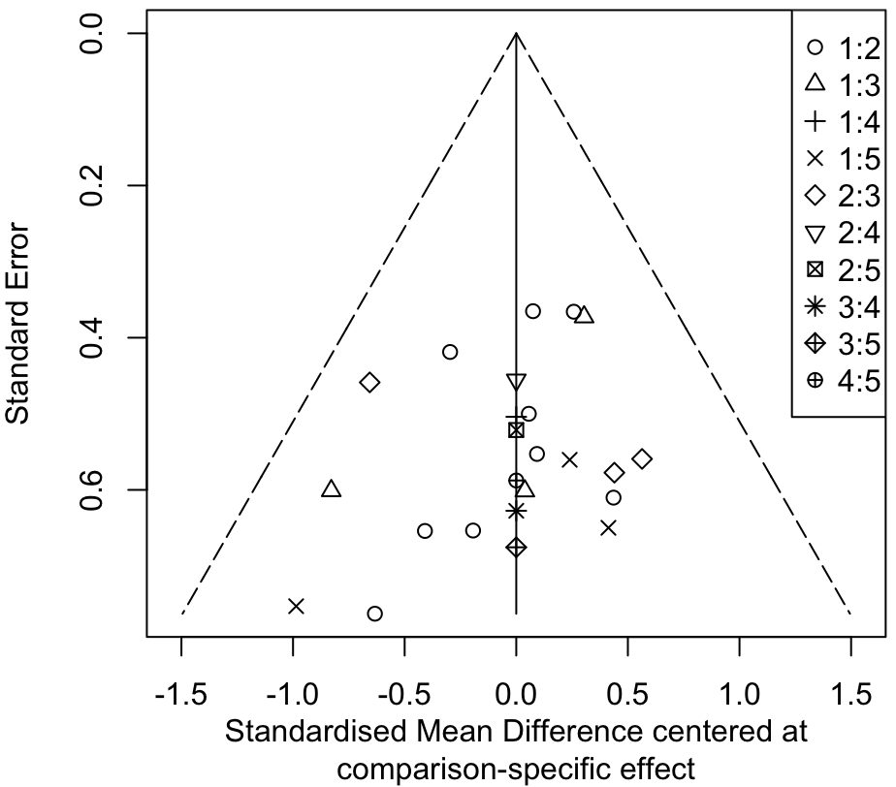

Figure 1. Funnel plots of: A, mean difference (MD) in maximal oxygen uptake (V̇O_{2peak}) (mL⋅kg⁻¹⋅min⁻¹) for the intention-to-treat analysis; B, MD in V̇O_{2peak} (mL⋅kg⁻¹⋅min⁻¹) for the per-protocol analysis; C, standardized mean difference (SMD) in V̇O_{2peak} for the intention-to-treat analysis; D, SMD in V̇O_{2peak} for the per-protocol; E, SMD in time-trial (TT) performance for the intention-to-treat analysis; F, SMD in TT performance for the per-protocol analysis.

Table 1. Medline (Ovid), In-Process, In-Data-Review & Other Non-Indexed Citations (February 11, 2024)
# | Query | Results
1 | (intensity distribution or training-intensity distribution or polarized training or polarised training or polarized model or polarised model or threshold training or threshold model or pyramidal training or pyramidal model).ti,ab | 4.843
2 | (canoe or canoers or canoeing or paddle or paddlers or paddling or kayak or kayakers or kayaking).ti,ab | 4,321
3 | (cycling or cyclist or cyclists or cycle or cycler or cyclers or bicycle or bicyclist or bicyclists or biking or bike or biker or bikers).ti,ab | 640,721
4 | (duathlon or duathlete or duathletes).ti,ab | 47
5 | (endurance athlete or endurance sport or aerobic athlete or aerobic endurance or long distance or ultra endurance or ultra-endurance or aerobic sport).ti,ab | 19.294
6 | (multisport or multi-sport).ti,ab | 178
7 | (rowing or rower or rowers).ti,ab | 2,104
8 | (skiers or skiing or ski or cross country or cross-country).ti,ab | 8.906
9 | (swimming or swim or swimmers).ti,ab | 47,377
10 | (running or runners or marathon or marathoners or ultramarathon or ultramarathoners or track athletes or (track adj2 field) or sprinters or sprint athletes or sprinting or joggers or jogging or cross-country or cross country).ti,ab | 85,557
11 | (triathlon or triathlete or triathletes or ironman).ti,ab | 1,995
12 | 2 or 3 or 4 or 5 or 6 or 7 or 8 or 9 or 10 or 11 | 790,811
13 | 1 and 12 | 195
14 | limit 13 to (english and journal article) | 190

Table 2. SPORTDiscus (EBSCOhost) (February 11, 2024)
# | Query | Limiters/Expanders | Results
S1 | TI ( (intensity distribution OR training-intensity distribution OR polarized training OR polarised training OR polarized model OR polarised model OR threshold training OR threshold model OR pyramidal training OR pyramidal model) ) OR AB ( (intensity distribution OR training-intensity distribution OR polarized training OR polarised training OR polarized model OR polarised model OR threshold training OR threshold model OR pyramidal training OR pyramidal model) ) | Limiters - Language: English; Publication Type: Academic Journal Expanders - Apply equivalent subjects  Search modes - Boolean/Phrase | 823
S2 | TI ( (canoe OR canoers OR canoeing OR paddle OR paddlers OR paddling OR kayak OR kayakers OR kayaking) ) OR AB ( (canoe OR canoers OR canoeing OR paddle OR paddlers OR paddling OR kayak OR kayakers OR kayaking) ) | Limiters - Language: English; Publication Type: Academic Journal Expanders - Apply equivalent subjects  Search modes - Boolean/Phrase | 2,054
S3 | TI ( (cycling OR cyclist OR cyclists OR cycle OR cycler OR cyclers OR bicycle OR bicyclist OR bicyclists OR biking OR bike OR biker OR bikers) ) OR AB ( (cycling OR cyclist OR cyclists OR cycle OR cycler OR cyclers OR bicycle OR bicyclist OR bicyclists OR biking OR bike OR biker OR bikers) ) | Limiters - Language: English; Publication Type: Academic Journal Expanders - Apply equivalent subjects  Search modes - Boolean/Phrase | 28,891
S4 | TI ( (duathlon OR duathlete OR duathletes) ) OR AB ( (duathlon OR duathlete OR duathletes) ) | Limiters - Language: English; Publication Type: Academic Journal Expanders - Apply equivalent subjects  Search modes - Boolean/Phrase | 49
S5 | TI ( (endurance athlete OR endurance sport OR aerobic athlete OR aerobic endurance OR long distance OR ultra endurance OR ultra- endurance OR aerobic sport) ) OR AB ( (endurance athlete OR endurance sport OR aerobic athlete OR aerobic endurance OR long distance OR ultra endurance OR ultra- endurance OR aerobic sport) ) | Limiters - Language: English; Publication Type: Academic Journal Expanders - Apply equivalent subjects Search modes - Boolean/Phrase | 6.900
S6 | TI ( (multisport OR multi- sport) ) OR AB ( (multisport OR multi- sport) ) | Limiters - Language: English; Publication Type: Academic Journal Expanders - Apply equivalent subjects  Search modes - Boolean/Phrase | 242
S7 | TI ( (rowing OR rower OR rowers) ) OR AB ( (rowing OR rower OR  rowers) ) | Limiters - Language: English; Publication Type: Academic Journal Expanders - Apply equivalent subjects  Search modes - Boolean/Phrase | 1,896
S8 | TI ( (skiers OR skiing OR ski OR cross country OR cross-country) ) OR AB (  (skiers OR skiing OR ski OR cross country OR cross-country) ) | Limiters - Language: English; Publication Type: Academic Journal Expanders - Apply equivalent subjects  Search modes - Boolean/Phrase | 4,452
S9 | TI ( (swimming OR swim OR swimmers) ) OR AB ( (swimming OR swim OR swimmers) ) | Limiters - Language: English; Publication Type: Academic Journal Expanders - Apply equivalent subjects  Search modes - Boolean/Phrase | 8,673
S10 | TI ( (running OR runners OR marathon OR marathoners OR ultramarathon OR ultramarathoners OR track athletes OR (track N2 field) OR sprinters OR sprint athletes OR sprinting OR joggers OR jogging OR cross- country OR cross country) ) OR AB ( (running OR runners OR marathon OR marathoners OR ultramarathon OR ultramarathoners OR track athletes OR (track N2 field) OR sprinters OR sprint athletes OR sprinting OR joggers OR jogging OR cross- country OR cross country) ) | Limiters - Language: English; Publication Type: Academic Journal Expanders - Apply equivalent subjects  Search modes - Boolean/Phrase | 28,646
S11 | TI ( (triathlon OR triathlete OR triathletes OR ironman) ) OR AB ( (triathlon OR triathlete OR triathletes OR ironman) ) | Limiters - Language: English; Publication Type: Academic Journal Expanders - Apply equivalent subjects  Search modes - Boolean/Phrase | 1,765
S12 | S2 OR S3 OR S4 OR S5 OR S6 OR S7 OR S8 OR S9 OR S10 OR S11 | Expanders - Apply equivalent subjects  Search modes - Boolean/Phrase | 71,196
S13 | S1 AND S12 | Expanders - Apply equivalent subjects Search modes - Boolean/Phrase | 369

Table 3. Study selection
Study | Eligible | Reason
Arroyo-Toledo et al. [1] | No | Unable to obtain the individual participant data
Auersperger et al. [2] | No | Did not compare a polarized TID intervention to a comparator group that utilized different TID model
Carnes et al. [3] | No | Did not compare a polarized TID intervention to a comparator group that utilized different TID model
Clemente-Suarez et al. [4] | No | Did not report results for V̇O2peak or TT performance, pre- and post-intervention
Enoksen et al. [5] | Yes
Esteve-Lano et al. [6] | Yes
Festa et al. [7] | Yes
Filipas et al. [8] | Yes
Filipas et al. [9] | Yes
Hebisz et al. [10] | No | Did not report results for V̇O2peak or TT performance, pre- and post-intervention
Hebisz et al. [11] | No | Unable to obtain the individual participant data
Hebisz et al. [12] | No | Unable to obtain the individual participant data
Hebisz et al. [13] | No | Unable to obtain the individual participant data
Ingham et al. [14] | No | Did not include polarized TID intervention group
Kim et al. [15] | No | Did not compare a polarized TID intervention to a comparator group that utilized different TID model
Muñoz et al. [16] | Yes
Neal et al. [17] | Yes
Pérez et al. [18] | Yes
Pérez et al. [19] | No | Companion report
Pla et al. [20] | No | Did not include recreational or competitive trained endurance athletes
Pla et al. [21] | No | Companion report
Röhrken et al. [22] | No | Did not report results for V̇O2peak or TT performance, pre- and post-intervention
Schneeweiss et al. [23] | Yes
Sellés-Pérez et al. [24] | Yes
Stöggl et al. [25] | No | Companion report
Stöggl et al. [26] | Yes
Talsnes et al. [27] | Yes
Treff et al. [28] | Yes
Zinner et al. [29] | Yes

Table 4. Study design characteristics
Study | Design | Stratification | Wash-in (weeks) | Intervention (weeks) | Taper
Esteve-Lano et al. [6] | Randomized | None | 3.0 | 18.0 | Yes
Festa et al. [7] | Randomized | None | 2.0 | 6.0 | Yes
Filipas et al. [8] | Randomized | Age, V̇O_{2peak}, 5-km running TT time | 6.0 | 16.0 | Yes
Filipas et al. [9] | Randomized | Age, V̇O_{2peak}, 5-km running TT time | 4.0 | 8.0 | Yes
Muñoz et al. [16] | Randomized | None | 8.0 | 10.0 | Yes
Neal et al. [17] | Randomized crossover | None | 4.0 | 6.0 | No
Pérez et al. [18] | Randomized | V̇O_{2peak} | 0.0 | 12.0 | Yes
Schneeweiss et al. [23] | Randomized | None | 0.0 | 3.0 | Yes
Sellés-Pérez et al. [24] | Non-randomized | Previous training program | 10.0 | 13.0 | Yes
Stöggl et al. [26] | Randomized | V̇O_{2peak}, training mode | 0.0 | 9.0 | Yes
Talsnes et al. [27] | Randomized | None | 5.0 | 8.0 | No
Treff et al. [28] | Non-randomized | None | 3.0 | 8.0 | No
Zinner et al. [29] | Non-randomized | V̇O_{2peak} | 4.0 | 3.0 | Yes
Peak oxygen uptake (V̇O_{2peak}), time-trial (TT)

Table 5. Participant characteristics
Study | Sample size | Females | Performance level | Sport | Age  (years) | Body mass  (kg) | Height  (cm) | BMI  (kg⋅m⁻²) | V̇O_{2peak}  (mL⋅kg⁻¹⋅min⁻¹)
Esteve-Lano et al. [6] | 15 | 0 | Competitive | Running | 26.4 (5.4) | 65.2 (2.9) | 174.3 (4.8) | 21.5 (1.2) | 67 (6.1)
Festa et al. [7] | 35 | 7 | Recreational | Running | 41.5 (8.6) | 71.5 (8.8) | 174 (5.3) | 23.6 (2.4) | 53.3 (6.5)
Filipas et al. [8] | 30 | 0 | Competitive | Running | 36.6 (5.6) | 64.5 (3.2) | 175.3 (8.8) | 21 (1.1) | 68.3 (3.8)
Filipas et al. [9] | 30 | 0 | Competitive | Running | 34.4 (6.3) | 64.6 (6.6) | 180.5 (6.9) | 19.8 (0.6) | 68.1 (2.8)
Muñoz et al. [16] | 35 | 3 | Recreational | Running | 34.3 (7.4) | 71.3 (12.0) | 176.1 (7.2) | 22.9 (2.6) | 61.6 (7.9)
Neal et al. [17] | 11 | 0 | Competitive | Cycling | 37.5 (6.2) | 76.7 (6.5) | 177.5 (5.7) | 24.3 (1.6) | -
Pérez et al. [18] | 20 | 0 | Recreational | Running | 37.9 (8.9) | 74.4 (10.4) | 176.6 (5.8) | 23.7 (2.3) | 56.8 (5.2)
Schneeweiss et al. [23] | 18 | 4 | Competitive | Cycling | 17.9 (3.6) | 62.5 (8.6) | 173.7 (9.0) | 20.7 (1.8) | -
Sellés-Pérez et al. [24] | 15 | 0 | Recreational | Triathlon | 29.1 (6.7) | 71.4 (4.2) | 175.5 (5.6) | 23.2 (0.9) | 55.7 (4.5)
Stöggl et al. [26] | 41 | 4 | Competitive | Combined | 31.4 (6.7) | 73.1 (8.9) | 179.8 (7.1) | 22.6 (1.7) | 62 (7.5)
Talsnes et al. [27] | 39 | 10 | Competitive | Cross-country skiing | 17.6 (0.7) | 69.1 (8.0) | 177.4 (8.2) | 21.9 (1.7) | 66.7 (7.1)
Treff et al. [28] | 14 | 0 | Competitive | Rowing | 20.1 (2.0) | 89 (8.8) | 188.9 (6.7) | 24.9 (1.3) | 65.6 (5.2)
Zinner et al. [29] | 45 | 24 | Recreational | Running | 27.6 (6.9) | 71.2 (12.4) | 173.9 (10.0) | 23.4 (2.5) | 46.6 (6.6)
All data is expressed as a mean (SD). Body mass index (BMI), combined (cross-country skiing, cycling, running, triathlon), peak oxygen uptake (V̇O_{2peak})

Table 6. Intervention characteristics
Study | Mesocycles | Mesocycle description | Periodization | Resistance training | Zone borders |  | Group name | Intended TID (%) |  |  | Intended TID model
 |  |  |  |  | First | Second |  | Zone 1 | Zone 2 | Zone 3
Esteve-Lano et al. [6] | 6 | 2 build, 1 recovery | Reverse | Yes | VT | RCP | Z1 | 80 | 10 | 10 | Polarized
 |  |  |  |  |  |  | Z2 | 65 | 25 | 10 | Pyramidal
Festa et al. [7] | 2 | 2 build, 1 recovery | Reverse | No | VT | RCP | PET | 77 | 3 | 20 | Polarized
 |  |  |  |  |  |  | FOC | 40 | 50 | 10 | Threshold
Filipas et al. [8] | 4 | 3 build, 1 recovery | Reverse | No | VT | RCP | POL | 80 | 5 | 15 | Polarized
 |  |  |  |  |  |  | PYR | 77 | 16 | 7 | Pyramidal
Filipas et al. [9] | 2 | 3 build, 1 recovery | Reverse | Yes | VT | RCP | POL | 80 | 5 | 15 | Polarized
 |  |  |  |  |  |  | PYR | 77 | 16 | 7 | Pyramidal
Muñoz et al. [16] | 3 | 2 build, 1 recovery | Reverse | Yes | VT | RCP | PET | 75 | 5 | 20 | Polarized
 |  |  |  |  |  |  | BThET | 45 | 35 | 20 | Pyramidal
Neal et al. [17] | 1 | n/a | None | n/a | LT | LTP | POL | 80 | 0 | 20 | Polarized
 |  |  |  |  |  |  | THR | 55 | 45 | 0 | Pyramidal
Pérez et al. [18] | 3 | 3 build, 1 recovery | Reverse | Yes | VT | VT₂ | POL | - | - | - | Polarized
 |  |  |  |  |  |  | THR | - | - | - | Pyramidal
Schneeweiss et al. [23] | 1 | n/a | None | n/a | 2 mmol⋅L⁻¹ | 4 mmol⋅L⁻¹ | POL | 87 | 0 | 13 | Polarized
 |  |  |  |  |  |  | LIT | 100 | 0 | 0 | Low
Sellés-Pérez et al. [24] | 3 | 3 build, 1 recovery | Reverse | Yes | VT | VT₂ | POL | - | - | - | Polarized
 |  |  |  |  |  |  | PYR | - | - | - | Pyramidal
Stöggl et al. [26] | 2 | 2 build, 1 recovery | Reverse | Yes | 2 mmol⋅L⁻¹ | 90% HR_{peak} | POL | - | - | - | Polarized
 |  |  |  |  |  |  | HVT | - | - | - | Pyramidal
 |  |  |  |  |  |  | THR | - | - | - | Threshold
 |  |  |  |  |  |  | HIIT | - | - | - | High
Talsnes et al. [27] | 1 | n/a | None | Yes | 82% HR_{peak} | 88% HR_{peak} | HITG | - | - | - | Polarized
 |  |  |  |  |  |  | LITG | - | - | - | Low
Treff et al. [28] | 1 | n/a | None | Yes | LT₁ | LT₁+1.5 mmol⋅L⁻¹ | POL | - | - | - | Polarized
 |  |  |  |  |  |  | PYR | - | - | - | Pyramidal
Zinner et al. [29] | 1 | 3 build, 1 recovery | None | No | 2 mmol⋅L⁻¹ | 4 mmol⋅L⁻¹ | POL | - | - | - | Polarized
 |  |  |  |  |  |  | HIIT | - | - | - | High
 |  |  |  |  |  |  | HVT | - | - | - | Low
First lactate threshold (LT, LT₁), lactate turning point (LTP), not available (n/a), peak heart rate (HR_{peak}), respiratory compensation point (RCP), second ventilatory threshold (VT₂), training intensity distribution (TID), ventilatory threshold (VT). Group names: between thresholds endurance training (BThET), focused endurance training (FOC), high-intensity interval training (HIIT), high-intensity training group (HITG), high volume training (HVT), low intensity training (LIT), low intensity training group (LITG), polarized (PET, POL), pyramidal (PYR), threshold hold training (THR), zone 1 (Z1), zone 2 (Z2).
Table 7. Maximal oxygen uptake test characteristics
Study | Metabolic system | Exercise mode and equipment | Initial intensity | Increment intensity | Stage duration | Measurement criteria | Outcome
Esteve-Lano et al. [6] | Vmax 29C; Sensormedics, Yorba Linda, CA, USA | Running; treadmill (Technogym Run Race 1400 HC, Gambettola, Italy) | 11 km⋅h⁻¹ | 0.5 km⋅h⁻¹ | 30 sec | The highest V̇O₂ value obtained for any continuous 1-minute period during the tests. At least 2 of the following criteria were also required for the attainment of V̇O_{2max}:1. a plateau in V̇O₂ values despite increasing velocity, a respiratory exchange ratio ≥1.15, or the attainment of a peak  HR value above 95% of the age-predicted maximum | V̇O_{2max}
Festa et al. [7] | Quark PFT; COSMED, Rome Italy | Running; Treadmill (Run Race 800; Technogym, Gambettola, Italy) | Determined by the subject capacity | 0.5 km⋅h⁻¹ | 60 sec | V̇O_{2max} was defined as the highest 30 sec average achieved during the test | V̇O_{2max}
Filipas et al. [8] | K5, COSMED, Rome Italy | Running; regular 400 m track | 12 km⋅h⁻¹ | 0.5 km⋅h⁻¹ | 60 sec | V̇O_{2peak} was calculated as the average 30 sec V̇O₂ measurements. HR >95% of known maximal HR, respiratory exchange ratio >1.05, and lactate >8.0 mmol·L⁻¹ | V̇O_{2peak}
Filipas et al. [9] | K5, COSMED, Rome Italy | Running; regular 400 m track | 12 km⋅h⁻¹ | 0.5 km⋅h⁻¹ | 60 sec | V̇O_{2peak} was calculated as the average 30 sec V̇O₂ measurements. HR >95% of known maximal HR, respiratory exchange ratio >1.05, and lactate >8.0 mmol·L⁻¹ | V̇O_{2peak}
Muñoz et al. [16] | Vmax 29C; Sensormedics, Yorba Linda, CA, USA | Running; treadmill (Technogym Run Race 1400 HC, Gambettola, Italy) | 8 km⋅h⁻¹ | 0.5 km⋅h⁻¹ | 30 sec | The highest V̇O₂ value obtained for any continuous 1-minute period during the tests. At least 2 of the following criteria were also required for the attainment of V̇O_{2max}: 1. a plateau in V̇O₂ values despite increasing velocity, a respiratory exchange ratio ≥1.15, or the attainment of a peak HR value above 95% of the age-predicted maximum | V̇O_{2max}
Pérez et al. [18] | Metalyzer 3B; Cortex-medical, Leipzig, Germany | Running; treadmill (Run MedTechnogym, Cessena, Italy) | 4.5 km⋅h⁻¹ | Part 1: 4.5, 8, 10, and 12 km⋅h⁻¹  Part 2: 0.5 km⋅h⁻¹ | Part 1: 3 min  Part 2: 30 sec | 1. occurrence of a plateau in V̇O₂ despite an increase in speed; 2. elevated blood lactate concentration (≥ 8 mmol/L); 3. elevated respiratory exchange ratio (R ≥ 1.0); 4. elevated HR (≥ 90% of (220–age)); and 5. maximal perceived exertion | V̇O_{2max}
Sellés-Pérez et al. [24] | Portable gas-exchange analyzer (Cosmed® K4b 2, Italy | Running, 400-metre homologated track | 10 km⋅h⁻¹ | 3 km⋅h⁻¹ | Every 200 m | Highest V̇O₂ value obtained for any continuous 1-minute period | V̇O_{2max}
Stöggl et al. [26] | nSpire, Zan 600 USB, Oberthulba, Germany | Cycling; all athletes (n = 15 cyclists; n = 3 triathletes) engaging in cycling training trained with their own bike and completed all tests on a bicycle ergometer (Ergoline, Ergoselect 100P; Bitz, Germany) using their own cycling shoes and pedal system.  Running; other athletes (n = 16 runners, n = 6 triathletes, n = 8 cross-country skiers) ran during the study and completed their pre- and post-testing on a motorized treadmill (HP Cosmos, Saturn, Traunstein, Germany). | Cycling: 200 watts  Running: 8 km⋅h⁻¹, 0.5% incline | Cycling: 15 watts  Running: 0.5 km⋅h⁻¹ | 30 sec | V̇O_{2peak} was achieved if three of  the four following criteria were met: 1. plateau in V̇O₂, i.e., an increase < 1.0 mL·min⁻¹·kg⁻¹ despite an increase in velocity or power output; 2. respiratory exchange ratio >1.1; 3. HR ± 5% of age predicted HR_{peak}; and (4) peak blood lactate (LA_{peak}) > 6 mmol·L⁻¹ after exercise. | V̇O_{2peak}
Talsnes et al. [27] | Oxycon Pro, Jaeger GmbH, Hoechberg, Germany | Running; motor-driven treadmill (RL 2500; Rodby, Vänge, Sweden) | 5% inclination with a starting speed of 4.4 m·s-1. | The speed was increased by 0.6 m·s⁻¹ after 1 and 2 min, and thereafter increased by 0.3 m·s⁻¹ every min until exhaustion | 60 sec | Highest 1-minute average | V̇O_{2peak}
Treff et al. [28] | Metamax 3x, Cortex Biophysics, Leipzig, Germany | Rowing; rowing ergometer | 60 watts | Lightweight class: 30 watts  Open weight class: 35 watts | 60 sec | Highest V̇O₂ with increasing workload and averaged over a 30-s interval. V̇O_{2max} was considered when V̇O₂ failed to increase with progressive work rate (leveling off) or at least a plateau of V̇O₂ was present. A plateau was defined as an increase in V̇O₂ < 150 mL·min⁻¹ | V̇O_{2max}
Zinner et al. [29] | Cortex Metamax 3B, Leipzig, Germany | Running; treadmill (mercury, h/p/cosmos sports and medical GmbH, Nussdorf-Traunstein, Germany) | Women: 7 km⋅h⁻¹  Men: 8 km⋅h⁻¹ | 1.0 km⋅h⁻¹ | 3 min with 15 sec rest between stages | Three of the four following criteria were met: 1) plateau in V̇O₂, that is, an increase G 1.0 mL·min⁻¹·kg⁻¹ despite an increase in velocity; 2) respiratory exchange ratio >1.1; 3) HR ± 5% of age predicted HR_{peak}; and 4) peak blood lactate (peak lactate) >6 mmol·L⁻¹ after exercise. | V̇O_{2peak}
Maximal oxygen uptake (V̇O_{2max}), oxygen uptake (V̇O₂), peak oxygen uptake (V̇O_{2peak}).

Table 8. Time-trial test characteristics
Study | Exercise mode | Course type | Distance (km) | Competitors | Familiarization | Same course pre/post intervention
Esteve-Lano et al. [6] | Running | Cross-country | 10.4 | No | No | Yes
Festa et al. [7] | Running | 400-m track | 2.0 | No | No | Yes
Filipas et al. [8] | Running | 400-m track | 5.0 | No | No | Yes
Filipas et al. [9] | Running | 400-m track | 5.0 | No | No | Yes
Muñoz et al. [16] | Running | Road | 10.0 | Yes | No | No
Neal et al. [17] | Cycling | Cycle Ergometer | 40.0 | No | No | Yes
Schneeweiss et al. [23] | Cycling | Cross-country | 8.4 (females, U17 males), 12.6 (senior males) | Yes | No | Yes
Talsnes et al. [27] | Running | Asphalt | 4.5 (females), 6.4 (males) | No | No | Yes
Treff et al. [28] | Rowing | Row Ergometer | 2.0 | No | No | Yes
Zinner et al. [29] | Running | 400-m track | 5.0 | No | Yes | Yes

Table 9. Risk of bias for maximal oxygen uptake results
Study | D1 | D2 | D3 | D4 | D5 | Overall
Festa et al. [7] | Low | Some concerns | Low | Low | Low | Low
Filipas et al. [8] | Low | Some concerns | Low | Low | Low | Low
Filipas et al. [9] | Low | Some concerns | Low | Low | Low | Low
Pérez et al. [18] | Low | Some concerns | Low | Low | Low | Low
Selles-Perez et al. [24] | High | Some concerns | Low | Low | Low | High
Stöggl et al. [26] | Low | Some concerns | Low | Low | Low | Low
Talsnes et al. [27] | Low | High | Low | Low | Low | High
Treff et al. [28] | High | Some concerns | Low | Low | Low | High
Zinner et al. [29] | High | High | Low | Low | Low | High
Risk of bias arising from the randomization process (D1), Risk of bias due to deviations from the intended interventions (effect of assignment to intervention) (D2), Risk of bias due to missing outcome data (D3), Risk of bias in measurement of the outcome (D4), Risk of bias in selection of the reported result (D5).

Table 10. Risk of bias for time-trial performance results
Study | D1 | D2 | D3 | D4 | D5 | Overall
Esteve-Lano et al. [6] | Low | Some concerns | Low | Low | Low | Low
Festa et al. [7] | Low | Some concerns | Low | Low | Low | Low
Filipas et al. [8] | Low | Some concerns | Low | Low | Low | Low
Filipas et al. [9] | Low | Some concerns | Low | Low | Low | Low
Muñoz et al. [16] | Low | Some concerns | Low | Some Concerns | Low | Some concerns
Neal et al. [17] | Low | Some concerns | Low | Low | Low | Low
Schneeweiss et al. [23] | Low | Some concerns | Low | Some Concerns | Low | Some concerns
Talsnes et al. [27] | Low | High | Low | Low | Low | High
Treff et al. [28] | High | Some concerns | Low | Low | Low | High
Zinner et al. [29] | High | High | Low | Low | Low | High
Risk of bias arising from the randomization process (D1), Risk of bias due to deviations from the intended interventions (effect of assignment to intervention) (D2), Risk of bias due to missing outcome data (D3), Risk of bias in measurement of the outcome (D4), Risk of bias in selection of the reported result (D5).

Table 11. Results for weekly training intensity distribution (intention-to-treat analysis)
Study | Group name | Group size | Completed TID Model | TID (min) |  |  |  |  | TID (%)
 |  |  |  | Zone 1 | Zone 2 | Zone 3 | Total |  | Zone 1 | Zone 2 | Zone 3
Esteve-Lano et al. [6] | Z1 | 6 | Polarized | 250 (26) | 36 (19) | 35 (16) | 320 (28) |  | 78 (4) | 11 (5) | 11 (5)
 | Z2 | 6 | Pyramidal | 159 (55) | 64 (13) | 35 (4) | 258 (63) |  | 61 (6) | 25 (3) | 14 (4)
Festa et al. [7] | PET | 19 | Polarized | 155 (18) | 6 (3) | 38 (9) | 199 (20) |  | 78 (4) | 3 (1) | 19 (4)
 | FOC | 16 | Threshold | 64 (8) | 81 (14) | 20 (10) | 165 (13) |  | 39 (4) | 49 (7) | 12 (6)
Filipas et al. [8] | POL | 15 | Polarized | 279 (0) | 21 (0) | 48 (0) | 348 (1) |  | 80 (0) | 6 (0) | 14 (0)
 | PYR | 15 | Pyramidal | 279 (1) | 55 (0) | 25 (0) | 358 (1) |  | 78 (0) | 15 (0) | 7 (0)
Filipas et al. [9] | POL | 15 | Polarized | 279 (1) | 21 (1) | 48 (0) | 348 (1) |  | 80 (0) | 6 (0) | 14 (0)
 | PYR | 15 | Pyramidal | 279 (1) | 54 (1) | 25 (1) | 358 (1) |  | 78 (0) | 15 (0) | 7 (0)
Muñoz et al. [16] | PET | 17 | Polarized | 168 (37) | 34 (16) | 33 (11) | 234 (46) |  | 72 (7) | 14 (6) | 14 (4)
 | BThET | 18 | Pyramidal | 92 (38) | 86 (47) | 31 (9) | 209 (51) |  | 44 (16) | 41 (16) | 15 (4)
Neal et al. [17] | POL | 6 | Polarized | 289 (71) | 0 (0) | 67 (6) | 356 (75) |  | 81 (3) | 0 (0) | 19 (3)
 | THR | 5 | Pyramidal | 319 (148) | 172 (13) | 0 (0) | 491 (148) |  | 62 (12) | 38 (12) | 0 (0)
Pérez et al. [18] | POL | 11 | Polarized | 288 (38) | 21 (23) | 53 (19) | 362 (41) |  | 79 (3) | 5 (6) | 15 (6)
 | THR | 9 | Pyramidal | 261 (50) | 125 (47) | 7 (20) | 393 (57) |  | 66 (9) | 32 (11) | 2 (5)
Schneeweiss et al. [23] | POL | 10 | Polarized | 329 (34) | 0 (0) | 88 (22) | 417 (56) |  | 79 (3) | 0 (0) | 21 (3)
 | LIT | 8 | Low | 510 (40) | 0 (0) | 0 (0) | 510 (40) |  | 100 (0) | 0 (0) | 0 (0)
Sellés-Pérez et al. [24] | POL | 7 | Polarized | 769 (18) | 36 (16) | 103 (2) | 908 (24) |  | 85 (1) | 4 (2) | 11 (1)
 | PYR | 8 | Pyramidal | 704 (16) | 167 (9) | 29 (4) | 901 (21) |  | 78 (1) | 19 (1) | 3 (0)
Stöggl et al. [26] | POL | 11 | Polarized | 483 (76) | 36 (50) | 183 (43) | 691 (123) |  | 69 (11) | 5 (7) | 26 (6)
 | HVT | 8 | Pyramidal | 596 (33) | 96 (24) | 11 (11) | 697 (69) |  | 85 (5) | 14 (3) | 2 (2)
 | THR | 11 | Threshold | 321 (51) | 381 (51) | 0 (0) | 561 (47) |  | 46 (7) | 54 (7) | 0 (0)
 | HIIT | 9 | High | 300 (5) | 0 (0) | 402 (5) | 440 (9) |  | 43 (1) | 0 (0) | 57 (1)
Talsnes et al. [27] | HITG | 19 | Polarized | 532 (76) | 26 (8) | 65 (8) | 622 (76) |  | 85 (2) | 4 (1) | 11 (2)
 | LITG | 19 | Polarized | 650 (71) | 27 (5) | 31 (5) | 709 (73) |  | 92 (1) | 4 (1) | 4 (1)
Treff et al. [28] | POL | 6 | Polarized | 492 (90) | 3 (4) | 29 (14) | 524 (91) |  | 94 (3) | 1 (1) | 6 (3)
 | PYR | 6 | Pyramidal | 511 (37) | 17 (9) | 13 (7) | 541 (29) |  | 94 (3) | 3 (2) | 2 (1)
Zinner et al. [29] | POL | 16 | Pyramidal | 110 (32) | 13 (23) | 11 (7) | 134 (14) |  | 81 (21) | 11 (19) | 8 (6)
 | HIIT | 13 | Polarized | 28 (5) | 13 (14) | 27 (16) | 68 (10) |  | 40 (2) | 20 (23) | 39 (23)
 | HVT | 16 | Pyramidal | 151 (29) | 10 (13) | 0 (0) | 160 (27) |  | 94 (8) | 6 (8) | 0 (0)
All data is expressed as a mean (SD). Training intensity distribution (TID). Group names: between thresholds endurance training (BThET), focused endurance training (FOC), high-intensity interval training (HIIT), high-intensity training group (HITG), high volume training (HVT), low intensity training (LIT), low intensity training group (LITG), polarized (PET, POL), pyramidal (PYR), threshold hold training (THR), zone 1 (Z1), zone 2 (Z2).

Table 12. Results for weekly training intensity distribution (per-protocol analysis)
Study | Group | Group size | TID model | TID (min) |  |  |  |  | TID (%)
 |  |  |  | Zone 1 | Zone 2 | Zone 3 | Total |  | Zone 1 | Zone 2 | Zone 3
Esteve-Lano et al. [6] | 1 | 3 | Polarized | 241 (28) | 20 (11) | 48 (11) | 309 (19) |  | 78 (7) | 6 (3) | 16 (4)
 | 2 | 11 | Pyramidal | 182 (62) | 61 (13) | 31 (8) | 274 (62) |  | 65 (9) | 23 (5) | 12 (5)
Festa et al. [7] | 1 | 19 | Polarized | 155 (18) | 6 (3) | 38 (9) | 199 (20) |  | 78 (4) | 3 (1) | 19 (4)
 | 2 | 4 | Pyramidal | 66 (11) | 64 (11) | 27 (6) | 158 (21) |  | 42 (2) | 41 (2) | 17 (5)
 | 3 | 12 | Threshold | 63 (7) | 86 (10) | 18 (10) | 167 (9) |  | 38 (4) | 51 (7) | 11 (5)
Filipas et al. [8] | 1 | 15 | Polarized | 279 (0) | 21 (0) | 48 (0) | 348 (1) |  | 80 (0) | 6 (0) | 14 (0)
 | 2 | 15 | Pyramidal | 279 (1) | 55 (0) | 25 (0) | 358 (1) |  | 78 (0) | 15 (0) | 7 (0)
Filipas et al. [9] | 1 | 15 | Polarized | 279 (1) | 21 (1) | 48 (0) | 348 (1) |  | 80 (0) | 6 (0) | 14 (0)
 | 2 | 15 | Pyramidal | 279 (1) | 54 (1) | 25 (1) | 358 (1) |  | 78 (0) | 15 (0) | 7 (0)
Muñoz et al. [16] | 1 | 5 | Polarized | 163 (43) | 16 (5) | 39 (9) | 217 (43) |  | 74 (7) | 8 (4) | 18 (3)
 | 2 | 20 | Pyramidal | 138 (35) | 55 (22) | 29 (7) | 222 (41) |  | 62 (10) | 25 (8) | 13 (4)
 | 3 | 7 | Threshold | 53 (27) | 115 (62) | 30 (13) | 199 (73) |  | 27 (11) | 57 (13) | 16 (5)
Neal et al. [17] | 1 | 6 | Polarized | 289 (71) | 0 (0) | 67 (6) | 356 (75) |  | 81 (3) | 0 (0) | 19 (3)
 | 2 | 4 | Pyramidal | 363 (127) | 170 (14) | 0 (0) | 533 (132) |  | 67 (7) | 33 (7) | 0 (0)
 | 3 | 1 | Threshold | 141 (0) | 180 (0) | 0 (0) | 321 (0) |  | 44 (0) | 56 (0) | 0 (0)
Pérez et al. [18] | 1 | 11 | Polarized | 288 (38) | 21 (23) | 53 (19) | 362 (41) |  | 79 (3) | 5 (6) | 15 (6)
 | 2 | 9 | Pyramidal | 261 (50) | 125 (47) | 7 (20) | 393 (57) |  | 66 (9) | 32 (11) | 2 (5)
Schneeweiss et al. [23] | 1a | 5 | Polarized | 316 (36) | 0 (0) | 80 (23) | 396 (59) |  | 80 (3) | 0 (0) | 20 (3)
 | 2a | 3 | Low | 498 (43) | 0 (0) | 0 (0) | 498 (43) |  | 100 (0) | 0 (0) | 0 (0)
 | 1b | 5 | Polarized | 342 (29) | 0 (0) | 96 (19) | 438 (48) |  | 78 (2) | 0 (0) | 22 (2)
 | 2b | 5 | Low | 518 (41) | 0 (0) | 0 (0) | 518 (41) |  | 100 (0) | 0 (0) | 0 (0)
Sellés-Pérez et al. [24] | 1 | 7 | Polarized | 769 (18) | 36 (16) | 103 (2) | 908 (24) |  | 85 (1) | 4 (2) | 11 (1)
 | 2 | 8 | Pyramidal | 704 (16) | 167 (9) | 29 (4) | 901 (21) |  | 78 (1) | 19 (1) | 3 (0)
Stöggl et al. [26] | 1 | 10 | Polarized | 488 (79) | 29 (47) | 185 (45) | 675 (116) |  | 70 (11) | 4 (7) | 26 (6)
 | 2 | 10 | Pyramidal | 555 (90) | 138 (92) | 8 (10) | 668 (87) |  | 79 (13) | 20 (13) | 1 (1)
 | 3 | 8 | Threshold | 303 (38) | 399 (38) | 0 (0) | 564 (52) |  | 43 (5) | 57 (5) | 0 (0)
 | 4 | 9 | High | 300 (5) | 0 (0) | 402 (5) | 440 (9) |  | 43 (1) | 0 (0) | 57 (1)
Talsnes et al. [27] | 1a | 9 | Polarized | 571 (106) | 24 (5) | 48 (18) | 643 (97) |  | 88 (4) | 4 (1) | 8 (4)
 | 2a | 1 | Pyramidal | 615 (0) | 34 (0) | 28 (0) | 677 (0) |  | 91 (0) | 5 (0) | 4 (0)
 | 1b | 20 | Polarized | 564 (80) | 25 (8) | 57 (15) | 647 (73) |  | 87 (3) | 4 (1) | 9 (3)
 | 2b | 4 | Pyramidal | 660 (92) | 31 (4) | 25 (2) | 716 (97) |  | 92 (0) | 4 (0) | 3 (0)
Treff et al. [28] | 1 | 6 | Polarized | 489 (99) | 4 (4) | 33 (10) | 526 (100) |  | 93 (2) | 1 (1) | 6 (2)
 | 2 | 6 | Pyramidal | 500 (23) | 20 (5) | 14 (6) | 534 (24) |  | 94 (2) | 4 (1) | 3 (1)
Zinner et al. [29] | 1 | 9 | Polarized | 120 (13) | 1 (2) | 15 (2) | 135 (13) |  | 88 (2) | 1 (1) | 11 (2)
 | 2 | 16 | Pyramidal | 116 (38) | 17 (11) | 2 (4) | 135 (34) |  | 83 (17) | 14 (11) | 3 (7)
 | 3 | 4 | Threshold | 27 (6) | 51 (23) | 8 (9) | 86 (36) |  | 33 (7) | 59 (5) | 7 (8)
 | 4 | 7 | High | 28 (4) | 1 (3) | 40 (5) | 69 (7) |  | 41 (2) | 2 (4) | 58 (5)
 | 5 | 7 | Low | 175 (26) | 0 (0) | 0 (0) | 175 (26) |  | 100 (0) | 0 (0) | 0 (0)
All data is expressed as a mean (SD). Training intensity distribution (TID). Schneeweiss et al. [23] groups 1a and 2a include junior and female athletes who completed an 8.4 km time-trial, and groups 1b and 2b include senior athletes who completed a 12.6 km time-trial. Talsnes et al. [27] groups 1a and 1b include female athletes who completed a 4.6 km time-trial, and groups 1b and 2b include male athletes who completed a 6.4 km time-trial.

Table 13. Results for peak oxygen uptake (intention-to-treat analysis)
Study | Group name | Group size | Intended  TID model | Baseline  (mL⋅kg⁻¹⋅min⁻¹) | Follow-up  (mL⋅kg⁻¹⋅min⁻¹) | Delta  (mL⋅kg⁻¹⋅min⁻¹) | Delta  (%)
Festa et al. [7] | PET | 19 | Polarized | 53.0 (5.9) | 53.6 (4.8) | 0.6 (2.9) | 1.5 (5.7)
 | FOC | 16 | Threshold | 53.7 (7.4) | 53.2 (7.7) | -0.5 (2.8) | -0.8 (6.2)
Filipas et al. [8] | POL | 15 | Polarized | 68.5 (3.3) | 69.9 (3.6) | 1.4 (2.0) | 2.1 (3.0)
 | PYR | 15 | Pyramidal | 68.1 (4.3) | 68.9 (3.5) | 0.8 (1.5) | 1.3 (2.2)
Filipas et al. [9] | POL | 15 | Polarized | 68.1 (2.9) | 68.1 (3.9) | 0.1 (1.4) | 0.1 (2.1)
 | PYR | 15 | Pyramidal | 68.2 (2.8) | 68.8 (2.6) | 0.6 (1.3) | 0.9 (1.9)
Pérez et al. [18] | POL | 11 | Polarized | 56.7 (5.5) | 56.1 (6.3) | -0.6 (3.0) | -1.1 (5.3)
 | THR | 9 | Pyramidal | 56.8 (5.0) | 58.4 (4.7) | 1.7 (2.9) | 3.1 (5.2)
Sellés-Pérez et al. [24] | POL | 7 | Polarized | 54.7 (4.3) | 55.1 (5.5) | 0.4 (6.0) | 1.2 (11.4)
 | PYR | 8 | Pyramidal | 56.5 (4.8) | 57.6 (4.9) | 1.1 (2.9) | 2.1 (5.6)
Stöggl et al. [26] | POL | 11 | Polarized | 60.6 (8.3) | 67.3 (7.8) | 6.7 (3.9) | 11.6 (8.4)
 | HVT | 8 | Pyramidal | 60.5 (9.4) | 62.1 (9.8) | 1.5 (2.9) | 2.6 (4.5)
 | THR | 11 | Threshold | 63.2 (4.6) | 60.8 (7.1) | -2.4 (4.0) | -4.1 (6.8)
 | HIIT | 9 | High | 63.7 (7.1) | 66.6 (5.8) | 2.8 (3.5) | 4.8 (5.9)
Talsnes et al. [27] | HITG | 19 | Polarized | 67.4 (6.7) | 68.1 (5.5) | 0.7 (3.6) | 1.4 (5.5)
 | LITG | 19 | Low | 65.9 (7.7) | 64.9 (6.3) | -1.1 (3.1) | -1.3 (4.9)
Treff et al. [28] | POL | 6 | Polarized | 68.0 (7.1) | 68.4 (6.8) | 0.3 (2.0) | 0.6 (2.8)
 | PYR | 6 | Pyramidal | 63.5 (2.7) | 64.5 (1.7) | 1.0 (3.4) | 1.7 (5.6)
Zinner et al. [29] | POL | 16 | Polarized | 45.9 (5.4) | 47.1 (5.4) | 1.2 (2.8) | 2.8 (6.0)
 | HIIT | 13 | High | 48.6 (5.4) | 50.4 (6.3) | 1.7 (3.5) | 3.6 (7.2)
 | HVT | 16 | Low | 45.6 (8.3) | 46.5 (8.8) | 0.9 (2.4) | 2.1 (5.4)
All data is expressed as a mean (SD). Group names: focused endurance training (FOC), high-intensity interval training (HIIT), high-intensity training group (HITG), high volume training (HVT), low intensity training group (LITG), polarized (PET, POL), pyramidal (PYR), threshold hold training (THR).

Table 14. Results for time-trial performance (intention-to-treat analysis)
Study | Group | Group size | Intended  TID model | Baseline  (sec) | Follow-up  (sec) | Delta  (sec) | Delta  (%)
Esteve-Lano et al. [6] | Z1 | 7 | Polarized | 2233.3 (131.5) | 2074.7 (94.3) | -158.6 (72.4) | -7.0 (2.9)
 | Z2 | 8 | Pyramidal | 2253.1 (135.3) | 2130.1 (134.7) | -123.0 (18.5) | -5.5 (0.8)
Festa et al. [7] | PET | 18 | Polarized | 532.9 (79.7) | 513.2 (70.9) | -19.8 (34.7) | -3.4 (5.5)
 | FOC | 16 | Threshold | 526.3 (65.3) | 510.7 (60.4) | -15.6 (15.7) | -2.9 (2.9)
Filipas et al. [8] | POL | 15 | Polarized | 997.7 (47.9) | 986.3 (47.0) | -11.5 (11.0) | -1.1 (1.1)
 | PYR | 15 | Pyramidal | 992.8 (56.6) | 986.7 (55.7) | -6.1 (5.8) | -0.6 (0.6)
Filipas et al. [9] | POL | 15 | Polarized | 997.1 (34.5) | 989.7 (37.5) | -7.5 (5.9) | -0.8 (0.6)
 | PYR | 15 | Pyramidal | 992.9 (31.8) | 983.5 (32.6) | -9.3 (7.0) | -0.9 (0.7)
Muñoz et al. [16] | PET | 17 | Polarized | 2345.6 (280.6) | 2227.7 (271.2) | -117.9 (84.4) | -5.0 (3.1)
 | BThET | 18 | Pyramidal | 2496.9 (293.9) | 2395.1 (284.2) | -101.8 (79.4) | -4.1 (3.0)
Neal et al. [17] | POL | 6 | Polarized | 3891.8 (151.3) | 3764.7 (146.2) | -127.2 (78.6) | -3.3 (2.0)
 | THR | 5 | Pyramidal | 3816.2 (283.2) | 3873.2 (345.8) | 57.0 (216.5) | 1.5 (5.9)
Schneeweiss et al. [23] | POL | 10 | Polarized | 2860.3 (427.5) | 2952.8 (485.7) | 92.5 (132.5) | 3.1 (4.5)
 | LIT | 8 | Low | 3058.2 (356.0) | 3081.6 (321.7) | 23.4 (153.7) | 1.0 (5.2)
Talsnes et al. [27] | HITG | 18 | Polarized | 1687.7 (192.3) | 1644.0 (189.6) | -43.7 (43.0) | -2.6 (2.5)
 | LITG | 13 | Low | 1635.1 (189.2) | 1612.2 (199.7) | -22.8 (53.4) | -1.4 (3.2)
Treff et al. [28] | POL | 6 | Polarized | 371.6 (10.3) | 369.8 (8.4) | -1.8 (3.2) | -0.5 (0.9)
 | PYR | 7 | Pyramidal | 368.8 (7.6) | 367.0 (6.4) | -1.9 (2.1) | -0.5 (0.6)
Zinner et al. [29] | POL | 16 | Polarized | 1573.6 (179.5) | 1527.8 (213.0) | -45.8 (104.5) | -3.0 (6.3)
 | HIIT | 13 | High | 1517.8 (217.9) | 1479.1 (196.0) | -38.8 (103.6) | -2.3 (5.9)
 | HVT | 14 | Low | 1710.4 (394.5) | 1574.6 (372.7) | -135.7 (190.4) | -7.5 (9.4)
All data is expressed as a mean (SD). Group names: between thresholds endurance training (BThET), focused endurance training (FOC), high-intensity interval training (HIIT), high-intensity training group (HITG), high volume training (HVT), low intensity training (LIT), low intensity training group (LITG), polarized (PET, POL), pyramidal (PYR), threshold hold training (THR), zone 1 (Z1), zone 2 (Z2).

Table 15. Assessment of local inconsistency for mean difference in peak oxygen uptake (intention-to-treat analysis)
Comparison | Number of studies (k) | Direct evidence proportion | Effect size in network meta-analysis | Effect size from direct evidence | Effect size from indirect evidence | Difference between direct and indirect | z-value | p-value
2:1 | 6 | 0.99 | -0.0567 | -0.1313 | 9.8297 | -9.9610 | -1.08 | 0.2799
3:1 | 2 | 0.88 | -2.0193 | 2.4536 | 1.3213 | -3.7749 | -0.69 | 0.4893
4:1 | 2 | 0.84 | 2.5388 | 1.8728 | 5.9686 | -4.0958 | -0.91 | 0.3649
5:1 | 2 | 0.98 | -2.3408 | -2.3010 | -4.5850 | 2.2840 | 0.19 | 0.8490
2:3 | 1 | 0.21 | 1.9626 | 1.3042 | 2.1389 | -0.8347 | -0.18 | 0.8566
2:4 | 1 | 0.21 | -2.5955 | -4.5235 | -2.0954 | -2.4281 | -0.54 | 0.5885
2:5 | 0 | 0.00 | 2.2841 | - | 2.2841 | -- | - | -
3:4 | 1 | 0.53 | -4.5582 | -5.8277 | -3.1080 | -2.7197 | -0.63 | 0.5276
3:5 | 0 | 0.00 | 0.3214 | - | 0.3214 |  | - | -
4:5 | 1 | 0.54 | 4.8796 | 3.8995 | 6.0487 | -2.1491 | -0.51 | 0.6107

Table 16. Assessment of local inconsistency for mean difference in peak oxygen uptake (per-protocol analysis)
Comparison | Number of studies (k) | Direct evidence proportion | Effect size in network meta-analysis | Effect size from direct evidence | Effect size from indirect evidence | Difference between direct and indirect | z-value | p-value
2:1 | 9 | 0.99 | -0.1053 | -0.0979 | -1.1039 | 1.0060 | 0.12 | 0.9008
3:1 | 3 | 0.83 | -1.4976 | -1.7366 | -0.3279 | -1.4087 | -0.37 | 0.7085
4:1 | 2 | 0.72 | 2.4480 | 1.5852 | 4.6415 | -3.0563 | -0.79 | 0.4314
5:1 | 1 | 0.90 | 4.6570 | 5.2038 | -0.1009 | 5.3047 | 0.41 | 0.6807
2:3 | 3 | 0.65 | 1.3924 | 1.5771 | 1.0527 | 0.5244 | 0.17 | 0.8639
2:4 | 2 | 0.70 | -2.5532 | -3.2767 | -0.8723 | -2.4044 | -0.62 | 0.5327
2:5 | 1 | 0.88 | -4.7622 | -4.9124 | -3.6835 | -1.2289 | -0.10 | 0.9184
3:4 | 2 | 0.88 | 3.9456 | -4.0634 | -3.0579 | -1.0056 | -0.18 | 0.8598
3:5 | 1 | 0.96 | -6.1546 | -5.5388 | -22.0944 | 16.5556 | 0.79 | 0.4268
4:5 | 1 | 0.93 | -2.2090 | -2.4870 | 1.6803 | -4.1673 | -0.26 | 0.7980

Table 17. Assessment of local inconsistency for standardized mean difference in peak oxygen uptake (intention-to-treat analysis)
Comparison | Number of studies (k) | Direct evidence proportion | Effect size in network meta-analysis | Effect size from direct evidence | Effect size from indirect evidence | Difference between direct and indirect | z-value | p-value
2:1 | 6 | 0.96 | -0.0424 | -0.0732 | 0.7851 | -0.8583 | -0.88 | 0.3768
3:1 | 2 | 0.89 | -0.2833 | -0.3670 | 0.3663 | -0.7334 | -0.90 | 0.3661
4:1 | 2 | 0.84 | 0.3105 | 0.2324 | 0.7111 | -0.4787 | -0.66 | 0.5113
5:1 | 2 | 0.95 | -0.3420 | -0.3341 | -0.4889 | 0.1548 | 0.14 | 0.8872
2:3 | 1 | 0.40 | 0.2408 | 0.1704 | 0.2870 | -0.1166 | -0.19 | 0.8476
2:4 | 1 | 0.39 | -0.3529 | -0.5909 | -0.2032 | -0.3877 | -0.61 | 0.5409
2:5 | 0 | 0.00 | 0.2996 | - | 0.2996 | - | - | -
3:4 | 1 | 0.54 | -0.5937 | -0.7612 | -0.3981 | -0.3632 | -0.53 | 0.5954
3:5 | 0 | 0.00 | 0.0588 | - | 0.0588 | - | - | -
4:5 | 1 | 0.65 | 0.6525 | 0.5548 | 0.8343 | -0.2795 | -0.43 | 0.6687

Table 18. Assessment of local inconsistency for standardized mean difference in peak oxygen uptake (per-protocol analysis)
Comparison | Number of studies (k) | Direct evidence proportion | Effect size in network meta-analysis | Effect size from direct evidence | Effect size from indirect evidence | Difference between direct and indirect | z-value | p-value
2:1 | 9 | 0.98 | -0.0631 | -0.0619 | -0.1254 | 0.0635 | 0.06 | 0.9553
3:1 | 3 | 0.89 | -0.3476 | -0.3746 | -0.1270 | -0.2476 | -0.31 | 0.7586
4:1 | 2 | 0.77 | 0.2913 | 0.1532 | 0.7437 | -0.5905 | -0.83 | 0.4076
5:1 | 1 | 0.72 | 0.6508 | 0.7500 | 0.3896 | 0.3604 | 0.37 | 0.7110
2:3 | 3 | 0.72 | 0.2846 | 0.3045 | 0.2339 | 0.0706 | 0.12 | 0.9030
2:4 | 2 | 0.85 | -0.3543 | -0.4684 | 0.2809 | -0.7492 | -0.90 | 0.3685
2:5 | 1 | 0.87 | -0.7138 | -0.7080 | -0.7543 | 0.0463 | 0.04 | 0.9714
3:4 | 2 | 0.79 | -0.6389 | -0.6436 | -0.6216 | -0.0219 | -0.03 | 0.9792
3:5 | 1 | 0.56 | -0.9984 | -0.7983 | -1.2500 | 0.4517 | 0.48 | 0.6346
4:5 | 1 | 0.79 | -0.3595 | -0.3584 | -0.3636 | 0.0051 | 0.00 | 0.9965

Table 19. Assessment of local inconsistency for standardized mean difference in time-trial performance (intention-to-treat analysis)
Comparison | Number of studies (k) | Direct evidence proportion | Effect size in network meta-analysis | Effect size from direct evidence | Effect size from indirect evidence | Difference between direct and indirect | z-value | p-value
2:1 | 6 | 1.00 | -0.1656 | -0.1656 | - | - | - | -
3:1 | 1 | 1.00 | 0.0374 | 0.0374 | - | - | - | -
4:1 | 1 | 0.87 | 0.2261 | 0.1795 | 0.5472 | -0.3676 | -0.35 | 0.7265
5:1 | 3 | 1.00 | -0.0720 | -0.0720 | - | - | - | -
2:3 | 0 | 0.00 | -0.2031 | - | -0.2031 | - | - | -
2:4 | 0 | 0.00 | -0.3917 | - | -0.3917 | - | - | -
2:5 | 0 | 0.00 | -0.0937 | - | -0.0937 | - | - | -
3:4 | 0 | 0.00 | -0.1886 | - | -0.1886 | - | - | -
3:5 | 0 | 0.00 | 0.1094 | - | 0.1094 | - | - | -
4:5 | 1 | 0.84 | 0.2980 | 0.3520 | 0.0127 | 0.3393 | 0.35 | 0.7265

Table 20. Assessment of local inconsistency for standardized mean difference in time-trial performance (per-protocol analysis)
Comparison | Number of studies (k) | Direct evidence proportion | Effect size in network meta-analysis | Effect size from direct evidence | Effect size from indirect evidence | Difference between direct and indirect | z-value | p-value
2:1 | 9 | 0.95 | -0.0508 | -0.0830 | 0.5370 | -0.6200 | -0.86 | 0.3899
3:1 | 3 | 0.85 | -0.3361 | -0.2580 | -0.7888 | 0.5308 | 0.73 | 0.4676
4:1 | 1 | 0.73 | 0.1627 | 0.0447 | 0.4765 | -0.4319 | -0.45 | 0.6542
5:1 | 3 | 0.90 | 0.3618 | 0.2544 | 1.3528 | -1.0984 | -0.93 | 0.3529
2:3 | 3 | 0.76 | 0.2853 | 0.4036 | -0.0817 | 0.4853 | 0.79 | 0.4279
2:4 | 1 | 0.87 | -0.2135 | -0.4240 | 1.2468 | -1.6708 | -1.30 | 0.1930
2:5 | 1 | 0.49 | -0.4126 | -0.8731 | 0.0329 | -0.9060 | -1.24 | 0.2154
3:4 | 1 | 0.57 | -0.4988 | -0.2642 | -0.8041 | 0.5399 | 0.57 | 0.5706
3:5 | 1 | 0.38 | -0.6979 | -0.7133 | -0.6884 | -0.0249 | -0.03 | 0.9769
4:5 | 1 | 0.76 | -0.1991 | -0.4491 | 0.5762 | -1.0254 | -0.86 | 0.3889

References

1. Arroyo-Toledo JJ, Sortwell AD, Clemente-Suárez VJ. The effect of 12-week of pyramidal and polarized training intensity distribution in national elite adolescent swimmers. J Swim Res. 2021;28(1):48-54.
2. Auersperger I, Jurov I, Laurencak K, Leskosek B, Škof B. The effect of a short-term training period on physiological parameters and running performance in recreationally active female runners. Sport Mont. 2020;18(1):69-74.
3. Carnes AJ, Mahoney SE. Polarized versus high-intensity multimodal training in recreational runners. Int J Sports Physiol Perform. 2019;14(1):105-12.
4. Clemente-Suarez VJ, Dalamitros AA, Nikolaidis PT. The effect of a short-term training period on physiological parameters and running performance: intensity distribution versus constant-intensity exercise. J Sports Med Phys Fitness. 2018;58(1-2):1-7.
5. Enoksen E, Shalfawi SA, Tønnessen E. The effect of high- vs. low-intensity training on aerobic capacity in well-trained male middle-distance runners. J Strength Cond Res. 2011;25(3):812-8.
6. Esteve-Lanao J, Foster C, Seiler S, Lucia A. Impact of training intensity distribution on performance in endurance athletes. J Strength Cond Res. 2007;21(3):943-9.
7. Festa L, Tarperi C, Skroce K, La Torre A, Schena F. Effects of different training intensity distribution in recreational runners. Front Sports Act Living. 2019;1:70.
8. Filipas L, Bonato M, Gallo G, Codella R. Effects of 16 weeks of pyramidal and polarized training intensity distributions in well-trained endurance runners. Scand J Med Sci Sports. 2022;32(3):498-511.
9. Filipas L, Bonato M, Maggio A, Gallo G, Codella R. Effects of plyometric training on different 8-week training intensity distributions in well-trained endurance runners. Scand J Med Sci Sports. 2023;33(3):200-12.
10. Hebisz P, Cortis C, Hebisz R. Acute effects of sprint interval training and chronic effects of polarized training (sprint interval training, high intensity interval training, and endurance training) on choice reaction time in mountain bike cyclists. Int J Environ Res Public Health. 2022;19(22):14954.
11. Hebisz P, Hebisz R. The effect of polarized training (SIT, HIIT, and ET) on muscle thickness and anaerobic power in trained cyclists. Int J Environ Res Public Health. 2021;18(12):6547.
12. Hebisz P, Hebisz R, Drelak M. Comparison of aerobic capacity changes as a result of a polarized or block training program among trained mountain bike cyclists. Int J Environ Res Public Health. 2021;18(16):8865.
13. Hebisz R, Hebisz P, Danek N, Michalik K, Zaton M. Predicting changes in maximal oxygen uptake in response to polarized training (sprint interval training, high-intensity interval training, and endurance training) in mountain bike cyclists. J Strength Cond Res. 2022;36(6):1726-30.
14. Ingham SA, Carter H, Whyte GP, Doust JH. Physiological and performance effects of low- versus mixed-intensity rowing training. Med Sci Sports Exerc. 2008;40(3):579-84.
15. Kim TH, Han JK, Lee JY, Choi YC. The effect of polarized training on the athletic performance of male and female cross-country skiers during the general preparation period. Healthcare. 2021;9(7):851.
16. Muñoz I, Seiler S, Bautista J, España J, Larumbe E, Esteve-Lanao J. Does polarized training improve performance in recreational runners? Int J Sports Physiol Perform. 2014;9(2):265-72.
17. Neal CM, Hunter AM, Brennan L, O'Sullivan A, Hamilton DL, De Vito G, Galloway SD. Six weeks of a polarized training-intensity distribution leads to greater physiological and performance adaptations than a threshold model in trained cyclists. J Appl Physiol. 2013;114(4):461-71.
18. Pérez A, Ramos-Campo DJ, Freitas TT, Rubio-Arias JÁ, Marín-Cascales E, Alcaraz PE. Effect of two different intensity distribution training programmes on aerobic and body composition variables in ultra-endurance runners. Eur J Sports Sci. 2019;19(5):636-44.
19. Pérez A, Ramos-Campo DJ, Marín-Pagan C, Martínez-Noguera FJ, Chung LH, Alcaraz PE. Impact of polarized versus threshold training on fat metabolism and neuromuscular variables in ultrarunners. Int J Sports Physiol Perform. 2020;15(3):375-82.
20. Pla R, Le Meur Y, Aubry A, Toussaint JF, Hellard P. Effects of a 6-week period of polarized or threshold training on performance and fatigue in elite swimmers. Int J Sports Physiol Perform. 2019;14(2):183-9.
21. Pla R, Pujos-Guillot E, Durand S, Brandolini-Bunlon M, Centeno D, Pyne DB, et al. Non-targeted metabolomics analyses by mass spectrometry to explore metabolic stress after six training weeks in high level swimmers. J Sports Sci. 2021;39(9):969-78.
22. Röhrken G, Held S, Donath L. Six weeks of polarized versus moderate intensity distribution: a pilot intervention study. Front Physiol. 2020;11:534688.
23. Schneeweiss P, Schellhorn P, Haigis D, Niess AM, Martus P, Krauss I. Effect of two different training interventions on cycling performance in mountain bike cross-country Olympic athletes. Sports. 2022;10(4):53.
24. Selles-Perez S, Fernández-Sáez J, Cejuela R. Polarized and pyramidal training intensity distribution: relationship with a half-Ironman distance triathlon competition. J Sports Sci Med. 2019;18(4):708-15.
25. Stöggl T, Sperlich B. Polarized training has greater impact on key endurance variables than threshold, high intensity, or high volume training. Front Physiol. 2014;5:33.
26. Stöggl TL, Björklund G. High intensity interval training leads to greater improvements in acute heart rate recovery and anaerobic power as high volume low intensity training. Front Physiol. 2017;8:562.
27. Talsnes RK, Engdahl LJ, Sandbakk Ø. How do the effects of an 8-week intervention influence subsequent performance development in cross-country skiers? Int J Sports Physiol Perform. 2022;17(4):594-604.
28. Treff G, Winkert K, Sareban M, Steinacker JM, Becker M, Sperlich B. Eleven-week preparation involving polarized intensity distribution is not superior to pyramidal distribution in national elite rowers. Front Physiol. 2017;8:515.
29. Zinner C, Schäfer Olstad D, Sperlich B. Mesocycles with different training intensity distribution in recreational runners. Med Sci Sports Exerc. 2018;50(8):1641-8.

