Young people’s attachment to and sense of belonging in Armenia amid war and displacement

Authors: Marina Shapira, Sarah Wilson, Scot Hunter, Maria Fotopoulou and Maria Zaslavskaya

Keywords: Armenian diaspora, Artsakh, young people, migration, displacement, refugees, identities, belonging

Abstract
This article explores the sense of belonging in the Republic of Armenia among young working-age Armenians who were born in the country or newcomers from Syria (since the start of the Syrian War in 2011) and Artsakh (Nagorno-Karabakh), since the 2020 44-day war between Azerbaijan and Armenia.
The article focuses on the complexity of belonging in Armenia, examining both attachment to the physical territory of the Republic of Armenia and to a broader symbolic, transnational Armenian identity. This exploration is situated within both national and international contexts, as the experiences of young Armenians are shaped not only by local factors but also by their connections to the Armenian diaspora and broader factors affecting global migration, notably the wars in Syria, Nagorno-Karabakh and Ukraine. This sociological study contributes to diaspora and return migration literature by employing a mixed-methods approach, including surveys, interviews, and focus groups. Its intersectional and transnational perspective compares the experiences of local Armenians with displaced people from Artsakh (Artsakhtsis) and Syrian-Armenians, while also acknowledging differences that reflect national origin, age and gender.
Our findings highlight distinct expressions of belonging across these different groups and notably tensions between newcomers’ self-identities and others’ perceptions of them, as they try to reconcile their own sense of belonging to a symbolic or 'imagined' national community with the realities of life in the Republic of Armenia. While locals and displaced people from Artsakh (Artsakhtsis) feel more "at home”, Syrian-Armenians face greater challenges to feeling that they belong. At the same time, we found that all groups consider symbolic markers of Armenian identity, including self-identification, language, and cultural heritage to be more important than physical or primordial markers such as ancestry or place of birth, though local Armenians place relatively more importance on the latter than Syrian or Artsakhtsi newcomers. Overall, respondents who strongly identified with Armenia as their permanent home tended to view the country more positively than those who did not, emphasising its welcoming nature and capacity to address socio-economic challenges.
By examining belonging among young people in Armenia, newcomers and locals, and exploring how national, ethnic and socio-demographic factors shape their attachment within both local and international contexts, this article contributes to migration and diaspora studies conceptually, methodologically, and empirically.

Introduction
Since its independence in 1991 the Republic of Armenia has faced an ongoing demographic crisis resulting from mass outmigration. Approximately one million individuals have left, mostly to the Russian Federation or other former Soviet republics (Habibov and Afandi 2011; Gomółk 2018; Cairns and Sargsyan 2019). As a result, Armenia has one of the highest rates of emigration in the world (Galstyan and Galstyan 2021). Initially out-migration reflected economic hardship in the wake of the dissolution of the Soviet Union, chaotic transformation to a capitalist economy, and the first war between Armenia and Azerbaijan over Artsakh (Nagorno Karabagh), but has continued ever since. The number of 15–29-year-olds dropped by 30% between 2011 and 2019, prompting the Armenian government to prioritize the retention of its younger age groups in the light of their vital role in driving economic and social development (IOM 2020). However, since 2011, Armenia has received tens of thousands of newcomers, mostly ethnic Armenians displaced by war in Syria (2011-onwards), Artsakh (2020 and 2023) and Ukraine (2022-onwards).
The study on which this article is based aimed to understand factors shaping the experiences of both Armenian-born and newcomer youth and their intentions to stay in Armenia. Much research on other contexts highlights that a sense of belonging to a new country is crucial to the integration of newcomers and their decisions to stay or leave (Duval 2003; Toruńczyk-Ruiz and Brunarska 2020; Barbiano di Belgiojoso 2016; Amit 2018). The multi-dimensional nature of belonging, shaped by historical, cultural, and social, and connections to the host society, has thus often been explored in relation to newcomers, including diasporan newcomers, who must reconcile their sense of belonging to a symbolic or 'imagined' national community with the realities of life in the country to which they have moved. However, in a context where socio-economic challenges and regional instability may lead even longstanding residents to question their future in the country, a strong sense of belonging is essential. Indeed, belonging has been identified not only as crucial to the socio-cultural, civic and economic integration of immigrants (Ehrkamp and Leitner 2006), but also to general well-being and social cohesion, and therefore to the construction of an inclusive, resilient and stable society (Painter 2013; Young et al., 2004; Waller 2020). In this article we therefore expand the conventional scope of work in this area to explore belonging not only among newcomers (predominantly ethnic Armenians displaced from Artsakh and Syria), but also young people who were born in the Republic of Armenia.
To understand how Armenians from diverse backgrounds connect with the Republic of Armenia and its social and cultural fabric, this article explores the meanings attached to the notion of "being Armenian” by various groups and how these link to forms of belonging and attachment. (“Forms of attachment” is used as an umbrella term for exploring different aspects of the sense of belonging). We examine how the diverse forms and varying levels of attachment to the country that exist among groups of young people in Armenia relate to their different national and socio-cultural backgrounds, reflecting too on how newcomers considered their Armenian identity prior to coming to Armenia, how this identity has evolved in the country, and how these changes have affected their sense of belonging.
The study employed a mixed-methods and intersectional approach comprised of quantitative surveys supplemented by individual and focus group interviews with young people, and interviews with policymakers, academics and NGO workers. Anonymised quotations from the qualitative data are used throughout this article to elucidate survey findings. Overall, the article provides a robust and nuanced exploration of the sense of belonging among young Armenians, capturing both broader trends and how their attachment to the Republic of Armenia is shaped by their different national, ethnic, and socio-demographic backgrounds.

Contexts: Migration to and from Armenia
Armenian history has long been shaped by migration. Religious persecution, economic challenges, geopolitical conflicts and natural disasters have caused the dispersion and relocation of Armenian communities across the centuries (Rasuly-Paleczek and Six-Hohenbalken 2017). The Armenian diaspora underwent further significant changes in the 20th century as the Genocide and deportations of 1915 resulted in the deaths of over one million Armenians in the Ottoman Empire and the displacement of many others. Diasporic communities grew as a result in existing centres as well as new locations in the Middle East, Europe, the USA and beyond (Rasuly-Paleczek 2017). By 2022, an estimated eight million Armenians were living outside of the Republic of Armenia, the population of which numbered slightly under three million (World Bank 2023).
Though predominantly a territory of outmigration, the area that is now the Republic of Armenia has also seen a modest level of ‘return’ in-migration. During the First World War and the Armenian Genocide more than 200,000 Ottoman Armenian refugees sought shelter in the Russian imperial territories of Transcaucasia, including what is now the Republic of Armenia. In the aftermath of the Russian Revolution and after a brief period of Armenian independence, this territory became a Soviet Republic. Genocide survivors from the Ottoman Empire also sought refuge in this new Soviet Republic, to which around 10,000 Armenians moved between 1921 and 1925, with a total of 42,000 resettling by 1936. In the largest wave of immigration or “Great Repatriation” (1946-49), 89,750 Armenians, many from Arab countries (Sanjian 2023), relocated to Soviet Armenia. Although both Soviet authorities and returnees framed this movement as ‘repatriation,’ most of the diasporan Armenians who arrived in Soviet Armenia had their roots in Western Armenia and had no connections to this territory (Suny 1993; Laycock 2012, 2016, 2017). Life in Soviet Armenia was hard, with repatriates facing inadequate housing, shortages, social isolation and political repression. In the short term, they had little choice but to navigate the complexities of the Soviet system (Laycock 2012, 2016, 2017), but many later left. The data is incomplete (Grigoryan 2014) but many of these “repatriates” left Armenia in the 1980s or after the Soviet Union's collapse, though some remained, taking pride in their parents’ contribution to the country (Pattie 2004). Though in a very different context, this previous experience suggests that ethnic Armenians may not always have an easy experience of ‘repatriation’.
The dramatic post-independence outmigration from Armenia outlined above has prompted Armenian governments to prioritize the retention of its youth, recognizing their vital role in driving economic and social development (IOM 2020). The demographic trend of outmigration and population decline began to shift around 2011, with the arrival of various groups of newcomers. As noted, these groups include ethnic Armenians from historic and more recent diasporas: ethnic Armenians displaced by war in Syria (2011-onwards), Armenians returning from other former Soviet republics, and displaced individuals from Artsakh (2020-onwards). Their decision to stay in Armenia permanently, or for an extended period, has the potential to alleviate the overall trend of population decline.
Although these newcomers are all ethnic Armenians, they bring diverse perspectives and experiences shaped by their varied national backgrounds and historical, cultural, social and economic ties to the country, and by the circumstances behind their immigration. They also possess a range of skills and professional experiences, transnational social networks and economic resources that have enriched the country’s socio-economic and cultural landscapes and introduced much greater diversity (Gomółk 2018). These factors may also affect these newcomers’ experiences and sense of belonging in Armenia, the focus of this article. The next sections outline the main factors that underlie Armenian identity and belonging and provide some introduction to these different groups of newcomers and their connections to Armenia.

Syrian-Armenians and other newcomers from the ‘old’ diaspora.
The Armenian diaspora today consists of two distinct diasporic groups: the "old” diaspora, made up of the descendants of Armenian Genocide survivors and pre-Genocide Armenian communities (in many cases going back centuries) (Manaseryan 2014; Tchilingirian 2021); and the "new” diaspora, comprised of Armenians who left Armenia either during the Soviet period (1921-1991), or since 1991. Most of the latter reside in the Russian Federation, other former Soviet republics or in other (predominantly ‘Western’) countries where they often join 'old' diasporan communities. For Armenians from the ‘old’ diaspora, as for other diasporan groups, the national “home” is a symbolic notion, not always tied to a physical place. It encompasses multiple forms of belonging linked to locality, family and personal histories, familial homes, and collective memories transmitted across generations that create a sense of home that transcends physical geographical boundaries (Chernobrov and Wilmers 2020; Biasetto 2017; Kasbarian 2015, 2018). For diasporan Armenians, the significance of this symbolic home was intensified by the long absence of an Armenian nation-state, as historically Armenian-populated lands were divided between the Persian, Ottoman, Russian Empires and then, after the First World War, between the Turkish Republic and the Soviet Union. Apart from a brief period of independence (1918-1920), there was no independent Armenian state between 1375 (when the last Armenian Kingdom of Kilikia (Cilicia) ceased to exist) and 1991 when the Republic of Armenia declared its independence (Hovannisian 2004).
Between 1991 and 2020, the largest group of newcomers to Armenia consisted of members of this old diaspora, comprising of Syrian-Armenians who were forced to leave Syria due to the 2011 war, along with migrants from Lebanon, Iraq, and other Middle Eastern countries. Armenia's policy response towards this group centres around "repatriation", and most Syrian-Armenians have taken Armenian citizenship in recent years drawing on simplified citizenship processes (Fagasinki 2016; Dira 2015; Calin-Stefan 2014; UNHCR 2020).
Research on Syrian Armenian arrivals (Kasbarian 2015, 2025; Fittante 2017; Ghahrivan 2017; Hakobyan 2016) who at first glance seem well-positioned to integrate into, and feel a sense of belonging within Armenian society, is growing. The collective memory of the Armenian Genocide has been found to facilitate their acceptance by local Armenians (Calin-Stefan 2014, 57; Ghahriyan 2017) despite initial linguistic difficulties related to Syrians’ use of Western rather than the Eastern Armenian language (Hakobyan 2016). The importance of economic integration to promoting a sense of belonging among immigrants, including diasporic immigrants, to the ‘host’ country has also been highlighted in existing literature (Chow 2007; Amit and Litwin 2009; Amit and Bar-Lev 2014). Notably, Armenia’s economic situation including housing shortages and low incomes (Dira 2015) has undoubtedly affected integration experiences of Syrian-Armenians; as the likelihood of returning to Syria diminished, many Syrian-Armenians residing in Armenia moved on elsewhere or planned to do so (Hakobyan, 2016).

Newcomers from Artsakh
There has been much less research into the experiences of Nagorno-Karabakh/Artsakh Armenians, tens of thousands of whom sought refuge in Armenia when war broke out in Artsakh in Autumn 2020. The name Karabakh refers to the historical Armenian region of Artsakh, renamed Nagorno (or ‘Mountainous’) Karabakh during the Soviet era. For Armenians, Karabakh is a historical Armenian territory with ancient churches and monasteries and seats of Armenian princes (meliks) (Tchilingarian, 2019). During the Soviet period the region had an overwhelming Armenian majority and is a place of profound historical and cultural importance for Armenians. Designated the Autonomous Nagorno-Karabakh Region of Azerbaijan by the Soviet Government in 1921, it is still formally internationally recognised as part of Azerbaijan, and Azerbaijanis also regard this territory as a region of significant cultural and historical importance (de Waal 2021).
Protests in favour of self-determination for the Nagorno-Karabakh erupted in the aftermath of Perestroika in 1988, escalating into war (1991–1994) between Armenia and Azerbaijan. Armenia emerged victorious from this war, occupying seven Azerbaijani regions adjacent to Nagorno-Karabakh (de Waal 2013, 2021; Broers 2019) and displacing the Azerbaijani population from these territories. The former NKAO itself became the de-facto Nagorno Karabakh Republic, populated only by Armenians. In September 2020 however, Azerbaijan launched a decisive offensive, supported by years of military buildup, Turkish support, and advanced drone technology. Exploiting global distractions, such as the Covid-19 pandemic and approaching US elections, this offensive reclaimed key territories, including Shushi, and demoralised Armenian forces. A Russian-brokered ceasefire in November froze this 44-day war, cementing Azerbaijan’s victory and displacing tens of thousands (de Waal, 2021). Around 90,000 ethnic Armenians fled Artsakh to Armenia, with 55% later returning (UN Armenia 2021). The Armenian government granted displaced Artsakhtsis similar domestic rights to those guaranteed to refugees (even if they do not have refugee status according to international law), including rights to education, employment, medical assistance, and social services, but their long-term future remained uncertain. This uncertainty ended in September 2023, when after an 18 month-long blockade, Azerbaijan attacked Nagorno-Karabakh, forcing its capitulation and displacing the entire Armenian population of Artsakh, around 120,000 people, from their historic homeland (Gzoyan, Chakhmakhchyan and Meyroyan 2023; UNESCO 2023).

Newcomers from former Soviet Republics
Since February 2022, Armenia has seen a substantial influx of newcomers from the Russian Federation and other former Soviet republics, including ethnic Armenians, and 50,000-70,000 Russians and Belarusians. They have ‘relocated’ to the Republic of Armenia for a variety of reasons including safety, better quality of life, and to avoid arrest, military conscription, economic sanctions and war. A small number of refugees from Ukraine have also arrived in Armenia. These newcomers have brought valuable skills, expertise, and financial resources that have boosted Armenia’s economy, but their presence has also intensified competition for jobs and increased living, particularly housing, costs in Yerevan, the capital city, but also in other places to which newcomers have moved after being priced out of the capital (World Bank 2023). Some of this groups are Armenians who moved between Armenia and other parts of the USSR during the Soviet period, who may be more familiar with Eastern Armenian culture and language, and the realities of life in Armenia. They may also have strong emotional ties and a powerful sense of attachment not only to a symbolic homeland but also to the physical place and space occupied by the Republic of Armenia (though research presented elsewhere in this volume suggests that this is not guaranteed).

The importance of belonging
Many scholars argue that humans have a fundamental need to belong, which encompasses feelings of security, acceptance, inclusion, and emotional connection (Baumeister and Leary 1995; Levett-Jones et al. 2009). Identity and belonging are often intertwined, reflecting the subjective experience of being part of a social group or place (Black 2002). A sense of belonging, or "psychological home," evolves throughout life and includes spiritual, emotional, and national dimensions shaped by cultural traditions, historical memories, and social norms (Sigmon et al. 2002; Duncan and Lambert 2004). At the same time, belonging is context-dependent and individualised (Caxaj and Berman 2010).
Migration transforms a person’s cultural and social landscape. Understanding the factors that facilitate processes by which newcomers develop a sense of belonging in a new place is crucial. A common measure of the sense of national belonging of immigrants to their new country is their willingness to become citizens (Chow 2007). However, this measure alone is unreliable – immigrants are often eager to acquire citizenship in their host country for practical reasons, without feeling strongly attached to it (Papazian and Öztürk 2022). Researchers who have examined the relationship between immigrants’ sense of belonging to their ethnic heritage and national identity in the host country (Wu and So 2019) have found that migrants do not abandon their connection to their country of origin but instead blend their existing identities to create a new sense of belonging (Lerner et al. 2007). As such, sociological studies have employed composite measures of belonging that include national identity (Amit and Bar-Lev 2014; Jedwab 2009), feeling at home (Sigmon et al. 2002), life satisfaction (Raijman and Geffen 2017), and commitment to staying in the new country (Chow 2007; Amit and Bar-Lev 2014). This work further suggests that the ways that immigrants are perceived by the local population, and the perceived degree of closeness between newcomers and local populations, also affect newcomers’ sense of belonging (Amit and Bar-Lev 2014).
For diasporan migrants, developing a sense of belonging to their "new" home may be simultaneously easier and in some ways more complicated than for other immigrants (Calin-Stefan 2014; Ghahriyan 2017; Raijman and Geffen 2017; Amit and Bar-Lev 2014). Immigrants are often described as occupying a "liminal" space and possessing "split identities" (Bolsajian 2018). This is exacerbated for diasporan immigrants who not only relocate physically from one country to another like other immigrants, but also exist in a transitional state between their symbolic and "real" homelands. Their identities are not merely dual therefore but are further complicated by the need to reconcile between their diasporan identities and that of locals. Diasporan immigrants often see themselves – and are described by host country governments and in cultural narratives - as “repatriating”, “returning to their homeland”, or "coming home", but local populations do not always perceive them as such and may treat them as "strangers within the gates" (Safran 1991, 92). This discrepancy highlights the inherent tension in diasporic identity, where self-identification and policy discourses do not always align with everyday perceptions in the homeland. Such complex dynamics of identity and belonging have been widely observed in the Armenian context (e.g. Kasbarian 2015, 2025, Karamanian 2019).
While belonging to the majority ethnic group offers protection (Phinney and Ong 2007), immigrants can also develop connections to their host country through emotional, social, cultural, civic, and political engagement (Burgat 2003; Bloemraad 2007; Huddy and Khatib 2007). Notably, establishing local connections and close contacts with local populations can enhance perceptions of similarities between immigrants and the host country population (De Jong Gierveld et al. 2015; Juang et al. 2018; see Albert 2021), and help to develop a sense of belonging (May 2011) among some, but not all, diasporan newcomers (Amit and Bar-Lev 2014).

Markers of Armenian identity and attachment to Armenia
The concept of identity is complex, and often oversimplified by categories including ‘race’, religion, or nation. As several authors have argued (e.g. Libaridian 1987, Fittante 2015), Armenian identity, like all national identity, varies across time and place, reflecting lived experience rather than static definitions. As such, discussions of Armenian identity should be grounded in specific temporal and local contexts that highlight its evolving and multifaceted nature, shaped by specific historical, social, and cultural circumstances, rather than a single, monolithic idea (Fittante 2015).
Smith argues that national identity is constructed, first and foremost, around a unique belief system held by a pre-existing core ethnie (Smith 1986), comprising myths, symbols, and traditions that endow each nation its distinctive identity (Smith 1999; Armstrong 1982; Ranger and Hobsbawm 1984). This belief system incorporates a homeland (including significant landmarks), a shared ancestry, culture, religion, language, historical figures—both heroes and adversaries—and pivotal historical events, including past glories and national catastrophes. Together, these elements provide people with a meaningful sense of belonging to the nation (Smith 1999; Panossian 2002).
While Smith’s (1986, 1999) approach emphasises the deep historical roots of these myths and symbols, thereby stressing continuity, Hobsbawm, like Anderson (2020), places greater emphasis on their constructed nature, highlighting the modernity of nations (Ranger and Hobsbawm 1984; Panossian 2002). Small, isolated communities, connected through shared common narratives, traditions, myths, and symbols, produced and disseminated through oral histories, handwritten manuscripts and later printed books, become part of broader imagined communities or nations (Anderson, 2020).
Armenians define their identity not just by current realities but through a selective reading of their historical and cultural past. For Armenians, this belief system includes, though is not limited to, King Tigran the Great (140– 55 BCE); to Christianity, with Armenians being the first nation to adopt Christianity in 301 CE—a date linked to King Trdat's conversion and Saint Gregory the Illuminator, founder of the Armenian Church (Panossian, 2002); to Mount Ararat; and to the 1915 Genocide. The invention of the Armenian alphabet around 405 CE, the subsequent translation of the Bible into Armenian (436 CE), and the systematic recording of Armenian history by Movses Khorenatsi in late antiquity (Khorenatsi, 2022) were crucial factors in the emergence of the Armenian nation.
While not underestimating the role of modernity and more recent events in Armenian history—such as Armenia’s independence in 1991 and 1994 victory in the Karabakh War—Panossian (2002) focuses on these historical dimensions as underpinning three core pillars of Armenian national identity: Christianity, Armenian nationalism, and the 1915 Genocide. Christianity, and being the first Christian nation, is central to Armenian identity, as the Armenian Church severed all ties with the Patriarchate of Constantinople in 554 CE, becoming independent and evolving into a national church (Panossian, 2002). The second pillar, Armenian ethnic nationalism, is grounded in the idea of Armenians as a primordial "community of descent," unifying people into the Armenian nation based on the jus sanguinis principle. Although never politically mainstream, this pillar remains influential and constitutes a vital aspect of Armenian identity. The third pillar is the 1915 Genocide during which approximately half of the world’s Armenian population was killed by the Young Turk regime in the Ottoman Empire and almost all remaining Armenians were expelled from their historical territories. According to Panossian (2002) the 1915 Genocide has become the defining moment and great ‘equaliser’ of contemporary Armenian identity (Libaridian 1981); since 1915 being Armenian, especially in the diaspora, has meant being a Genocide survivor.
For Armenians born and raised in Armenia, the jus soli principle – rooted to living in Armenia- has become more prominent. For Armenian diasporans, in contrast, identity is less about connection to a specific physical location and more about the shared national identity outlined above and membership of Armenian cultural and political organisations. As such, for diasporan Armenians, identity is a more symbolic concept (Chernobrov and Wilmers 2020; Biasetto 2017; Kasbarian 2015, 2018). There may also be a strong local dimension to Armenian identity for some diasporan Armenians. Notably, a survey carried out among Armenians living in Istanbul (Örs and Komsuoğlu 2007) revealed that for Turkey’s Armenians, Armenian identity is more strongly tied to local community membership and deep historical connection to the land where they currently live than to cultural practices like speaking Armenian or attending church, which are related to preserving and passing on culture (ibid). Furthermore, while the concept of Armenian identity and its preservation are deeply intertwined with history, culture and collective memories, especially for those who live outside the historical (or contemporary) Armenian territories (Tchilingirian 2018), today, Armenian identity in the diaspora may be shaped more by personal interpretation and the connections individuals make to cultural symbols, suggesting a shift from “being” to “thinking” Armenian (ibid). These evolving processes of identity formation call for a broader, more flexible understanding that moves beyond rigid ethnic definitions to encompass diverse expressions of Armenianness in the 21st century (Tchilingirian 2018).
There is therefore an extensive body of work on the identities and belonging of the Armenian diaspora outside Armenia (also see Björklund 2003; Ter-Matevosyan et al. 2017; Abramson 2013; Oshagan 1986), and on historical repatriation and the experiences of Armenian diasporans in Armenia during the 1920s, 1930s and 1940s (Sanjian 2023; Suny, 1993; Laycock 2012, 2016, 2017). However, there has been relatively little research into contemporary 'return' migration by diasporan Armenians to Armenia until recently (Kasbarian 2015; Fittante 2017; Grigoryan 2014). Furthermore, while there is a growing body of studies examining the experiences of ‘return’ migrants (primarily Syrian-Armenians), there is a lack of sociological work on how Armenian diasporans and others who ‘return' to their historical homeland reconcile their sense of belonging to a symbolic or 'imagined' national community to the realities of life in the Republic of Armenia.

Methods and Data.
The literature reviewed above suggests that local Armenians’ sense of ethnic and national identity may align with their physical presence in the country, as well as with dominant cultural narratives and societal norms, contributing to a strong sense of belonging. In contrast, diasporan newcomers and others, influenced by their pre-migration experiences and preexisting identities, may rely on more symbolic forms of attachment, such as their historical, cultural and linguistic ties to the nation.
Given the complexity of conceptions of belonging (see Amit and Bar-Lev 2014), we employed various indicators in our study to enable comparisons between local Armenians’, Syrian-Armenians’ and Artsakhtsis’ perceptions of Armenia as home; the importance to them of ‘physical’ and ‘symbolic’ forms of attachment to Armenia; their attitudes towards Armenia; and their closeness to other groups of Armenians resident in the country. We further adopted an intersectional approach to explore how respondents’ sense of belonging may also differ by gender and age (Raijman and Geffen 2017). To consider the importance of close contact between newcomers and their ‘hosts’ in fostering a sense of belonging (De Jong Gierveld et al. 2015; Juang et al. 2018; May 2011), we also examined cross-community ties between the local Armenian population and newcomer groups.
A mixed-method explanatory sequential design was adopted (Ivankova et al. 2006), combining survey questionnaires and qualitative interviews. Survey data collection enabled identification of overall trends in attachment and belonging to Armenia and different types of Armenian identity among various groups of young Armenians, while qualitative approaches explored these trends in greater depth.

The survey
The survey was co-designed by UK and Armenian researchers and distributed both face-to-face and online by the latter. Participants representing the three groups: Armenian locals, Syrian refugees, and displaced Artsakhtsis were recruited using a non-proportionate quota sampling method. As such, only descriptive analysis was conducted on the data.
The survey data were collected over three distinct phases between November 2021 and December 2022, involving a total of 897 respondents (aged 18-35). Respondents from all 11 regions of Armenia took part and were divided into three groups: (1) Armenian locals (people born in Armenia with no migration history); (2) Syrian refugees who have made Armenia their home in the last 11 years; and (3) people displaced from Artsakh (in 2020). Newcomers from former Soviet republics or non-diasporan migrants were not included in the survey sample. Table 1 presents the demographic information collected for each group, and Table 2, their geographical distribution. Slightly more than half of the participants (52%) were ‘locals’ with no migration history; 25% had been displaced from Artsakh; and 22 percent were Syrian refugees.
Table 1 is about here
The age range (18–35) was selected to represent the segment of the Armenian population (both local and newcomer) that is essential for labour market retention, and those most likely to consider leaving for different opportunities abroad having already transitioned from education into work. A majority of local (74%) and Artsakhtsi (63%) respondents lived outside Yerevan while 83 percent of the Syrians were Yerevan residents (see Table 2).
Table 2 is about here
To establish dimensions of Armenian identity and sense of belonging in Armenia we constructed composite measures from the survey variables. Respondents were asked to specify “who can be described as Armenian?”, by picking the four most important factors and ranking them from first to fourth most important from the following options:
- born in Armenia;
- live in Armenia;
- born in Armenia to Armenian parents;
- born to Armenian parents anywhere in the world;
- have an Armenian-sounding name/surname;
- speak Armenian;
- belong to an Armenian church;
- share historical memories/history with Armenian people;
- anyone who self-identifies as Armenian.
Two composite variables were then created. The first combined the scores of all the variables that linked to ascriptive features of belonging to an ethnic group (being born to Armenian parents, having Armenian sounding name/surname), or being born in or living in Armenia. This variable is referred to in the study as the “physical” dimension of belonging for the purposes of brevity. The second composite variable, consisted of “symbolic” markers of belonging to an ethnic group (speaking Armenian, belonging to the Armenian Church, sharing historical memories, and self-describing as Armenian), and is referred to in our further analysis as the “symbolic” dimension of belonging.
Survey participants were asked whether they think that Armenia “is home” and were given the following response options:
(1) ‘yes’;
(2) ‘yes this is one of my homes’;
(3) ‘yes for now but not in the future’;
(4) ‘no’;
(5) ‘not for now but maybe in the future’.

To provide a clearer distinction between strong and weaker senses of belonging, participants who responded with an unconditional ‘yes’, were grouped together as having a strong sense of Armenia as home. The remaining participants, who responded with less certainty (responses 2 – 5), were grouped together as having a weaker sense of Armenia as home.
Finally, to estimate inter- and intra-group proximity, all survey respondents were asked to select whether they felt:
(1) very close;
(2) mostly close;
(3) neither close nor distant;
(4) mostly distant; or
(5) very distant
to a) local Armenians, b) newcomers from Artsakh, c) newcomers from Syria, and d) the Armenian diaspora.

Qualitative interviews and focus groups.
After three rounds of survey collection, interviews and focus groups with young people and key informants (academics, NGO workers and policymakers) were conducted in person by the authors and colleagues in Armenia. The survey provided a baseline for these interviews and focus groups that further explored meanings and processes of belonging, affinity to Armenia and Armenian society, and closeness to other groups within Armenia. We used convenience and snowball sampling to recruit participants. Key informants engaged in supporting newcomers in various capacities, some of whom were diasporans themselves, were also interviewed. All phase one interviews were conducted by Armenian researchers. Phase two interviews were conducted by UK academics in English, Russian and Armenian.
All qualitative data were anonymously transcribed and translated into English (where necessary), while thematic analysis was approached inductively and iteratively. In this paper we report on findings from 10 individual qualitative interviews and 10 focus group interviews conducted with young people mostly aged 18-35. In addition to members of the same three groups included in the survey, diasporan Armenians from Lebanon, Iran and the Russian Federation were also interviewed.
Most of the second qualitative phase participants reported a high level of education, reflecting recruitment at two Yerevan universities. This contrasted with participants in the first wave of focus groups, where most Syrian-Armenians and Artsakhtsis had secondary or technical education qualifications, and women reported higher levels of education than men. Overall, local focus groups reported higher levels of education than newcomers. Both men and women participated in the qualitative phase. Local focus groups were predominantly male, while more local women participated in individual qualitative interviews.
The following sections present our findings on the sense of home, key ‘physical’ and ‘symbolic’ markers of Armenian identity, perceived closeness to other groups, attitudes towards Armenia among the different groups of respondents, and how these varied by age and gender.

Findings: Analysis and Discussion
The results revealed that just over half of ‘local’ young people (55%) had a strong sense of belonging to Armenia, according to the measure used in the study, responding with an unconditional ‘yes’ to the question “Is Armenia home?”. However, a substantial proportion of these local respondents (45%) did not feel so strongly connected to their country as home, while Syrian and Artsakhtsi respondents had a weaker sense of Armenia as home than locals (see Table 3 and Figure 1.1).
Table 3 about here
While seemingly surprising in relation to local participants, these findings reflect the heterogenous composition of the analytical category ‘weaker sense of Armenia as home’. For some respondents Armenia was one of their homes, implying that they have multiple places where they feel connected and comfortable, while others indicated that their sense of home is contingent on their future and aspirations, which might include leaving Armenia. While employing such a ‘simplified’ dichotomization is necessary in quantitative research and highlighted important findings, the qualitative data nuanced these findings.
Figure 1.1 is about here

Among newcomers, the qualitative data highlighted that an affinity with, and sense of belonging to, Armenia was something that had been cultivated through family and other connections forged over the years.
“Everybody was told that he/she is an Armenian, but not everybody understood it. Some people living in Armenia do not understand that they are Armenians. It does not matter that we are from Syria and the others were born in Yerevan. We are all Armenians.” (FG2, Syrian man, Yerevan focus group with 1 woman and 6 men from Syria)
Such declarations reflected the significance of the country as a focal point for identity and affiliation among many diasporans:
“I mean…we’ve all started here, our roots are here, and even if we lived on the outside, we all have this kind of pull to Armenia, …because of all the traditions and cultures we’ve been taught about Armenia. There is a sense of belonging here, despite being eastern or western or whatever. I try to forget that as much possible and just try and enjoy my Armenian ethnicity to the fullest while I still have it, you know.” (P3, Lebanese-Armenian woman, Yerevan)
Although most participants felt Armenia to be their home in this sense therefore, their notions of home reflected the complex trajectories of people who had moved between different countries in their lifetimes, and, among those who had been forcibly displaced, a sense of fragility. This sense of vulnerability is even more evident in the quotation below, which illustrates the pain of losing a former life but also a determination to move on by avoiding forming attachments to new places and identities and thus further loss:
“So, to my mind, when you ask me the question which is your home, I compare it to the old memories that I have. In my memory of course, [Syria] is a very beautiful and very good place, and I’m still connected there but I have become a person who doesn’t like being tied to one place, to one nationality. …That’s very narrow [restrictive] and it feels to me like I could live anywhere where I feel comfortable.” (FG1, Syrian man, Yerevan, focus group with 2 women and 2 men from Syria)
A group that significantly differed in their conceptualization of home were young Artsakhtsis, all of whom spoke of home in relation to the territories they had recently been forced to leave. For them, Artsakh is a part of Armenia. Hence, there was a strong sense of belonging to Armenia among this group, all of whom spoke of themselves as Armenians and as part of Armenian society. As one young man put it:
“I don’t consider myself as a refugee, I don’t differentiate Karabakh [Artsakh] from Armenia. We all are Armenians and live in the same country and I consider the term ‘refugee’ wrong, …the term ‘displaced’ matches more.” (FG4, Artsakhtsi man, Shirak region, focus group with 3 women and 3 men from Artsakh)
Interestingly therefore, while Artsakhtsis were the group least likely to feel that Armenia is their only home (rather than just one of their homes), they also strongly rejected the label of "refugee," believing that Artsakh and Armenia are part of the same country. It is important to note however that these interviews took place prior to September 2023 and the expulsion of Armenians from Artsakh. At the time of the interviews, Artsakhtsis living in Armenia had a very concrete image of "home" in their minds—their actual homes in Artsakh, to which they hoped to return. In contrast, by 2022 most Syrian-Armenians doubted that they would ever return to Syria.
Overall, these findings underscore the idea that perceptions of home can vary significantly based on personal memories, life trajectories and considerations of safety. They also suggest that the traditional notion of home as tied to a single place or nationality may not even apply to locally-born Armenian respondents, let alone those with complex migration histories.
We further explored the notion of ‘being Armenian’ along two different dimensions of identity identified using the ‘physical’ and ‘symbolic’ markers of identity described above. Findings show (Table 3 and Figures 1.2 – 1.3) that for all groups, both locals and newcomers alike, symbolic markers of Armenian identity are far more important than physical ones. Thus Table 3 represents the average attachment scores based on what it means to be Armenian, considering both physical and symbolic factors. However, when we compare the groups, locals have the lowest score for symbolic attachment (1.41 compared to 1.53 and 1.55 for Artsakhtsis and Syrians), but the highest score for physical attachment (0.75 compared to 0.68 and 0.63 for Artsakhtsis and Syrians). As such, ‘physical’ markers of belonging (being born to Armenian parents, having an Armenian sounding name) or actual presence in Armenia (being born in Armenia and/or living in Armenia) are relatively more important when considering what it means to be Armenian for local Armenians than for newcomers from Syria and Artsakh. The latter groups attached more importance in relative terms to symbolic markers of Armenian identity, such as self-identification as Armenian, speaking Armenian, belonging to the Armenian Church, and sharing memories of a common past.
Figure 1.2 is about here
Figure 1.3 is about here
Another form of attachment explored related to the perceived proximity between various groups in Armenia. Assessing the perceived proximity, or ‘closeness’, of newcomers not only to their own group, but also to the population of the host country overall and to distinct groups within that population, is a pivotal gauge of belonging. Equally significant is the perceived closeness of locals to members of each newcomer group, since such interactions can nurture mutual comprehension and forge enduring connections (Amit and Bar-Lev 2014). Research (Lerner et al. 2007) also underscores that the stronger newcomers’ affiliation with their own group, the greater the likelihood of their also forming a sense of closeness to the host country’s population and of developing a sense of belonging. This phenomenon has been explained with reference to an enhanced sense of security stemming from such affiliations, the ability to lean on support networks within one’s own group, and the reinforcement of individual identities through mutual interaction.

Our findings (refer to Table 3 and Figures 1.3-1.6) illustrate that for each group, perceived proximity to fellow group members surpasses that to outgroup members. They also reveal a further noteworthy pattern whereby respondents from Artsakh and Syria each exhibited a stronger sense of affinity with local Armenians than with each other; the perceived distance between different groups of newcomers was larger therefore than between each group of newcomers and locals.
Figure 1.4 is about here

However, the perceived distance between respondents from Artsakh and Syria is larger for the latter – in other words Artsakhtsi respondents felt closer to Syrians than the other way around. Furthermore, the findings also show that local Armenians distinguish between Syrian-Armenians currently in Armenia and the Armenian diaspora, and specifically, that local Armenians feel closer to (other) diasporans than to Syrian-Armenian refugees. Artsakhtsis expressed similar feelings of closeness to Syrian refugees as local Armenians, but felt less close to the Armenian diaspora than both local Armenians and Syrian-Armenians. Syrians meanwhile displayed the same (or just slightly higher level) of closeness to other members of the ‘old’ diaspora than to local Armenians but feel far closer to other diasporans than to Artsakhtsis.
Figure 1.5 is about here
Figure 1.6 is about here
This complexity is also reflected in the qualitative data which illuminated newcomers’ feelings of closeness to Armenian society but also reflected how their sense of belonging was affected by the ways they saw local Armenians as responding to them. In this respect, most Artsakhtsis recounted having made friends in, and having received support from, their new communities. Indeed, this group emphasized Armenian hospitality, discussing it as part of the Armenian identity to which they all subscribed. These points may reflect their experience of war in 2020 and memories of the First Karabakh war in the 1990s:
“We are alive due to our victims during 90s and the last war…” (FG4, Artsakhtsi man, Shirak region, focus group with 3 women and 3 men from Artsakh)
“Our friends, our brothers, and other relatives died to make it possible to live in Armenia, to live on our land...” (FG9, Artsakhtsi man, Yerevan, focus group with 6 men from Artsakh)
However, further probing also revealed some ambiguity in terms of everyday interactions with local Armenians:
“I don’t interact with the young people of this neighbourhood so much. Several youths that I met…were supportive. However, I am very sorry, young Armenian people are not so supportive and caring. They are cold. Anyway, I communicate with my old friends. We grew up together, we are in touch now and we will keep in touch in the future for sure.” (FG9, Artsakhtsi man, Yerevan, focus group with 6 men from Artsakh)
Indeed, a recurrent theme when reflecting on perceived differences between the communities they had left behind and the ones in which they now found themselves living was the latter’s perceived lack of community spirit:
“If someone plans work in Artsakh, the neighbours don’t remain apathetic, they help or advise, but here if a person dies with Covid no one tells anyone…” (FG4, Artsakhtsi man, Shirak region, focus group with 3 women and 3 men from Artsakh)
It is worth noting that despite the fact that all Artsakhtsi participants identified as Armenians and used the term ‘we’ to discuss Armenia, such comparisons between their new and former communities always involved a linguistic separation between ‘us’ and ‘them’, regardless of whether their new communities were discussed positively or negatively. Considering potential explanations for this perceived difference, one participant highlighted the construction of close-knit, supportive communities in Artsakh in response to hardship:
“Unity through hardship.” (FG4, Artsakhtsi woman, Shirak region, focus group with 3 women and 3 men from Artsakh)
Several other factors further contributed to the social distance between groups of newcomers and local communities. In their interviews, many newcomers expressed a greater sense of connection with Armenians from different parts of the world, than with local Armenians, a sentiment that was particularly strong among Syrians. Some focus group discussions highlighted the complexities of diasporan self-identities, as both diasporan but in the process of becoming local, and tensions between these aspects of self-identity (Boksajaian, 2018) and local perceptions of them as "strangers within the gate" (Safran's 1991, 92):
“No, they [locals] call us “Armenians from Diaspora”, we always feel that we are strangers. We are in our homeland, but we are strangers.”(FG6, Syrian woman, Yerevan, focus group with 6 women from Syria).
Indeed, attitudes towards old diasporan Armenians are often ambiguous and sometimes racialised:
When we arrived people called us Arabs, they thought we were a part of Muslim culture. I told people that we were born Armenians and we are Armenians.”(FG6, Syrian woman, Yerevan, focus group with 6 women from Syria)
Syrian-Armenians also highlighted differences between themselves and local Armenians, often pointing to differences in work ethic:
“… in Armenia, a task which you can do in Syria in a day will take you two weeks.” ( FG1, Syrian man, Yerevan, focus group with two women and two men from Syria.)
Such cultural differences, and speaking Western Armenian, were also discussed as a hindrance to establishing relationships in social or professional fields. Two Syrian women described how their competitiveness at work had lost them Armenian-born friends. To a degree, their comments may reflect cultural stereotypes of how the Soviet state ‘command’ economy still influences local Armenians’ motivations and work culture. At the same time, it is worth emphasizing that despite these differences, most Syrian-Armenian interviewees expressed a strong sense of belonging to, and being appreciated by, Armenian society. Indeed, several respondents noted that Syrian-Armenian entrepreneurship, work ethic, and culture are valued by local Armenians:
Yes, I feel I am a part of Armenian society. Local people tell me that Armenians from Syria are hard-working people, they tell me that they like our dialect and we should not change it, as it sounds very nice. I did not face any discrimination. (FG6, Syrian woman, Yerevan, focus group with 6 women from Syria).
In addition, the survey data allowed us to explore whether newcomers’ sense of belonging was linked to how welcoming they perceived Armenia to be. It is important to note that the survey design (namely that responses from individuals were collected only once) does not allow for the identification of causal connections as to whether a positive view of the Republic of Armenia fosters a stronger sense of belonging or whether newcomers with a strong sense of Armenia as their symbolic home are more inclined to view the country in a favourable light. That said, the survey findings, (see Figures 2.1 and 2.2), revealed that individuals who strongly regarded Armenia as home were more inclined to hold positive views of Armenia as a welcoming place, open to anyone wanting to live in and contribute to the country. This observation held true across all three groups, although among those who strongly identified Armenia as their home, local Armenians and Artsakhtsis expressed greater appreciation for the welcoming nature of Armenian society than Syrian Armenians.
Likewise, having a stronger sense of belonging and viewing Armenia as home were closely linked to how people assessed the socio-economic challenges they had encountered in Armenia and the impact of these challenges on their desire to stay or not. Those with a strong sense of belonging were less inclined to believe that Armenia’s socio-economic climate compels people to leave, in contrast to those with a weaker sense of belonging. Among the latter group, local Armenians were most likely to associate Armenia’s socio-economic challenges with out-migration, while Artsakhtsi respondents were the least likely to support such statements.
Interview and focus group data also pointed to complex dynamics surrounding newcomers’ perceptions of local Armenian attitudes towards refugees and newcomer groups in general. One diasporan young woman (P3) felt that Russians were particularly welcomed by local Armenians, and some Armenian newcomers from Russia also reported a positive experience of sociocultural integration:
I think that opportunities to integrate into society are very developed. And if I compare my social life in Moscow with the social life I have here in Armenia I have 1000 times more opportunities to live a lifestyle that is much more comfortable here. (P5, stakeholder, Armenian-Russian man, Yerevan)
These observations indicate that Armenia can indeed be a welcoming place for certain newcomer groups, perhaps particularly those with ties to Russia (though not always – see Baranova and Ter-Saakova, this issue). At the same time, they suggest that current experiences of migrants to Armenia reflect global patterns of transnationalism and that contemporary migrants do not have to surrender, and can build on, their pre-existing cultural and social capitals (see also Siegelbaum and Moch, 2016; King, 2018).
Focus groups with locals also suggested contrasting perceptions of Armenian hospitality, with half of the participants in each group stating that Armenian society is welcoming to all, and the other half disagreeing. As one local woman (Focus Group 5, P1) put it: “We are hospitable to our relatives, not tourists”. In contrast, another local participant reflected:
“[Armenia] is not a welcoming place for refugees… We are happy to [take] people from the diaspora,... because Armenians consider them tourists and think of getting some financial benefits from tourists. Additionally, they want to save an image of “a hospitable” nation.” (FG8, local man, Aragatsotn region, focus group with 1 woman and 5 local men)
Such experiences affected how close some newcomer respondents felt to local Armenians. A particularly negative view is expressed below:
“All your life you’ve been taught that you’re an Armenian, you should love Armenia, Ararat …. all that big, giant, beautiful picture. And then you come here, and you’re sort of ‘brother from another land’. And instead of helping you they add to your problems and create even more problems for you. And they make sure that you’re unwelcome here.” (FG1, Syrian man, Yerevan, Focus group with 2 women and 2 men from Syria).
Finally, the survey also allowed us to explore how the different dimensions of belonging discussed varied by gender and age. The results are discussed separately for individuals with a weaker or stronger sense of Armenia as their home, since our aim was to analyse how belonging intersects with these demographic factors in determining forms of Armenian identity.
Those who had a strong sense of Armenia as home placed greater emphasis on physical markers of belonging (such as being born to Armenian parents, having an Armenian sounding name/surname, or being born in or living in Armenia), compared to those with a weaker sense of Armenia as home. The latter showed a higher level of attachment to indicators representing symbolic markets of belonging (i.e. speaking Armenian, belonging to the Armenian Church, sharing historical memories, and self-describing as Armenian). This trend applied to both men and women across all groups, except for Syrian women, who gave more importance to physical markers of belonging when they had a weaker sense of Armenia as home.
Table 3.1 here
Conversely, those with a weaker sense of Armenia as home—both men and women (apart from Syrian women, whose attachment to symbolic markers did not vary by how strongly they felt Armenia was home)—attached greater significance to the symbolic dimension of belonging. Among locals and Syrians with a weak sense of belonging, older respondents (aged 30-35 for locals and 26-35 for Syrians) were more likely to prioritize symbolic markers. However, the reverse was observed among Artsakhtsis, where the youngest men (aged 18-25) showed the strongest attachment to symbolic aspects of belonging when they had a weaker sense of Armenia as home.
Table 3.2 here
As noted, the survey data were also used to explore how feelings of closeness to the local Armenian population were linked to the feeling that Armenia was home (see Figure 3.3). Interestingly, Syrian men with a weak sense of Armenia as home felt the highest level of closeness to local Armenians. What appears to be a paradoxical finding might reflect these men’s higher levels of contact with locals due to working outside the home. Similarly, Artsakhtsi women (who were more likely than Syrian women to work outside the home) pointed to a stronger connection with local Armenians than the latter group.
Figure 3.3 is here
The survey revealed therefore that attachment to Armenia is shaped by a complex interplay between gender, age and ethno-cultural features (e.g. being born and raised in Armenia as opposed to Syria or Artsakh), and highlighted the diverse ways in which Armenian identity and belonging are experienced across different groups. Those with a strong sense of belonging, men especially, gave more weight to physical markers of attachment, while symbolic attachment was most prominent among Syrians and women. Among individuals with a weaker sense of belonging, both age and gender played a significant role, with younger and older respondents displaying different patterns of attachment.
Qualitative data provided some further context as to how age, gender, and ethnicity shape views on Armenia. Older Syrians generally saw local Armenians as socially conservative. Indeed some labelled Armenian society as sexist, a view shared by some younger local Armenians in Yerevan. Older diasporans, who had spent more of their lives in Syria, also viewed local Armenians as less accepting of newcomers, attributing this to a desire to preserve Armenian identity or to lingering Soviet-era mistrust. As one Syrian participant noted:
“They are still young when it comes to the acceptance of others. They are developing…because we are from the Middle East, there are various types of people there, we already forgot asking the nationality of them or what is their background, but here they ask about the background. Maybe that comes from the Soviet Union because they used to live in a closed environment … But after they opened up, still they couldn’t open up their mentality to accept the other.” (FG1, Syrian man, Yerevan, focus group with 2 women and 2 men from Syria)

Conclusions
Our study could not explore every potential component of these groups’ sense of belonging, and notably, we do not have data relating to subjective well-being, life satisfaction and material conditions of life. Ideally, we would have liked to survey more non-Syrian respondents from the ‘old’ diaspora, including people from Iran, Lebanon, as well as newcomers from former Soviet republics like Russia and Georgia. However, the set of indicators analyzed tap into important dimensions of belonging in a methodologically robust fashion.
This study demonstrates the complex dynamics of newcomers’ sense of belonging and attachment to Armenia, highlighting various aspects of their connection to the country. Notably, it reveals that a significant proportion of local Armenians strongly identify with Armenia as their homeland. However, even among this group, a notable proportion (45%) express a weaker sense of attachment. Our interview data suggested that this group are more exposed than ever to travel, as well as to diverse cultures and lifestyles through media, education, and tourism, factors which contribute to the development of a more transnational identity. This exposure, combined with connections to family and friends abroad, in addition to difficult economic circumstances in Armenia itself, contributes to the perception that they could establish a home elsewhere too. Newcomers, particularly Syrians, are generally less likely than local Armenians to express a strong sense of belonging, a result that can be partially explained by the relatively short duration of their stay in the country, the transnational nature of their identities, and historical and cultural differences from the local population.
Our findings suggest therefore that feeling a sense of belonging in the Republic of Armenia is a multifaceted phenomenon, shaped by a blend of both physical and symbolic markers of belonging with symbolic markers of attachment to Armenian ethnicity being of great significance to all groups. Respondents’ sense of belonging encompassed both self-identification as part of an Armenian nation that is not confined to a specific territory and defined by shared collective memories and national symbols (notably the Armenian Church, the Armenian language, the 1915 Genocide,), as well as varying forms of attachment to, and experiences of living in, the Republic of Armenia. We found however, that locals place relatively greater emphasis on ‘physical’ markers of belonging, such as place of birth and place of residence, while newcomers emphasize symbolic markers such as language, religion, and self-identification. This discrepancy may explain feelings of alienation among newcomers, particularly members of the ‘old’ diaspora, although their connection to Armenia may strengthen over time, shaped by a regained sense of security and home, and developing family ties and cultural affiliations.
The study also examined the perceived closeness between different groups of young people in Armenia, (both locals and newcomers), and the role that this perceived closeness plays in nurturing a sense of belonging in Armenia. While newcomers generally exhibit a strong affinity to fellow group members and local Armenians, differences in culture, language, and experiences also created some social distance between groups. Furthermore, some newcomers were alienated by what they saw as preferential treatment for Russians.
The findings further highlight that study participants (most often local Armenians and Artsakhtsis) with a stronger sense of belonging were also more likely to hold positive views about the country’s welcoming nature and its resilience in addressing socio-economic challenges. As such, it seemed that a stronger sense of national belonging correlated with a more positive outlook on the nation’s socio-economic challenges and with firmer intentions to stay.
Our analysis of sociodemographic factors, reinforced by the interviews, further highlighted that age, gender, and closeness to local populations all significantly influenced whether individuals emphasized physical or symbolic markers of attachment to the country, with varying patterns observed across different groups. Overall, while locals and Artsakhtsis felt more "at home" in Armenia, Syrian refugees were more likely to experience tension between their self-identity and how they are perceived by others.
Grounded in a sociological perspective and using a mixed methods approach, the data collected by this study in Armenia (2021-2022) sheds robust light on how national, ethnic, and socio-demographic factors influence the sense of belonging and attachment among young people, both local and newcomers. The subsequent ethnic cleansing of Artsakh, and Russian non-intervention to prevent it, may have altered feelings of belonging in Armenia among all three groups. Overall, however, they suggest the ongoing importance of fostering community engagement but also, and in relation to all groups, of improving access to economic and housing opportunities to further develop a sense of belonging in the country which is rooted not only on the symbolic markers of identity but also on the actual presence in the Republic of Armenia and attachment to it.

References

Abramson, Yehonatan. 2017. “Making a Homeland, Constructing a Diaspora: The Case of Taglit-Birthright Israel.” Political Geography 58(1): 14–23.
Abramson, Scott. 2013. "Lebanese Armenians; A Distinctive Community in the Armenian Diaspora and in Lebanese Society." The Levantine Review 2(2): 188-216.
Albert, Isabelle. 2021. “Perceived Loneliness and the Role of Cultural and Intergenerational Belonging: The Case of Portuguese First-generation Immigrants in Luxembourg. European Journal of Ageing, 18: 299–310. https://doi.org/10.1007/s10433-021-00617-7
Amit, Karin. 2018. “Identity, Belonging and Intentions to Leave of First and 1.5 Generation FSU Immigrants in Israel”. Social Indicators Research, 139(3): 1219-1235.
Amit, Karin and Bar-Lev, Shirly. 2014. “Immigrants’ Sense of Belonging to the Host Country: The Role of Life Satisfaction, Language Proficiency, and Religious Motives.” Social Indicators Research, 124(3): 947–961. https://doi.org/10.1007/s11205-014-0823-3
Amit, Karin, and Litwin, Howard. 2009. “The Subjective Well-being of Immigrants aged 50 and Older in Israel.” Social Indicators Research, 98(1): 89–104. https://doi.org/10.1007/s11205-009-9519-5
Anderson, Benedict. 2020 “Imagined Communities: Reflections on the Origin and Spread of Nationalism.” In The New Social Theory Reader, 282-288. Routledge.
Barbiano di Belgiojoso, Elisa. 2016. Intentions on Desired Length of Stay Among Immigrants in Italy. Genus72: 1-22.
Baumeister, Roy. F. and Leary, Mark, R. 1995 “The Need to Belong: Desire for Interpersonal Attachments as a Fundamental Human Motivation”, Psychological Bulletin, 117:497–529. https://doi.org/10.1037/0033-2909.117.3.497
Bevelander, Pieter, and Pendakur, Ravi. 2009 “Social Capital and Voting Participation of Immigrants and Minorities in Canada”, Ethnic and Racial Studies, 32:1406–1430. https://doi.org/10.1080/01419870802298447
Biasetto, Cristina. 2017 “I am an Armenian Living in a non-Armenian Country” In Rasuly-Paleczek, Gabrielle, and Six-Hohenbalken, Maria. 2017. Migration and its Impact on Armenia: a field practice, ASSA working paper, Universität Wien, Vienna. https://www.google.com/url?sa=t&rct=j&q=&esrc=s&source=web&cd=&cad=rja&uact=8&ved=2ahUKEwi46bS-y4KBAxUXVkEAHRrpDgMQFnoECBYQAQ&url=https%3A%2F%2Falumni-ksa.univie.ac.at%2Fwp-content%2Fuploads%2FASSA-SN-2017-01_Migration-and-its-impact-on-Armenia.pdf&usg=AovVaw0R_eaN_NgTA-CMz9KTEoqv&opi=89978449.
Björklund, Ulf. 2003 “Armenians of Athens and Istanbul: the Armenian diaspora and the ‘Transnational’ Nation.” Global Networks 3(3) (2003): 337-354.
Black, Richard. 2002. “Conceptions of “Home” and the Political Geography of Refugee “Everybody was told that he/she is an Armenian, but not everybody understood it. Some: Between Assumption and Contested Reality in Bosnia-Herzegovina”. Applied Geography, 22(2):123–138. https://doi.org/10.1016/s0143-6228(02)00003-6
Bloemraad Irene. 2007. “Unity in Diversity? Bridging Models of Multiculturalism and Immigrant Integration”, Du Bois Review, 4: 317–336. https://doi.org/10.10170S1742058X0707018x
Bloemraad, Irene, Korteweg Anna and Yurdakul, Gökçe. 2008. “Citizenship and Immigration: Multiculturalism, Assimilation, and Challenges to the Nation-state”, Annual Review of Sociology, 34: 153–179. https://doi.org/10.1146/annurev.soc.34.040507.134608
Bolsajian, Monique. 2018. “The Armenian diaspora: Migration and its influence on identity and politics”. Global Societies Journal 6 (1).
Broers, Lourence. 2019. Armenia and Azerbaijan: Anatomy of a Rivalry. Edinburgh University Press.
Cairns, David and Sargsyan, Marine. 2019. Student and Graduate Mobility in Armenia. Switzerland: Palgrave Pivot Cham. https://doi.org/10.1007/978-3-030-19613-4.
Caxaj, Susana C, and Berman, Helen. 2010. “Belonging Among Newcomer Youths”. Advances in Nursing Science, 33(4): 17–30. https://doi.org/10.1097/ans.0b013e3181fb2f0f
Chernobrov, Dmitry, and Leila Wilmers. 2020. “Diaspora Identity and a New Generation: Armenian Diaspora Youth on the Genocide and the Karabakh War.” Nationalities Papers 48(5): 915-930.
Chow, Henry. P. H. 2007. “Sense of Belonging and Life Satisfaction among Hong Kong Adolescent Immigrants in Canada.” Journal of Ethnic and Migration Studies, 33(3): 511–520. https://doi.org/10.1080/13691830701234830
Cohen, Robin. 1997. Global Diasporas: An Introduction. London: UCL Press
De Jong Gierveld, Jenny, Van der Pas, Suzan, and Keating, Norah. 2015. “Loneliness of Older Immigrant Groups in Canada: Effects of Ethnic-cultural Background”. Journal of Cross-Cultural Gerontology, 30(3): 251–268. https://doi.org/10.1007/s10823-015-9265-x
De Waal, Thomas. 2021. "The Nagorny Karabakh Conflict in its Fourth Decade." CEPS Working Document 2 (2021).
De Waal, Thomas. 2013. Black Garden: Armenia and Azerbaijan Through Peace and War. NYU press.
Duncan, James, S, and Lambert, David. 2004. ‘Landscape of Home’. In J. S. Duncan, James, S, Johnson, Nula, and Schein, Richard, H. (Eds.), A Companion of Cultural Beography. Malden, MA: Blackwell. ISBN: 978-0-631-23050-2
Duval, David Timothy. 2003. “When Hosts Become Guests: Return Visits and Diasporic Identities in a Commonwealth Eastern Caribbean community”. Current Issues in Tourism 6 (4): 267-308.
Ehrkamp, Patricia, and Helga Leitner. "Rethinking Immigration and Citizenship: New Spaces of Migrant Transnationalism and Belonging." Environment and Planning A 38, no. 9 (2006): 1591-1597.
Fittante, Daniel. 2015. “Beyond the Analytical Categories of Armenian Identity”. Journal of the Society for Armenian Studies24.
Fittante, Daniel. 2017. “Connection without Engagement: Paradoxes of North American Armenian Return Migration”. Diaspora: A Journal of Transnational Studies 19:2-3: 147-169.
Galstyan, Nare and Mihran Galstyan. 2021. “Social Remittances during COVID-19: the “New Normality” Negotiated by Transnational Families”. Comparative Migration Studies, 9(21):1-19. https://doi.org/10.118
Calin-Stefan, Georgia. 2014. “The Integration of Syrian-Armenians in the Republic of Armenia: a Case Study”. Romanian Journal of Political Science, 14(2): 57-72.
Ghahriyan, Shushan. 2017. ‘Syrian-Armenian Immigrants in Armenia: A Sociological Analysis of Social Alienation’. In Rasuly-Paleczek, Gabrielle, and Six-Hohenbalken, Maria. 2017 Migration and its Impact on Armenia: a field practice, ASSA working paper, Universität Wien, Vienna. https://www.google.com/url?sa=t&rct=j&q=&esrc=s&source=web&cd=&cad=rja&uact=8&ved=2ahUKEwi46bS-y4KBAxUXVkEAHRrpDgMQFnoECBYQAQ&url=https%3A%2F%2Falumni-ksa.univie.ac.at%2Fwp-content%2Fuploads%2FASSA-SN-2017-01_Migration-and-its-impact-on-Armenia.pdf&usg=AovVaw0R_eaN_NgTA-CMz9KTEoqv&opi=89978449.
Global Voices. 2022. Silent and Uneasy: Armenia’s Response to the Russian Invasion of Ukraine.https://globalvoices.org/2022/03/08/silent-and-uneasy-armenias-response-to-the-russian-invasion-of-ukraine/
Gomółk, Krystyna E. 2018. “Threats to Armenian’s Security in the National Strategy and Practice with Special Emphasis on External Security.” Polish Political Science Yearbook 46(1):74-90. http://dx.doi.org/10.15804/ppsy2017105.
Grigoryan, Irena. 2014. Return and Other Forms of In-Migration in Armenia: Overview of Policies and Practices Civilitas Foundation.
Gzoyan, Edita, Svetah Chakhmakhchyan, and Edgar Meyroyan. 2023. "Ethnic Cleansing In Artsakh (Nagorno-Karabakh): Issues of Definition and Criminal Responsibility." International Journal of Armenian Genocide Studies 8(2): 56-85.
Habibov, Nazim N, and Afandi, Elvin N. 2011. “Self-Rated Health and Social Capital in Transitional Countries: Multilevel Analysis of Comparative Surveys in Armenia, Azerbaijan, and Georgia”. Social Science & Medicine 1982(72):1193-204. https://doi.org/10.1016/j.socscimed.2011.01.035.
Hakobyan, Arshak. 2016. Why Syrian-Armenians leave Armenia: RA Minister of Diaspora Affairs on the Issue of Syrian-Armenians (in Armenian). [Online]. Retrieved from: http://www.lragir.am/index/arm/0/country/view/128078. Accessed: 01/09/2023.
Hannerz, Ulf. 1990. “Cosmopolitans and Locals in World Culture”. Theory, Culture & Society, 7: 237–251. https://doi.org/10.1177/026327690007002014
Hayrapetyan, Anahit. 2020. “UNHCR Helps Displaced Syrian-Armenians Facing Hardship amid Pandemics.” UNHCR, May 28, 2020. https://www.unhcr.org/uk/news/stories/2020/5/ 5ecf78874/unhcr-helps-displaced-syrian-armenians-facing-hardship-amid-pandemic.html.
Hovannisian, Richard G. 2004. (ed.) The Armenian People From Ancient to Modern Times: The Dynastic Periods: From Antiquity to the Fourteenth Century. Palgrave Macmillan.
IOM, 2020. World Migration Report. UN 2020. Accesses from The World Migration Report 2020 (iom.int)
Ivankova, Nataliya V., John W Creswell, and Sheldon L. Stick. 2006. “Using Mixed-Methods Sequential Explanatory Design: From Theory to Practice.” Field Methods 18(1): 3–20. https://doi.org/10.1177/1525822X05282260.
Jedwab, Jack. 2009. “National Identities and Social Integration in Canada and Israel”, In Jedwab, Jack and Amit, Karin. Canadian Universe , 1(1): 73 – 96.
Juang, Linda P, Jeffery A Simpson, Richard M. Lee, Alexander Rothman, Peter F Titzmann, Maja Schachner, Lars Korn, Dorothee Heinemeier, and Cornelia Betsch. 2018. “Using an attachment framework to understand adaptation and resilience among immigrant and refugee youth”. American Psychologist, 73(6): 797–811. https://doi.org/10.1037/amp0000286
Karamanian, Armen Samuel. 2019. Returning to Ararat and Home At Last: Western Armenian Diasporan Discourse on Return to ‘Eastern’ Armenia (PhD Thesis, Macquarie University).
Kasbarian, Sossie. 2015. “The Myth and Reality of the “Return”-Diaspora in the “Homeland”, Diaspora, 18(3): 358-381. https://doi.org/10.3138/diaspora.18.3.358
Kasbarian, Sossie. 2016. The Istanbul Armenians: Negotiating Coexistence. STORRE: The Istanbul Armenians: negotiating coexistence (stir.ac.uk)
Kasbarian, Sossie. 2018. “The Politics of Memory and Commemoration: Armenian Diasporic Reflections on 2015” Nationalities Papers 46(1):123-143. https://doi.org/10.1080/00905992.2017.1347917
Kasbarian, Sossie. 2025. “Reconstructing Homelands between Precarity and Intentionality: Syrian Armenians in Armenia” Mashriq & Mahjar: Journal of Middle East and North African Migration Studies 12(1): 62-97.
Khorenatsi, Movses. (2022). History of Armenia.: Written by the 1st Armenian Historian Movses Khorenatsi. World Scholarly Press.
King, Charles. 2018. "Introduction: Nationalism, Transnationalism, and Postcommunism." In Nations Abroad, pp. 1-25. Routledge.
King, Russel and Christou, Anastasia. 2010. “Cultural Geographies of Counter‐diasporic Migration: Perspectives from the Study of Second‐generation ‘Returnees’ to Greece”. Population, Space and Place, 16(2): 103-119. https://doi.org/10.1002/psp.543
Kivisto, Peter and Paul R. Croll. 2012. Race and Ethnicity. Oxon, New York: Routledge. https://doi.org/10.4324/9780203181072
Kymlicka, Will. 2012. Multiculturalism: Success, Failure, and the Future. Migration Policy Institute, Washington, DC. Multiculturalism: Success, Failure, and the Future (migrationpolicy.org)
Laycock, Jo. 2012. "Armenian Homelands and Homecomings, 1945–9: The Repatriation of Diaspora Armenians to the Soviet Union." Cultural and Social History 9, no. 1: 103-123.
Laycock, Jo. 2016. “Survivor or Soviet stories? Repatriate Narratives in Armenian Histories, Memories and Identities.” History and memory, 28(2), 123-151.
Laycock, Jo. 2017. "Saving the Remnant or Building Socialism? Transnational Humanitarian Relief in Early Soviet Armenia." Moving the Social57: 77-96.
Leonie, Huddy and Nadia Khatib. 2007. “American Patriotism, National Identity, and Political Involvement.” American Journal of Political Science 51(1): 63-77.
Lerner, Julia, Tamar Rappaport and Edna Lomsky-Feder. 2007. “The Ethnic Script in Action: The Regrounding of Russian Jewish Immigrants in Israel”. Ethos, 35(2):168–195. https://doi.org/10.1525/eth.2007.35.2.168
Libaridian, Gerard J. 1987. The Ultimate Repression: the Genocide of the Armenians, 1915-1917. Genocide and the Modern Age: Etiology and Case Studies of Mass Death: 203-235.
Manaseryan, Tatul. 2014. Diaspora: The Comparative Advantage for Armenia. In: Armenian International Policy Research Group, Working Paper No.07/14.
Markosyan, Gayane. 2022. “The Russians Moving to Armenia.” Institute for War and Peace Reporting, March 11, 2022. https://iwpr.net/global-voices/russians-moving-armenia.
Oshagan, Vahe. 1986. "Literature of the Armenian Diaspora." World Literature Today, 60(2): 224-228
Ossewaarde, Marinus. 2007. “Cosmopolitanism and the Society of Strangers”. Current Sociology, 55(3): 367–388. https://doi.org/10.1177/001139210707608
Painter, Carla Valle. 2013. Sense of Belonging: Literature review. Citizenship and Immigration Canada= Citoyenneté et immigration Canada.
Panossian, Razmik. 2002. “The Past as Nation: Three Dimensions of Armenian Identity." Geopolitics 7 (2): 121-146.
Papazian, Hrag, and Öztürk, Salim Aykut. 2022. “Between Passports and Belongings: Armenian Citizenship Acquisition Among Armenians of Turkey” Citizenship Studies, 27(4): 481-497.
Pattie, Susan P. 1999. "Longing and Belonging: Issues of Homeland in Armenian Diaspora," PoLAR: Political and Legal Anthropology Review, 22(2): 80-92.
Pattie, Susan P. 2004. “From the Centers to the Periphery: Repatriation to the Armenian Homeland in the Twentieth Century” in Homecomings: Unsettling Paths of Return, ed. Anders Stefanson and Fran Markowitz (Lanham, MD: Lexington Books, 2004), 118.
Phinney, Jean S. and Anthony D. Ong. 2007. "Ethnic Identity Development in Immigrant Families." Immigrant Families in Contemporary Society: 51-68.
Raijman, Rebecca, and Rona Geffen. 2017. “Sense of Belonging and Life Satisfaction among post-1990 Immigrants in Israel” International Migration, 56(3):142–157. https://doi.org/10.1111/imig.12386
Rasuly-Paleczek, Gabrielle. 2017. Migration and its Impact on Armenia. In Rasuly-Paleczek, Gabrielle, and Six-Hohenbalken, Maria. 2017 Migration and its Impact on Armenia: a Field Practice, ASSA working paper, Universität Wien, Vienna. https://www.google.com/url?sa=t&rct=j&q=&esrc=s&source=web&cd=&cad=rja&uact=8&ved=2ahUKEwi46bS-y4KBAxUXVkEAHRrpDgMQFnoECBYQAQ&url=https%3A%2F%2Falumni-ksa.univie.ac.at%2Fwp-content%2Fuploads%2FASSA-SN-2017-01_Migration-and-its-impact-on-Armenia.pdf&usg=AOvVaw0R_eaN_NgTA-CMz9KTEoqv&opi=89978449.
Ranger, Terence, and Hobsbawm, Eric. 1984. The Invention of Tradition. Cambridge and New York.
Safran, William. 1990 "Diasporas in Modern Societies: Myths of Homeland and Return." Diaspora I (1): 83-99.
Sanjian, Ara. 2023. “Armenian Immigration to the USSR from Arab Countries (1946–1949)” In Eileen Kane, Masha Kirasirova, and Margaret Litvin (eds). 2023. Russian-Arab Worlds: A Documentary History (New York, 2023; online edn, Oxford Academic, 22 June 2023),
Sedgwick, Monique G, and Olive Yonge. 2008. “‘We’re it’, ‘we’re a team’, ‘we’re family’ Means a Sense of Belonging”. Rural and Remote Health, 8(3): 1021–1033. https://doi.org/10.22605/RRH1021
Seyfarth, Scott, Hossep Dolatian, Peter Guekguezian, Niamh Kelly and Tabita Toparlak. 2024. "Armenian (Yerevan Eastern Armenian and Beirut Western Armenian)”. Journal of the International Phonetic Association 54 (1): 445-478.
Sheffer, Gabriel. 2002. "A Nation and its Diaspora: A Re-examination of Israeli—Jewish Diaspora Relations." Diaspora: A Journal of Transnational Studies11(3): 331-358.
Siegelbaum, Lewis H., and Leslie Page Moch. 2016. "Transnationalism in One Country? Seeing and Not Seeing Cross-border Migration within the Soviet Union." Slavic Review75(4): 970-986.
Sigmon, Sandra, Whitcomb, Stacey R, and Snyder, Richard C. 2002. “Psychological Home”. In Fisher, Adrian, T, Sonn, Cristopher C, and Bishop, Brian J, (Eds.), Psychological Sense of Community: Research, Applications and Implications. New York: Kluwer. ISBN : 978-1-4613-5209-9
Silva, Sofia Marques da, Ana Milheiro Silva, Pablo Cortés-González, and Rūta Brazienė. 2021. "Learning to Leave and to Return: Mobility, Place, and Sense of Belonging amongst Young People Growing Up in Border and Rural Regions of Mainland Portugal." Sustainability 13(16): 9432.
Smith, Anthony D. 1986. The Ethnic Origins of Nations. Oxford: Basil Blackwell.
Smith. Antony D. 1999. Myths and Memories of the Nation. Oxford University Press
Suny, Ronald Grigor. 1993. Looking toward Ararat: Armenia in modern history. Indiana University Press.
Tchilingirian, Hratch. 2021. Armenians Beyond Diaspora. Making Lebanon Their Own, Caucasus Survey, 9(1): 85-87, DOI: 10.1080/23761199.2020.1754738
Tchilingirian, Hratch. "Armenia and Karabakh". Christianity in North Africa and West Asia, Edinburgh: Edinburgh University Press, 2018, pp. 190-201. https://doi.org/10.1515/9781474428064-020
Ter-Matevosyan, Vahram, Hamazasp Danielyan, Serge-Varak Sisserian, Nina Kankanyan, and Nayiri Shorjian. 2017. "Institutions and Identity Politics in the Armenian Diaspora: the Cases of Russia and Lebanon." Diaspora Studies 10(1): 64-80.
Toruńczyk-Ruiz, Sabina, and Zuzanna Brunarska. 2020. "Through Attachment to Settlement: Social and Psychological Determinants of Migrants’ Intentions to Stay." Journal of Ethnic and Migration Studies 46 (15): 3191-3209.
UNHCR, 2020. UNHCR Helps Displaced Syrian-Armenians Facing Hardship amid Pandemics. Retrieved From: https://www.unhcr.org/uk/news/stories/2020/5/5ecf78874/unhcr-helps-displaced-syrian-armenians-facing-hardship-amid-pandemic.html. Accessed: 12/08/2023.
UNHCR. 2023. “UNHCR Increasingly Concerned for Refugees Fleeing Karabakh Region.” United Nations, September 26, 2023. https://news.un.org/en/story/2023/ 09/1141457#:∼:text=Some%2019%2C000%20refugees%20have%20reportedly, law%20allowing%20them%20safe%20passage.
United Nations Armenia. 2021. “Updated Armenia Inter-Agency Response Plan.” October 27, 2021. https://armenia.un.org/en/155792-un-armenia-updated-inter-agency-response-plan.
Waller, Lee. 2021. A Sense of Belonging at Work: A Guide to Improving Well-being and Performance. Routledge.
World Health Organization. 2023. "Trends in Maternal Mortality 2000 to 2020”: estimates by WHO, UNICEF, UNFPA, World Bank Group and UNDESA/Population Division: executive summary.
Wu, Zheng and Viven W Y. So. 2019. “Ethnic and National Sense of Belonging in Canadian Society”. International Migration. https://doi.org/10.1111/imig.12650
Young, Anne F., Anne Russell, and Jennifer R. Powers. 2004. "The sense of belonging to a neighbourhood: can it be measured and is it related to health and well being in older women?." Social Science & Medicine 59(12) : 2627-2637.
Yeganyan, Ruben. 2013. “Migration Trends, Globalisation, and Human Development”. In: Migration and Human Development: Opportunities and Challenges. Yerevan:23‐51 https://www.undp.org/sites/g/files/zskgke326/files/migration/am/Migration_and_Human_development_eng.pdf
 | Group membership
 | Armenian  locals |  | Syrian  refugees |  | Displaced fr. Artsakh |  | Total
 | N | % | N | % | N | % | N | %
Age group
18-25 years | 165 | 34.9% | 84 | 42.4% | 74 | 32.7% | 323 | 36.0%
26-30 years | 141 | 29.8% | 47 | 23.7% | 84 | 37.2% | 272 | 30.3%
31-35 years | 167 | 35.3% | 67 | 33.8% | 68 | 30.1% | 302 | 33.7%
Total | 473 |  | 198 |  | 226 |  | 897
Gender
Male | 201 | 42.5% | 71 | 35.9% | 107 | 47.3% | 379 | 42.3%
Female | 272 | 57.5% | 127 | 64.1% | 119 | 52.7% | 518 | 57.7%
Total | 473 |  | 198 |  | 226 |  | 897
Marital status
Single | 210 | 44.4% | 109 | 55.1% | 105 | 46.5% | 424 | 47.3%
Married | 263 | 55.6% | 89 | 44.9% | 121 | 53.5% | 473 | 52.7%
Total | 473 |  | 198 |  | 226 |  | 897
Highest qualification
Primary or below | 46 | 9.7% | 28 | 14.1% | 11 | 4.9% | 85 | 9.5%
Secondary | 159 | 33.6% | 82 | 41.4% | 95 | 42.0% | 336 | 37.5%
Tech./Prof. College | 67 | 14.2% | 35 | 17.7% | 43 | 19.0% | 145 | 16.2%
Undergrad. + | 201 | 42.5% | 53 | 26.8% | 77 | 34.1% | 331 | 36.9%
Total | 473 |  | 198 |  | 226 |  | 897
Unemployment rate
Employed | 350 | 74.0% | 152 | 76.8% | 150 | 66.4% | 652 | 72.7%
Unemployed | 123 | 26.0% | 46 | 23.2% | 76 | 33.6% | 245 | 27.3%
Total | 473 |  | 198 |  | 226 |  | 897
Table 1 Demographic distribution of respondents by group membership.
Source: Survey of Young Armenians, the data was collected during 2021- 2022 in Armenia. Frequencies presented in the first column, with column percentages presented in the second column.

Table 2 Armenian provincial distribution of respondents by group membership.
 | Group membership
 | Armenian  Locals |  | Syrian  Refugees |  | Displaced fr.  Artsakh |  | Total
 | N | % | N | % | N | % | N | %
Province
Yerevan | 122 | 25.8% | 166 | 83.8% | 84 | 37.2% | 372 | 41.5%
Kotayq | 23 | 4.9% | 4 | 2.0% | 11 | 4.9% | 38 | 4.2%
Armavir | 17 | 3.6% |  |  | 10 | 4.4% | 27 | 3.0%
Ararat | 22 | 4.7% |  |  | 12 | 5.3% | 34 | 3.8%
Gegharqunik | 11 | 2.3% |  |  | 10 | 4.4% | 21 | 2.3%
Aragatsotn | 11 | 2.3% | 25 | 12.6% | 12 | 5.3% | 48 | 5.4%
Lori | 11 | 2.3% |  |  | 8 | 3.5% | 19 | 2.1%
Tavush | 63 | 13.3% | 1 | 0.5% | 25 | 11.1% | 89 | 9.9%
Syunik | 89 | 18.8% |  |  | 22 | 9.7% | 111 | 12.4%
Vayots Dzor | 17 | 3.6% |  |  | 12 | 5.3% | 29 | 3.2%
Shirak | 87 | 18.4% | 2 | 1.0% | 20 | 8.8% | 109 | 12.2%
Total | 473 |  | 198 |  | 226 |  | 897
Source: Survey of Young Armenians, the data was collected during 2021- 2022 in Armenia. Frequencies presented in the first column, with column percentages presented in the second column.

Table 3 Sense of home distribution, mean levels of attachment to Armenia, and mean levels of perceived closeness to different groups by group membership.
 | Newcomer Status
 | Armenian locals |  | Syrian refugees |  | Displaced fr. Artsakh |  | Total
Sense of Armenia as home*
Weak belonging | 213 | 45.03% | 133 | 67.17% | 169 | 74.78% | 515 | 57.41%
Strong belonging | 260 | 54.97% | 65 | 32.83% | 57 | 25.22% | 382 | 42.59%
Total | 473 |  | 198 |  | 226 |  | 897
Forms of attachment based on perceptions of what it means to be Armenian. ** | Mean  score |  | Mean  score |  | Mean  score |  | Mean  score
Physical dimension of Armenian identity | 0.75 |  | 0.68 |  | 0.63 |  | 0.70
Symbolic dimension of being Armenian | 1.41 |  | 1.53 |  | 1.55 |  | 1.47
Perceived closeness to groups. ***
Closeness to Syrian refugees | 3.92 |  | 4.27 |  | 3.82 |  | 3.97
Closeness to individuals from Artsakh | 4.37 |  | 3.61 |  | 4.66 |  | 4.27
Closeness to Armenian locals | 4.39 |  | 3.86 |  | 4.17 |  | 4.22
Closeness to Armenian diaspora | 4.04 |  | 3.91 |  | 3.77 |  | 3.95
Source: Survey of Young Armenians, the data was collected during 2021- 2022 in Armenia.
* Frequencies presented in the first column, with column percentages presented in the second column.
**These results correspond with a range of variables asking respondents to choose which four characteristics they felt were most important to Armenian identity. The mean number of times each characteristic was chosen overall is provided, and a higher score indicates higher levels of agreement with the statement.
** Results correspond with variables asking participants how close they felt to certain groups on a 5-point scale. Mean of the ordinal scales are presented in first column with standard deviation in the second. Higher mean indicates a greater level of closeness to each group.

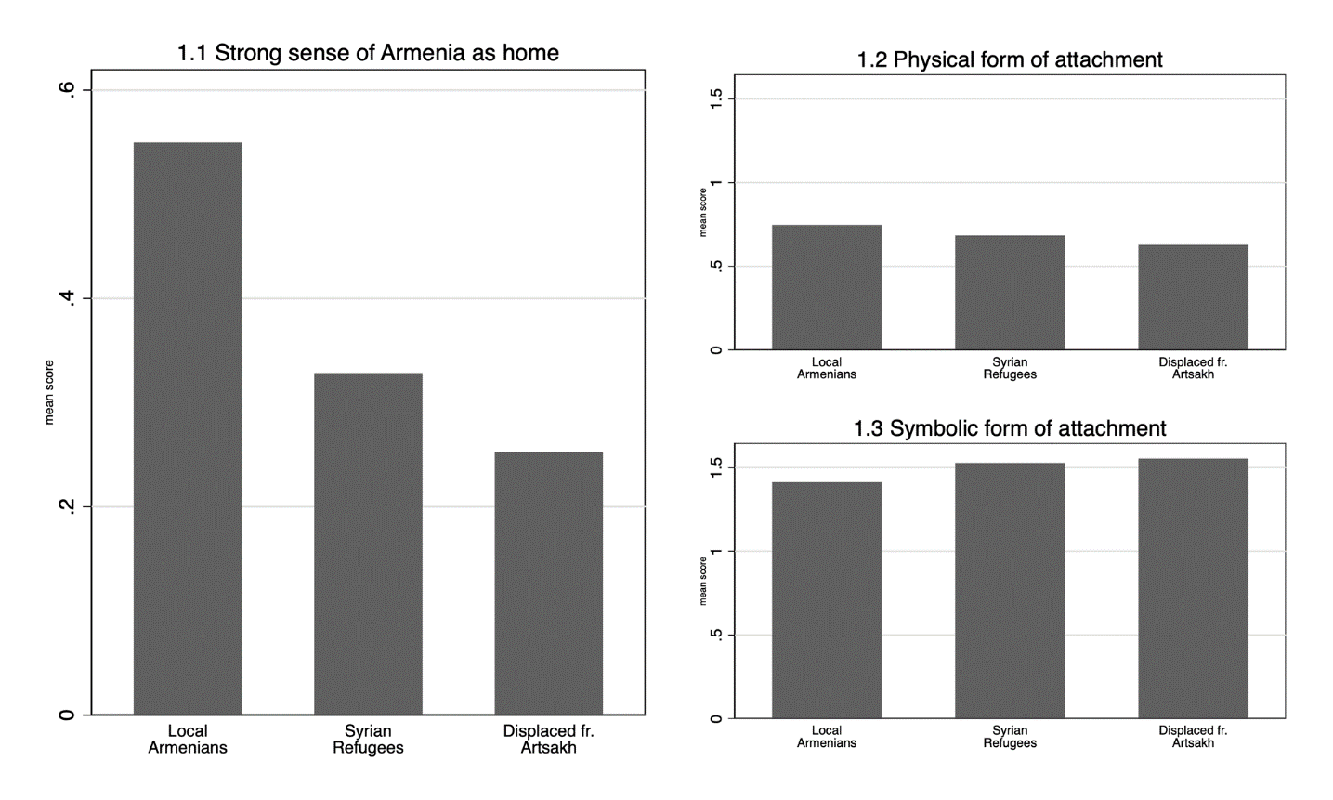
Figure 1.1 Mean level of respondents with a strong sense of Armenia as home by group membership.
Figure 1.2 & 1.3 Mean levels of attachment to Armenia based on perceptions of what it means to be Armenian.

3
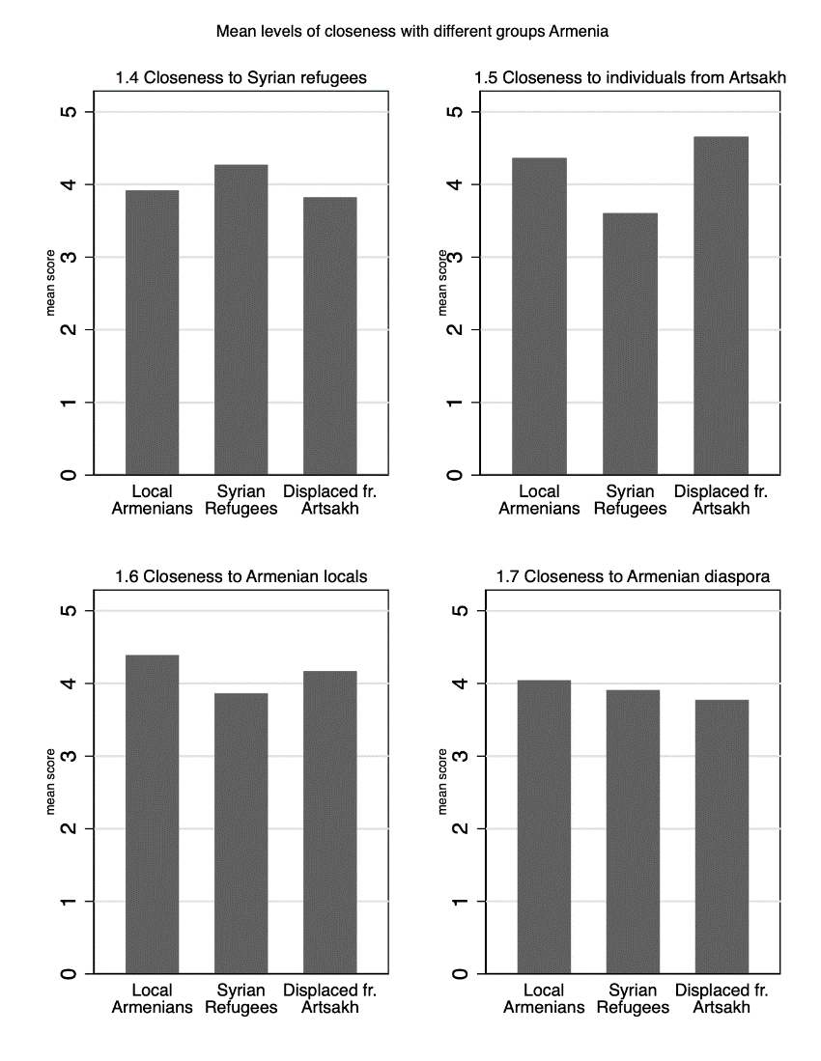
Figure 1.4 – 1.5 Mean levels of closeness with different groups in Armenia.
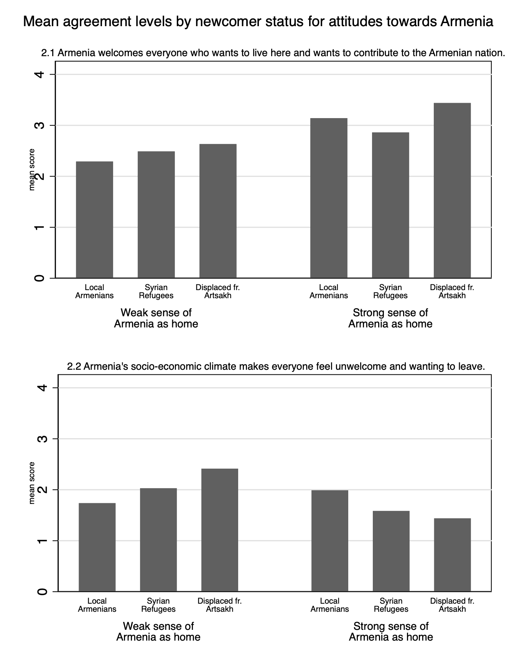
Figure 2.1 & 2.2 Mean agreement levels by newcomer status for attitudes towards Armenia, for both people with weaker and strong sense of Armenia as home.

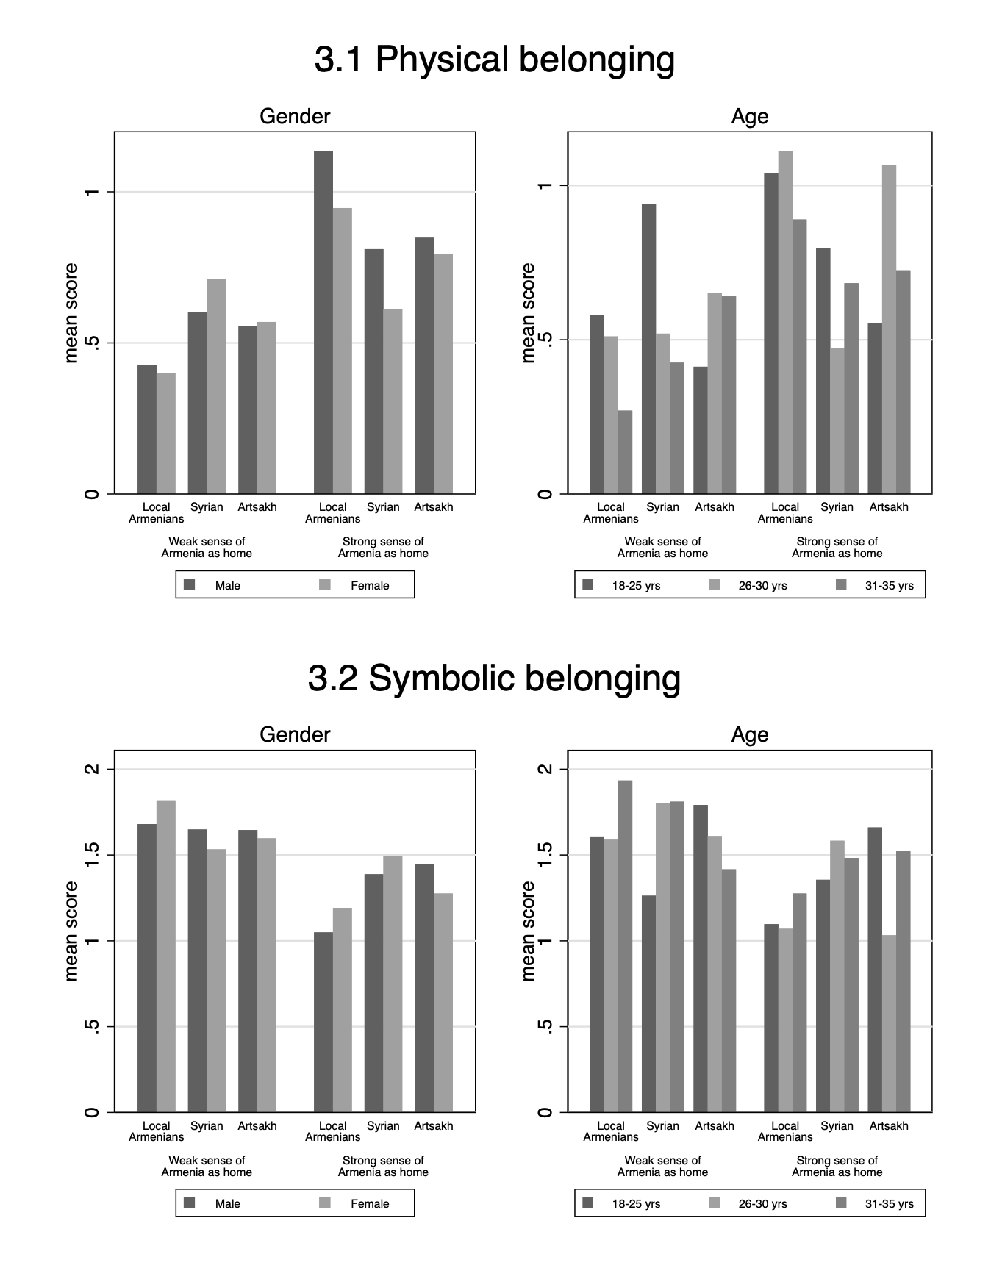
Figure 3.1 & 3.2 Mean levels of symbolic attachment by group membership and by social demographic factors, for both people with weaker and strong sense of Armenia as home.
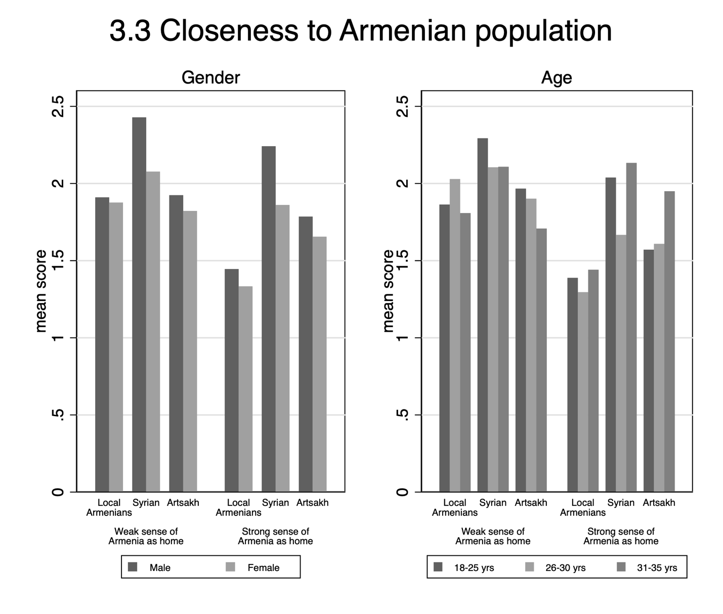
Figure 3.3 Mean levels of closeness to Armenia by group membership and by sociodemographic factors, for both people with weaker and strong sense of Armenia as home.

Acknowledgements
The project was funded by the British Academy as part of its ‘Humanities and Social Sciences Tackling Global Challenges’ programme (TGC\200273).
We extend our heartfelt thanks to all the participants who dedicated their time to this project and generously shared their invaluable insights and experiences. This work would not have been possible without you.
We are also profoundly grateful to everyone we encountered in Armenia—the colleagues from the Department of Sociology at Yerevan State University; academics, researchers, and professionals in and around Yerevan; Ukrainian charity workers and the incredible volunteers we met; a young Russian man who found an adoptive family in an independent café in Yerevan; a village woman who shyly photographed the stunning surroundings while tending her sheep (“You must think I’m silly—I live here and take photos like a tourist, but I can’t help it, it’s so beautiful”); a passionate small hotel manager fervently opposing the closure of the only regional university, which provided young people with an alternative to leaving their villages for the capital; the wonderful, strong, and courageous women we met at the Child Protection Centre of the Fund for Armenian Relief; and so many others.
You were our inspiration, and we dedicate this article to you.

Endnotes

The study received ethical approval from the General University Ethics Panel of the University of Stirling.
During the Soviet period Artsakh, as it is known to many Armenians, was the Nagorno Karabakh Autonomous Region of Azerbaijan, NKAO
Between 2011 and 2020, Armenia saw its largest population influx- Syrian war refugees, primarily descendants of Armenians who survived the 1915 Ottoman genocide, along with smaller numbers from Lebanon, Iraq, and other Middle Eastern countries. By 2016, approximately 20,000 Syrian-Armenian refugees (referred to here as Syrians) had arrived in Armenia (Hayrapetyan 2020).
Ethnic Armenians displaced from Nagorno-Karabakh (Artsakh) arrived in Armenia during and after the 44-day 2020 war with Azerbaijan. Of the 90,000 displaced (Markosyan 2022), about 55% later returned to Artsakh (United Nations Armenia 2021). In September 2023, following the ethnic cleansing of Nagorno-Karabakh, the entire Armenian population of Artsakh—120,000 people—fled to Armenia (UNHCR 2023).
Since February 2022, following Russia’s invasion of Ukraine, Armenia has experienced an influx of newcomers from Russia and other former Soviet republics. These include Ukrainian refugees, ethnic Armenians previously working in Russia, and 50,000–70,000 Russian and Belarusian migrants (Markosyan 2022), driven by fears of arrest, conscription, and economic sanctions.
Modern Armenian consists of two dialect families: Eastern Armenian, spoken in Armenia, Georgia, Russia, and Iran (i.e. in the historical Eastern Armenia that was a part of Persia and was annexed and joined to the Russian Empire as the result of the 1828 Russian-Persian War, and Western Armenian , historically spoken in the Ottoman Empire and now found across the Armenian diaspora in the Middle East, Europe, and the Americas (Seyfarth et al. 2024).
It remains to be seen how this will be affected by recent developments in Syria.
For the quantitative surveys, the initial phase included 225 participants from each of the three groups residing in rural Armenian regions were surveyed face-to-face. The second stage was conducted online, yielding 427 completed questionnaires in total. In the final stage, an additional 245 responses were obtained from local Armenians through an online survey. While most questions were consistent across all three phases of data collection, some were not asked uniformly at each stage.
The interviews that informed this paper were conducted in two phases. The first phase consisted of focus groups with Syrians (3 groups), displaced people from Artsakh (3 groups) and local young people (2 groups). The second wave of interviews mainly involved individual interviews with young people in Yerevan (6 interviews) and stakeholders (4 interviews) while we conducted further focus groups with Syrian-Armenians (2 groups). Both individual and focus group interviews were arranged at a time and place convenient for interviewees, with most of them held in coffee places and/or restaurants.
It should be noted that the UK research team included two Armenians, one a member of the ‘old’ diaspora while the other was raised in Yerevan, as such, the positionality of the interviewers varied, and this will have shaped the interview data.

