Changes in the Skeletal Muscle Proteome in Response to Saturated and Mono-unsaturated Fatty Acids
by
Andrew M. Shaw

Dr. Lee Hamilton

Word Count: 12,311

A thesis submitted for the degree of Masters of Philosophy

At
Health and Exercise Science Research Group
School of Sport
University of Stirling

01/10/2015

Dedication
This work is dedicated to my Grandfather Norman from whom I have learnt so much.
For all that you have done… Thank you.

Acknowledgements
First I would like to thank Dr Lee Hamilton for all his support, encouragement and guidance over the past 3 years. Thank you for taking me under your wing and affording me so much of your time and effort. I hope I can move forward with the skills you have given me and make you proud. I would also like to thank my secondary supervisors Dr Iain Gallagher and Dr Stuart Galloway whose doors were always open for a chat about data or a laugh! To Dr Olly Witard and Professor of Kevin Tipton, thanks for inspiring me to get involved in research, your teaching and advice have been invaluable. To the rest of HESRG staff thanks for everything, I am so proud to have been a part of this group.
To Lindsay, Lewis, Stewart, Silje and Lorna, thanks for the ‘craic’ and thanks especially to the latter three for all the hard work on my project. I couldn’t have wished for a better group of peers to spend my time here with. Good luck in the future and please do keep in touch.
Finally I would like to thank those closest to me, my mother Maxine, my father Stephen, my sister Catherine and my partner Aimee. My role models, my support, my family. Thank you for all that you do.

Contents
Abbreviations 5
Abstract 6
Introduction 7
Insulin signalling and insulin resistance 7
Circulating Insulin as a driver of insulin resistance 9
Circulating fatty acids as a driver of Insulin resistance 11
Role of saturated and unsaturated fatty acids on metabolic function in Skeletal Muscle. 12
Materials & Methodology 15
Materials 15
Cell culture 15
Glucose uptakes 15
Fatty Acid Methyl Ester (FAME) Analysis 15
Protein assays 16
Western blots 16
Mass Spectrometry 17
Quantification and bioinformatics analysis 17
Statistics 18
Results 19
C2C12 myotubes uptake PA and PAO 19
Media optimization test - Glucose (2DG) uptake 21
Media optimization test - PKB phosphorylation 22
Glucose (2DG) uptake 23
PKB Phosphorylation 24
Global Proteomics 25
Discussion 30
References 38
Appendices 41
Appendix 1 41
Appendix 2 42

Abbreviations
PA – Palmitate
PAO – Palmitoleate
SFA – Saturated Fatty Acids
MUFA – Mono-unsaturated Fatty Acids
PUFA – Poly-unsaturated Fatty Acids
NEFA – Non-esterified Fatty Acids
TAG – Triacylglycerol
DAG - Diacylglycerol
FFA – Free Fatty Acids
PKB – Protein Kinase B
PKC – Protein Kinase C
IRS-1 – Insulin Receptor Substrate-1
PI3K – Phosphoinositide3-kinase
IR – Insulin Receptor
PDK-1 - 3-phosphoinositide dependent protein kinase-1
AS160- Akt substrate of 160 kDa
GLUT- 4 - Glucose transporter type 4
MIRKO – Muscle Insulin Receptor Knockout
FIRKO – Fat Insulin Receptor Knockout
LIRKO – Liver Insulin Receptor Knockout
IPA – Ingenuity Pathway Analysis
CEM – Caveolin Enriched Membrane

Abstract
The prevalence of Type 2 Diabetes Mellitus (T2DM) in recent years and its association with many biomarkers of ill- health such as Obesity has thrust this condition into the research ‘spotlight’. Elevated levels of plasma fatty acids, especially saturated fatty acids in the obese are correlated to insulin resistance and as such much focus at both the basic and complex level has tried to elucidate the role of saturated fatty acids on insulin signaling in metabolic tissues such as the liver and skeletal muscle. Skeletal muscle is particularly important in the context of T2DM as it is the largest ‘glucose sink’ with more than 90% of glucose being up taken in response to insulin. Previous studies have shown that the saturated fatty acid Palmitate induces insulin resistance in skeletal muscle cells, whereas the unsaturated fatty acid Palmitoleate enhances insulin sensitivity in skeletal muscle. The aim of this study was to confirm or refute the previously reported effects of Palmitate and Palmitoleate on glucose uptake and PKB phosphorylation in C₂C₁₂ cells and carry out a thorough global proteomic screen to identify any changes across the proteome that may shed light on any effects noted. Our results show that a 16-hour treatment with 750 µM Palmitate increased intracellular Palmitate content 81%. Further, we observed that this increase in Palmitate caused a significant decrease in insulin-stimulated glucose uptake (p<0.001), despite having no significant impact on PKB Phosphorylation. Further this study showed that Palmitoleate treatment caused a 370% increase in intracellular Palmitoleate content but was unable to identify any significant impact on glucose uptake or PKB phosphorylation. After a proteomic screen with each treatment we identified 47 proteins differentially regulated between fatty acid treatments which can be grouped under fatty acid metabolism, glucose metabolism, apoptosis and ATP synthesis. IPA analysis revealed a possible link to mitochondrial dysfunction in PA treated cells which will require further validation. We were unable to elucidate any change that would suggest inhibition or sensitization of insulin signaling. Our results indicate that lipid-mediated repression in glucose uptake in C2C12 myotubes is unlikely to be caused by a repression insulin signaling as evidenced by the lack of differential regulation of key insulin signaling components.

Introduction
T2DM can be summarised as the progressive development of insulin resistance in key metabolic tissues including skeletal muscle, the liver and adipose tissue and the eventual death of the pancreatic Beta cells responsible for producing insulin. The general characteristics of insulin resistance and type 2 diabetes are fasting hyperglycaemia and a reduced ability to restore basal blood glucose in the post-prandial state. The association between the growing obesity epidemic and the increased incidence of Type2 diabetes has been accepted for decades. Currently there are 3 million people in the UK diagnosed with diabetes at a cost of 13.75 billion which equates to 10% of the NHS budget for England and Wales (Kavanos et al, 2012). This figure is likely to rise in the future with the World Health Organisation (WHO) predicting that Diabetes will rise to 7th in the risk tables for premature death by 2030. Perhaps most worrying is that the number of cases of diabetes has increased by 60% in the last decade [Diabetes UK (2015)]. These statistics highlight the socio-economic need to understand the basic mechanisms behind the association between obesity and metabolic dysfunction and disease in order that novel pharmacological therapies and interventions can be developed.

Insulin signalling and insulin resistance
Insulin signalling is complex in its nature and diverse in the physiological responses it brings about. These responses can be classified into the subgroups of proliferation, anabolism and substrate uptake and utilisation. Insulin is released from the pancreatic Beta cells in response to elevated plasma levels of glucose. Insulin then circulates around the body and influences the target tissues expressing the insulin receptor such as striated muscle, adipose and liver (Saltiel and Kahn, 2001). The insulin signalling cascade has been very well characterised and as such we have a relatively clear understanding of the key events involved. Binding of insulin to the insulin receptor (IR) results in the dimerization of the receptor alpha and beta subunits resulting in autophosphorylation of the tyrosine residues on the intracellular components of the receptor (Tanniguchi et al, 2006). Insulin receptor substrate-1 (IRS-1) is phosphorylated upon recruitment to the membrane by these phospho-tyrosine residues (Myers and White, 1997). Phosphorylation of IRS-1 recruits P-85, the regulatory subunit of PI3K, which in turn recruits the catalytic subunit P-110 (Cantley, 2002). This event forms a functional Phosphoinositide-3 kinase (PI3K) at the membrane. PI3K facilitates the phosphorylation of Phosphatidylinositol 4,5 bisphosphate (PIP2) (enriched in the plasma membrane) to Phosphatidylinositol 3,4,5-trisphosphate (PIP3) which recruits PH (plekstrin homology) domain containing proteins such as Phosphoinositide-dependent kinase-1 (PDK-1) to the plasma membrane (Cohen et al 1997). The phosphorylation of PIP2 - PIP3 also results in the recruitment and conformational change of Protein kinase B (PKB) to the membrane in close proximity to PDK-1 where it can phosphorylate PKB at Thr308 (Vanhaesebroeck and Alessi, 2000). PKB is then phosphorylated at Ser473 by mTORC2 (Sarbassov et al, 2005) leading to its full activation. PKB via the GTPase activating protein known as AS-160 stimulates the translocation and incorporation of GLUT-4 containing vesicles (regulated by RabGTPases) to the plasma membrane (Chen et al, 2014). The increase of GLUT-4 on the membrane increases the flux of glucose into the GLUT4 containing cells such as striated skeletal muscle and adipocytes. The action of insulin on peripheral tissues such as skeletal muscle and adipose is essential to the maintenance of normal glycaemic control. As an example skeletal muscle is responsible for 80% of the glucose clearance under insulin stimulated conditions (Defronzo and Tripathy, 2009). Aside from glucose uptake insulin’s role in the liver largely revolves around inhibiting the production of glucose by supressing gluconeogenesis (Persighin, 2009). However, one of the earliest detectable defects in the pathogenesis of Type2 diabetes is insulin resistance in the skeletal muscle (Defronzo and Tripathy, 2009).
There are a number of lines of evidence suggesting that the development of insulin resistance is associated with the defective insulin dependent activation/deactivation of molecules at the proximal end of insulin signalling cascade. This impairment of insulin induced signalling leads to a dulling of the cellular response to insulin and therefore the uptake of glucose to the GLUT4 expressing cells and the inhibition of glucose output from the liver is impaired leading to hyperglycaemia. As the sensitivity of these tissues is reduced blood glucose remains higher. As a result of higher blood glucose the pancreas will respond and secrete more insulin (Shanik et al, 2008). Over time the tissues become more insulin resistant and the beta cells of pancreas grow and proliferate to secretes more insulin until the pancreatic beta cells die resulting in the individual developing overt T2DM (Butler et al, 2003).
For some time there has been debate as to what tissue is most important in the transition from insulin resistance to tyep2 diabetes. Arguments can be made and indeed have been made for the adipose (Iozzo, 2009), skeletal muscle (Defronzo and Tripathy, 2009), liver (Perseghin, 2009), the brain (Pagotto, 2009) and collectively (Biddingher and Kahn, 2006). These will not be discussed in detail here and so we refer readers to the excellent reviews cited above. Briefly however we wish to bring the reader's attention to the Liver Insulin Receptor Knockout (LIRKO) and Muscle Insulin Receptor Knockout (MIRKO) mouse studies, which have provided insight into the role of these tissues in insulin resistance. LIRKO mice exhibit an overt diabetic phenotype with fasting hyperinsulinemia, mild fasting hyperglycaemia and significant fed hyperglycaemia and quickly develop diabetes (Michael et al, 2000). MIRKO mice exhibit reduced muscle glucose uptake however overall exhibit normal glucose homeostasis due to a compensatory mechanism where increasing amounts of glucose are deposed to the adipose tissue and gluconeogenesis in the liver is increasingly repressed (Kim et al 2000). However as MIRKO mice age they exhibit symptoms of metabolic syndrome with increasing adipose and lipid deposition in the liver (steatosis). The MIRKO mice also display increased nutrient partitioning to the liver leading to lipid deposition in the liver (Samuel and Schulman, 2012). This phenotype is somewhat reminiscent of individuals at risk of developing Type2 diabetes. As we mentioned earlier one of the earliest detectable defects in the offspring of 2 parents with T2D is skeletal muscle insulin resistance (Defronzo and Tripathy, 2009). In response to a glucose challenge these individuals partition more of the glucose to their liver leading to lipogenesis (Biddingher and Kahn, 2006). Excess lipid deposits in the liver (steatosis) are independently associated with insulin resistance and therefore increasing nutrient partitioning to the liver could lead to the development of T2D (Samuel and Shulman, 2012). These data combined with the insulin receptor knockout mice suggest a scenario whereby an individual with skeletal muscle insulin resistance develops insulin resistance in the liver which then leads to further whole body insulin resistance leading to T2D. Skeletal muscle may therefore play a central role in the pathogenesis of T2D and developing strategies to improve nutrient partitioning into the skeletal muscle away from the liver, or strategies which prevent insulin resistance in the skeletal muscle may be instrumental as therapeutics for the prevention/treatment of T2D.
Abundant high calorie foods have only been available relatively recently in our evolutionary history and therefore we have not evolved a mechanism to cope with the chronic overconsumption of such food (Neel, 1962). A great deal of research has focussed on understanding how overconsumption of different nutrients might cause insulin resistance and the next stage of this review will discuss in particular insulin itself and fat with a focus on the skeletal muscle.

Circulating Insulin as a driver of insulin resistance
Insulin is continually circulating in the bloodstream to ensure that blood glucose levels remain within the euglycemic range by supressing excessive hepatic glucose production. After a meal, levels of this hormone rise in response to glucose in the blood leading to insulin mediated glucose uptake into target tissues.
Hyperinsulinaemia is a condition characterised by increased levels of circulating insulin above what would be expected given the blood glucose level. Hyperinsulinaemia can occur in a variety of metabolic conditions but in the context of insulin resistance it is thought it may occur as both a mediating factor and as a result of insulin resistance. In obesity and nutrient oversupply chronic hyperglycaemia and dyslipidaemia result in a chronic adaption of the tissues to reduce uptake of these substrates by attenuating insulin signalling in response to certain lipid intermediates and the Randle hypothesis (mechanisms discussed later). The resulting reduction in uptake causes blood glucose to remain elevated despite insulin release and so the pancreas begins to secrete more insulin to bring about the desired result of euglycaemia. If nutrient oversupply is not relieved over time then this process is compounded resulting in more and more insulin being required to maintain euglycaemia. This leads to chronic basal hyperinsulinaemia. An interesting question in the literature is whether insulin contributes to the insulin resistant state or whether it is simply a result of insulin resistance.
Numerous studies conducted on rodents suggest that insulin itself appears to be an important contributor to insulin resistance. It has been shown that mice with transgenic overexpression of insulin become insulin resistant with both fasting and stimulated insulin levels being four times greater than controls. Insulin resistance typically results from sustained exposure to high insulin levels (Shanik et al, 2008).
Hyperinsulinemia is known to decrease the expression of Insulin receptor substrate 1 (IRS1) and IRS2 in both cell-culture models and in the tissues of mice (Pirola et al 2003). Knockout studies in rodents indicate that the IRS proteins constitute a ‘critical node’, such that the deletion of each isoform has a different biological consequence. First, hyperinsulinemia induces degradation of IRS1 protein and inhibits the synthesis of IRS2 at the transcriptional level. Second, some studies have shown that suppressor of cytokine signalling (SOCS) proteins might induce ubiquitin-mediated degradation of IRS1 and IRS2 (Hirashima et al, 2003). The downstream metabolic actions of insulin including glycogen synthesis, stimulation of glucose transport, adipocyte differentiation and lipid synthesis are inhibited. Regardless of the mechanism, decreased levels of IRS proteins, coupled with decreased levels of the IR itself, certainly contribute to the insulin resistance in diabetic states in both rodents and humans (Shimomura et al, 2000).
Decreased hepatic IRS1 correlates with the increased expression of genes that are involved in gluconeogenesis and increased levels of blood glucose. Downregulation of hepatic IRS2 results in enhanced expression of genes that are involved in lipogenesis (Taniguchi et al, 2005). As such it is plausible to suggest that circulating insulin at high levels as in hyperinsulinemia could contribute to the pathogenesis of insulin resistance.

Circulating fatty acids as a driver of Insulin resistance
Non esterified fatty acids (NEFA) circulate in the blood plasma bound to plasma albumin. Plasma NEFA concentrations fluctuate throughout the day and are fed by 2 sources. It is now well established that NEFA are the medium through which Triacylglycerol (TAG) are mobilised from the adipose tissue to the sites of utilization namely the liver, heart and skeletal muscle (Karpe et al, 2011). The other source of NEFA is via feeding where circulating dietary TAGs are hydrolysed to NEFA for uptake and storage in the adipose. However not all of the NEFA is up taken and some can escape to the plasma NEFA pool. This source of NEFA from feeding can contribute up to 50% of the pool in the post-prandial period and the amount contributed and the composition will reflect the amount of and what type of fat was in the meal. In obesity research it has been widely reported and accepted that plasma NEFA is greater in the obese than in the rest of the population. Indeed obese populations are commonly found to have a greater fatty acid flux when compared with lean populations and this is likely a contributing factor in the insulin resistant state (Schenk et al 2008). Insulin resistance in the obese is generally accepted to be multifactorial in origin. The importance of fatty acids in its development has been highlighted throughout the literature but particularly in two infusion trials in lean individuals (Schenk et al, 2007 and Bachmann et al, 2001) where infusion induced insulin resistance in the absence of the other factors associated with insulin resistance in obesity. Further evidence for the involvement of fatty acids in insulin resistance is the associated rise in insulin sensitivity with decreases in fatty acid amounts in the plasma of those who have undergone weight loss (Assali et al, 2001) and those involved in trials where lipolysis is inhibited (Bajaj et al, 2005). These along with other key studies highlight the ability of fatty acid flux to induce and reduce insulin resistance on its own. This has led to a large body of research from basic mechanistic studies to large scale clinical trials trying to elucidate how plasma NEFA might influence insulin resistance in the various tissues like the liver and skeletal muscle.
This concept was first proposed by Randal et al (1963) where they identified a link between increased FFA availability to the tissues and insulin resistance. They proposed that this could be the primary driver of the pathogenesis of type 2 diabetes. The mechanism behind this was termed the Randal cycle or glucose-fatty acid cycle and described a competition between glucose and fat for use as substrate in cell metabolism. Essentially the increased availability of Long chain acyl groups leads to greater amounts of cytosolic citrate from the krebs cycle. This cytosolic citrate results in inhibition of Phospho-fructokinase (PFK) and the eventual inhibition of hexokinase and glucose uptake (Randal et al 1963). More recently it has become clear that the Randal cycle as it has been described here and in many other pieces of literature does not tell the whole story of FFAs role in insulin resistance. Lipid accumulation in tissues such as liver and skeletal muscle are also biomarkers of the insulin resistant state. Increased accumulation in the obese is likely as a result of spill over of NEFA into the plasma pool. As a means of compensating for this spill over the other tissues such as the liver and skeletal muscle become additional ‘sinks’ for the increased lipid load. Whether this accumulation is a key driver in insulin resistance of these tissues is currently a bone of contention in the literature. Several studies in vitro and in vivo point to a role in the inhibition of the insulin signalling cascade. Further, recent study has investigated differential effects of saturated and unsaturated fatty acids on different tissues with some interesting results.

Role of saturated and unsaturated fatty acids on metabolic function in Skeletal Muscle.
The association of circulating fatty acids with obesity and insulin resistance has led to the query of whether the composition of those fatty acids matter and whether only certain types of fatty acids bring about negative responses in insulin sensitivity. Perhaps the seminal paper in this field was from Hunnicutt and colleagues (1994) who showed prolonged exposure of adipocytes to the saturated fatty acid Palmitate induced insulin resistance. The same was found in 1997 by another group (van Epps-Fung et al, 1997) along with the interesting finding that this effect was not mediated by a reduction of GLUT-4 translocation to the membrane but rather an inhibition of the transporter activity. Further to this several studies (Basu et al 1998) discovered that in the presence of ceramide, a derivative of palmitate, PKB activation is reduced possibly via PKC or a protein phosphatase. This introduced the idea that different fatty acids may produce different responses depending on the pathway affected by it or any of the downstream derivatives in the fatty acid synthesis pathways. The first paper to show the same effect on skeletal muscle was by Schmitz-Peiffer et al (1999) who again showed a repression of PKB activity. In the early 2000s a lot of work was done to elucidate the mechanism by which palmitate or namely its derivative ceramide brings about a repression in insulin signalling. A study by Schubert and colleagues (2000) found that in TF-1 cells repression of PKB was via de phosphorylation of PKB at Ser473 which would implicate a protein phosphatase and indeed in the same year another group confirmed this, this time in PC12 cells (Salinas et al, 2000). This was first explored in 2001 by Hajduch et al (2001) which highlighted that ceramide was associated with impaired PKB recruitment to the membrane where it is activated and this suggested that the mechanism in skeletal muscle could differ to that of the other tissues studied. The same group discovered a possible alternative mechanism a couple of years later where ceramide associated PKB repression was found to be dependent on another protein kinase, Protein kinase C(PKC) in L6 myotubes. Chavez et al (2003) were the first group to compare the effects of SFAs with MUFAs in a skeletal muscle model (C2C12s) and found that MUFAs oleate and palmitoleate had no effect on intracellular ceramide levels or insulin signalling. Dimopolous et al (2006) were the first to discover divergent effects of Palmitate and Palmitoleate in skeletal muscle (L6 myotubes). Cells treated with Palmitoleate exhibited a 2 fold increase in insulin stimulated glucose uptake compared to control. After this discovery much of the work from this group has focussed on the mechanism by which these events might occur. As described above the literature has identified two different potential mechanisms that ceramides might influence signalling one via de phosphorylation by a protein phosphatase and the other via PKC possibly by preventing recruitment of the PKB to the membrane where it is active. Drs Hundal and Hajduch and their respective groups have continued research in this area (Mahfouz et al, 2014) investigating the drivers of ceramide induced insulin resistance in different models of skeletal muscle. They demonstrated that ceramide induced repression of PKB in L6 myotubes and human primaries from healthy and diabetic patients resulted largely via PKC inhibition whereas in C2c12s the response is predominantly driven via PP2A. They provide some evidence that a lack of Caveolin Enriched Membranes (CEM) domains in the c2c12s are responsible for the effect being driven by PP2A and not PKC.
Mediating a repression on PKB is just one way in which fatty acids can attenuate insulin signalling. Obesity is associated with chronic low grade inflammation and indeed certain fatty acids are known to activate pro-inflammatory pathways. (Schenk et al 2008). Inflammatory proteins, tumor necrosis factor-α (TNF-α), interleukin-6 (IL-6) and interleukin (IL-8) as well as C-reactive Protein (CRP) have all been shown to be elevated in various models of insulin resistance and T2DM (de Luca and Olefsky, 2007). For a thorough examination of the role of inflammatory proteins in insulin resistance we direct readers to the following reviews (Schenk et al 2008; de Luca and Olefsky, 2007). We would, however, like to summarise by highlighting that fatty acids can induce repression of insulin mediated glucose uptake in skeletal muscle via direct interaction between inflammatory and insulin signalling pathways, namely through TLR mediated IKKB/ JNK repression of the IRS proteins at the proximal end of the insulin signalling pathway (Schenk et al 2008).
From the literature outlined and summarised above it is clear that fatty acids can play a role in the pathogenesis of insulin resistance with potential effects mediated via multiple pathways in multiple tissues. Of these, profound and contrasting effects have been observed within skeletal muscle and this coupled with skeletal muscles role as a glucose sink, highlights the importance of studying the mechanisms of insulin resistance in this tissue. This study aimed to understand, at the most basic level, whether saturated and un-saturated fatty acids can have divergent effects on skeletal muscle insulin sensitivity and, via a global-proteomic analysis, identify key changes in signalling proteins that could explain any differences observed.

Materials & Methodology

Materials
Pan PKB (4691) and PKB pThr308 (4056) antibodies were sourced from Cell signalling. Radioactive tracers were provided by Hartmann Analytic. All other reagents and lab consumables were sourced from Fisher Scientific unless otherwise stated.

Cell culture
C₂C₁₂ myoblasts (ATCC) were cultured in 6 or 12 well plates and maintained in a growth media containing High Glucose Dulbecco’s Modified Eagle Media (DMEM), 20% Fetal Bovine Serum (FBS) and a 1% Pen/Strep. Once 80-100% confluent the cells were differentiated using a Differentiating media containing High Glucose DMEM, 2% Donor Horse Serum and 1% Pen/Strep. Experiments were carried out once cells were fully differentiated into myotubes (typically 3-5 days post post low sera media change). For SILAC labeling C₂C₁₂ myoblasts were cultured for eight passages in SILAC-medium (arginine-, leucine- and lysine-free DMEM (Sigma-Aldrich (D9443)) supplemented with 1% penicillin/streptomycin, 10% dialyzed fetal bovine serum (FBS) (Life Technologies), D-glucose (3.5 g/L), sodium pyruvate (1 mM), non-essential amino acids (0.1mM), -mercaptoethanol (55 µM), L-leucine (105 mg/L), L-lysine-HCl (146 mg/L) and L-[13C615N4]-arginine-HCl (84 mg/L; CortecNet, Voisins-Le Bretonneux, France (CCN250P)) to ensure full incorporation of the metabolic label. Each experiment contained at least 2 technical replicates and was performed to an n of at least 3.

Glucose uptakes
After various serum starve protocols (see results for details) cells were stimulated with or without a bolus of insulin for a final concentration of 100nM for 30 minutes after various treatment paradigms with Palmitate and Palmitoleate. Glucose uptake assays were carried out using a buffer containing Tritiated 2-Deoxyglucose (10µm at 0.66µCi/ml). Ice cold saline (0.9% NaCl) was used to stop the reaction and cells were lysed using Sodium hydroxide (NAOH) lysis buffer and collected in Scintillation fluid for analysis.

Fatty Acid Methyl Ester (FAME) Analysis
Total lipids were extracted by homogenising in 20 volumes of chloroform/methanol (2:1 v/v). Total lipids were prepared according to the method of Folch et al. (1957) and non-lipid impurities were removed by washing with 0.88% (w/v) KCl. The weight of lipids was determined gravimetrically after evaporation of solvent and overnight desiccation under vacuum. Fatty acid methyl esters (FAME) were prepared by acid-catalysed transesterification of total lipids according to the method of Christie et al. (2003). Extraction and purification of FAME was performed as described by Ghioni et al. (1996). FAME were separated by gas-liquid chromatography using a ThermoFisher Trace GC 2000 (ThermoFisher, Hemel Hempstead, UK) equipped with a fused silica capillary column (ZBWax, 60m x 0.32 x 0.25 mm i.d.; Phenomenex, Macclesfield, UK) with hydrogen as carrier gas and using on-column injection. The temperature gradient was form 50 to 150oC at 40oC/min and then to 195oC at 1.5oC/min and finally to 220oC at 2oC/min. Individual methyl esters were identified by reference to published data (Ackman, 1980). Data were collected and processed using the Chromcard for Windows (version 2.00) computer package (Thermoquest Italia S.p.A., Milan, Italy).

Protein assays
Protein assays were carried out after every experiment. 96 well plates were used running samples in duplicate or triplicate where possible. BCA reagents were used for samples that were prepared for blots and Kinase assays and Bradford reagent for samples prepared for uptake assays. A standard curve was performed on each plate using 0, 2, 4, 6, 8 and 10µg of BSA standards in triplicate and plates were read using a Spectrophotometer at 750nm. The concentration of the unknown samples was determined using the equation of the standard curve. An R² value of at least 0.99 was used as a minimum for BCA standard curves and 0.97 for Bradford reagents representative curves are shown in Appendix 1.

Western blots
Equal amounts of protein were added to Laemmli Sample buffer and then boiled for 5 minutes. 7.5-10ul (equating to 15ug of protein) of sample was loaded onto a 10% acrylamide gel and subjected to SDS-Page at 150V for 1hour 15 minutes. Transfer to a nitrocellulose membrane was achieved using a BIO-RAD transfer tank at 30V for 2 hours. Membranes were blocked using 2-4% BSA in TBST for 1 hour and then exposed to a relevant primary antibody in TBST at 1:1000 overnight at 4°C. Peroxidase-conjugated secondary antibodies at 1:10000 in TBST were then used for 1 hour at room temperature. Imaging and quantification was achieved using a BIO-RAD Chemi Doc™ XRS molecular imager and Image Lab Software.

Mass Spectrometry
Trypsin-digested peptides were separated using an Ultimate 3000 RSLC (Thermo Scientific) nanoflow LC system. On average 0.5µg of protein was loaded with a constant flow of 5 µl/min onto an Acclaim PepMap100 nanoViper C18 trap column (100 µm inner-diameter, 2cm; Themro Scientific). After trap enrichment, peptides were eluted onto an Acclaim PepMap RSLC nanoViper, C18 column (75 µm, 15 cm; ThermoScientific) with a linear gradient of 2–40% solvent B (80% acetonitrile with 0.08% formic acid) over 65 min with a constant flow of 300 nl/min. The HPLC system was coupled to a linear ion trap Orbitrap hybrid mass spectrometer (LTQ-Orbitrap Velos, Thermo Scientific) via a nanoelectrospray ion source (Thermo Scientific). The spray voltage was set to 1.2 kV, and the temperature of the heated capillary was set to 250 °C. Full-scan MS survey spectra (m/z 335–1800) in profile mode were acquired in the Orbitrap with a resolution of 60,000 after accumulation of 1,000,000 ions. The fifteen most intense peptide ions from the preview scan in the Orbitrap were fragmented by collision-induced dissociation (normalized collision energy, 35%; activation Q, 0.250; and activation time, 10 ms) in the LTQ after the accumulation of 10,000 ions. Maximal filling times were 1,000 ms for the full scans and 150 ms for the MS/MS scans. Precursor ion charge state screening was enabled, and all unassigned charge states as well as singly charged species were rejected. The lock mass option was enabled for survey scans to improve mass accuracy (Olsen, J.V. et al., 2004). Data were acquired using the Xcalibur software.

Quantification and bioinformatics analysis

The raw mass spectrometric data files obtained for each experiment were collated into a single quantitated data set using MaxQuant (version 1.2.2.5) (Cox, J. and Mann, M. (2008). Nat Biotechnol 26, 1367-72.) and the Andromeda search engine software (Cox, J., et al, (2011) J. Prot. Research 10 (4), 1794-1805. Enzyme specificity was set to that of trypsin, allowing for cleavage N-terminal to proline residues and between aspartic acid and proline residues. Other parameters used were: (i) variable modifications, methionine oxidation, protein N-acetylation, gln pyro-glu, Phospho(STY); (ii) fixed modifications, cysteine carbamidomethylation; (iii) database: target-decoy human MaxQuant (ipi.HUMAN.v3.68); (iv) heavy labels: R6K4 and R10K8; (v) MS/MS tolerance: FTMS- 10ppm , ITMS- 0.6 Da; (vi) maximum peptide length, 6; (vii) maximum missed cleavages, 2; (viii) maximum of labeled amino acids, 3; and (ix) false discovery rate, 1%. Peptide ratios were calculated for each arginine- and/or lysine-containing peptide as the peak area of labelled arginine/lysine divided by the peak area of non-labelled arginine/lysine for each single-scan mass spectrum. Peptide ratios for all arginine- and lysine-containing peptides sequenced for each protein were averaged. Data is normalised using 1/median ratio value for each identified protein group per labelled sample. For over representation analysis Ingenuity Pathway Analysis from QIAGEN Inc. was used (https://www.qiagenbioinformatics.com/products/ingenuitypathway-analysis) according to their protocols.

Statistics
Figures and Statistical analyses were generated and carried out using the Graph Pad Prism 4 platform. Paired T-tests or a single factor ANOVA were used to determine significance between control and treatment groups. Proteins whose expression was changed compared to control were filtered for a fold change of 1.2 and proteins that were listed as differentially regulated between fatty acid treatments had a delta change of greater than 20%.

Results
C2C12 myotubes uptake PA and PAO.
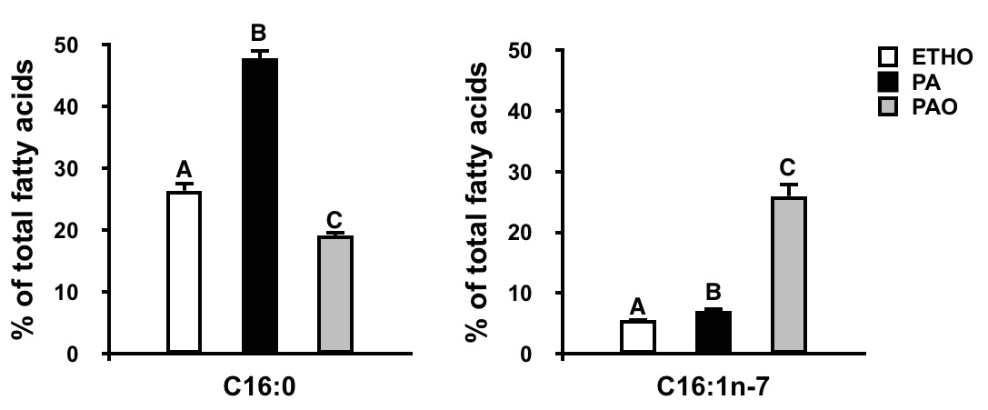
To ensure that fatty acid treatments lead to fatty acid uptake and incorporation into the cells fatty acid profiling via GC/MS was performed. Fatty Acid Methyl Ester (FAME) analysis was carried out on PA and PAO treated cells to determine full fatty acid profiles. 16 hours of treatment with each fatty acid was chosen as the appropriate time point based on (Dimopolous et al 2006). Figure 2A and 2B illustrates the effect of Palmitate and Palmitoleate treatment on C16:0 and C16:1 n-7 lipids as a percentage of total fatty acids detected. This analaysis revealed a significant increase in C16:0 lipids from around 25% to 50% of the total fatty acid pool with PA treatment and C16:1 n-7 lipids with PAO treated cells from less than 10% to 25% of the total pool as expected. Further, figure 3 profiles the proportion of all the different Saturated (SFAs), Mono-unsaturated (MUFAs) and Poly-unsaturated (PUFAs) fatty acids relative to the total pool. This deeper analysis of the FAME data showed fatty acid displacement from other pools (figure 3).
A
B
Figure 2. FAME analysis showing changes % of total fatty occupied by Palmitate and Palmitoleate acid in response to treatments. C₂C₁₂ cells were treated for 16 hours with PBS 5 mM glucose + 750 µM fatty acids/ethanol. The cells were collected and Fatty Acid Methyl Ester separated and analysed using gas-liquid chromatography. A) Palmitate (C16:0) as a % of total fatty acids in cells. Bars that do no share a letter are significantly different from control (p<0.001). ETHO : Control, PA: Palmitate, PAO: Palmitoleate. B) Palmitoleate (C16:1n-7) as a % of total fatty acids in cells. Bars that do no share a letter are significantly different from control (p<0.001). ETHO : Control, PA: Palmitate, PAO: Palmitoleate. Values are means ± SD, n=6.
For instance it can be seen that PA treatment results in an increase of longer 18:0 saturates while PAO results in a reduction in 16:0 and 18:0 saturates. Similarly several of the n-6 and one of the n-9 PUFAs are also displaced significantly compared to control while the n-3 PUFAs remain unchanged with either treatment.

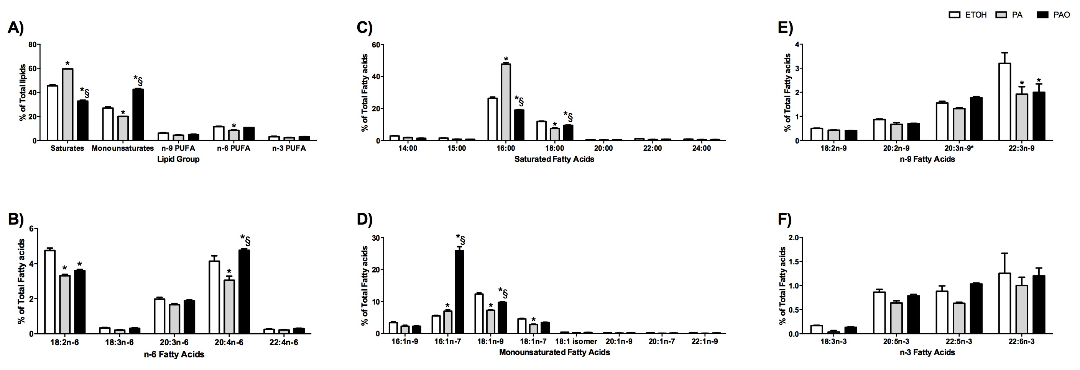
Figure 3. Full FAME analysis showing changes in the % of total fatty acids occupied by various classifications of fatty acids in response to ETH, PA and PAO treatments. C₂C₁₂ cells were treated for 16 hours with PBS 5 mM glucose + 750 µM fatty acids/ethanol. The cells were collected and Fatty Acid Methyl Ester separated and analysed using gas-liquid chromatography. A) % of Total lipids occupied by the various lipid classes after each treatment. B) % of total fatty acids occupied by the various n-6 PUFAs with each treatment C) % of total fatty acids occupied by the various saturated fatty acids with each treatment. D) % of total fatty acids occupied by the various MUFAs with each treatment. E) % of total fatty acids occupied by the various n-9 PUFAs with each treatment. F) % of total fatty acids occupied by the various n-3 PUFAs with each treatment.

Media optimization test - Glucose (2DG) uptake
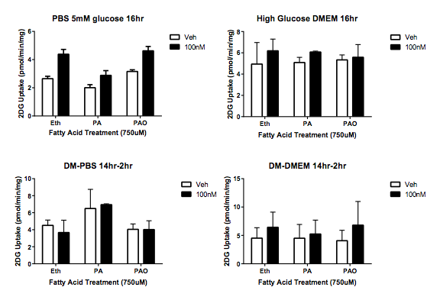
In order to optimise the pre-incubation protocol prior to insulin stimulations we carried out a number of fatty acid treatment paradigms with different serum starvation protocols followed by insulin stimulation (100nM)(Figure 4). In 4A cells were pretreated with fatty acids and serum starved for 16 hours in PBS +5mM glucose, in 4B 16 hours in DMEM, in 4C cells were treated for 14 hours in Differentiation media (DM) followed by treatment and serum starvation in PBS+ 5mM Glucose and 4D in 14 hours pre-treatment in DM followed by 2 hours treatment and serum starvation in DMEM. Folowing this, cells were incubated with and without inuslin to a concentration of 100nM for 30mins. Cells then underwent a radiolabeled glucose uptake assay which was quantified as detailed in the methods. Figure 4 illustrates that the 16 hour treatment with PBS 5 mM glucose + fatty acid (Figure 4A) showed the greatest difference between control and insulin-stimulated glucose uptake across all treatments and the least variability between replicates.
A
C
B
D
Figure 4. Glucose uptake in media optimization tests. C₂C₁₂ cells were treated for 16 hours with A) PBS + fatty acids/ethanol B) DMEM + fatty acids or ethanol C) 14 hours in DM + fatty acid treatments/ethanol and 2 hours in PBS + fatty acids/ethanol hours D) 2 hours in DMEM + fatty acids/ethanol. Cells were stimulated for 30 minutes with 100 nM insulin and 5 mM 2-Deoxy-[³H]^{D}-glucose to assess glucose uptake. Eth: Control, PA: Palmitate, PAO: Palmitoleate. Values are means ± SD, n=4.

Media optimization test - PKB phosphorylation
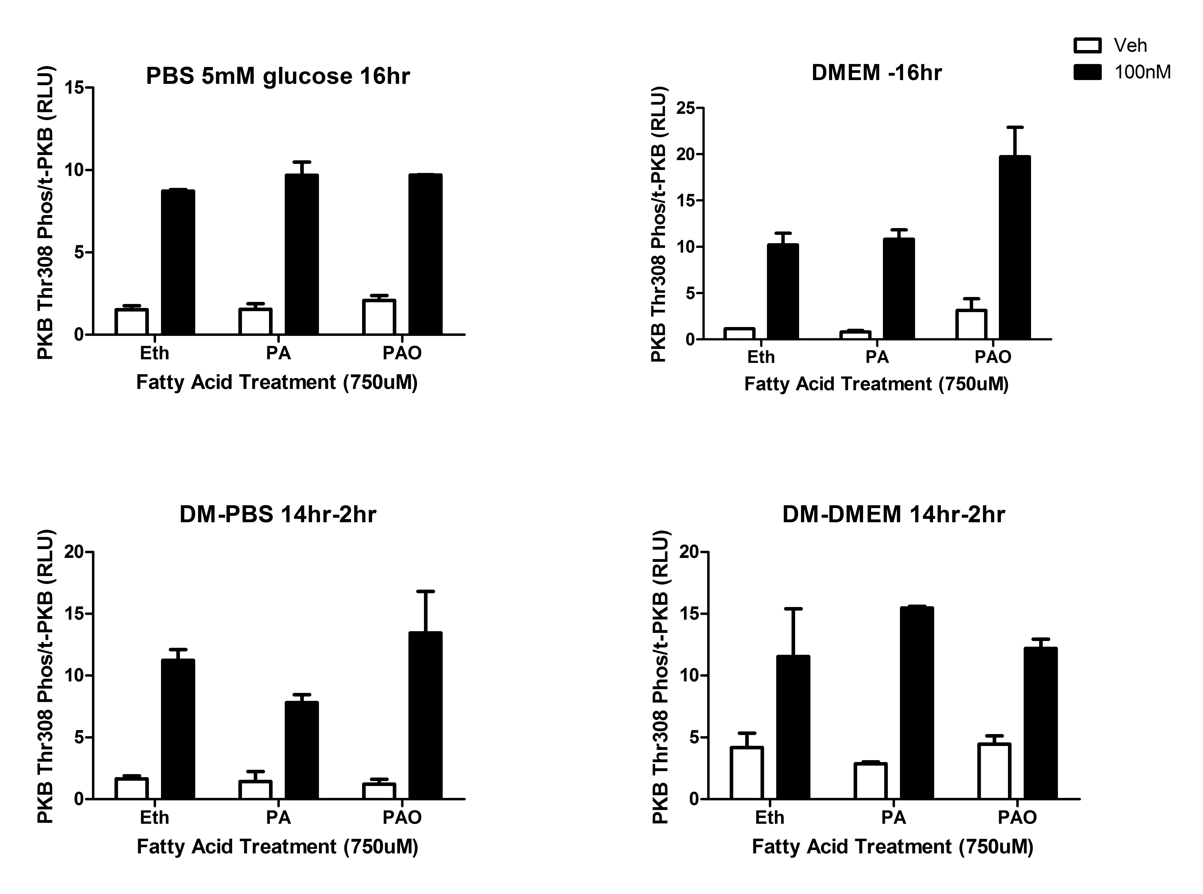
In parallel to the glucose uptake experiments cells were pre-treated as described above with various media and starvation protocols followed by insulin stimulation (100nM). Cells were lysed in a triton lysis buffer and prepared in lamelli sample buffer for western blotting. Samples were blotted for total and phosphorylated PKB^{Thr 308} to assess insulin-signaling responses in the different media. Figure 5 shows phospho-PKB^{Thr 308} -/+ insulin stimulation normalized to the total PKB. Similar to the glucose uptake data the greatest and most reproducible difference was observed in 16 hours of PBS +5mM glucose and with this data all future experiments were performed using that treatment paradigm.
A
B
C
D

Figure 5. PKB phosphorylation in media optimization tests. C₂C₁₂ cells were treated for 16 hours with A) PBS 5mM glucose+ fatty acids/ethanol B) DMEM + fatty acids or ethanol C) 14 hours in DM + fatty acid treatments/ethanol and 2 hours in PBS + fatty acids/ethanol hours D) 2 hours in DMEM + fatty acids/ethanol. Cells were stimulated for 15 minutes with 100 nM insulin and blotted for PKB phosphorylation. Eth: Control, PA: Palmitate, PAO: Palmitoleate. Values are means ± SD, n=3.

Glucose (2DG) uptake
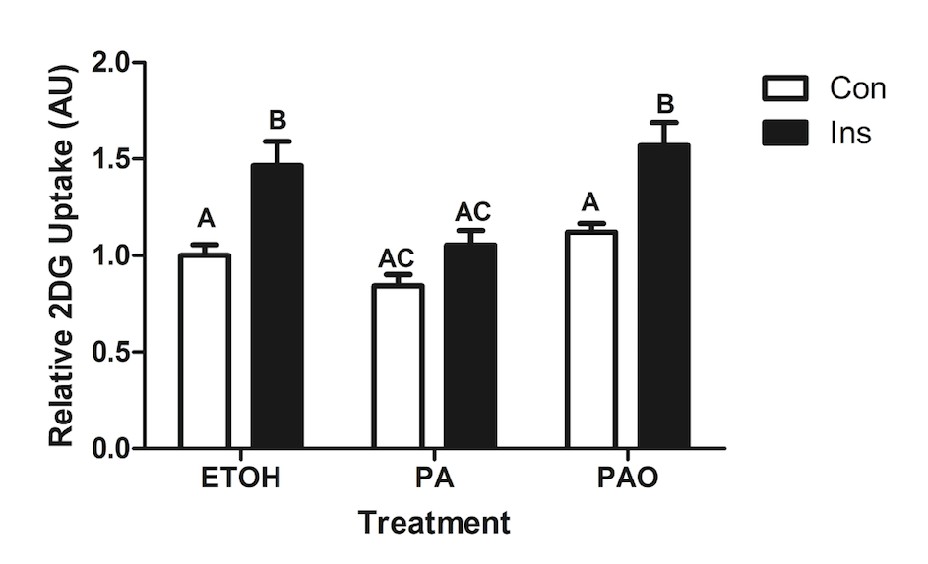
Given the results from the media optimization tests and FAME analysis, we replicated the experiment in Fig3B. We again treated the cells with PBS 5 mM glucose + 750µM fatty acid treatments/control for 16hrs followed by100 nM insulin for 30 minutes and assessed glucose uptake. There was a significant reduction in insulin stimulated glucose uptake in cells treated with Palmitate relative to basal uptake when compared with ETH or PAO treatments (p<0.001)(Figure 5). Insulin stimulation significantly raised glucose uptake with Palmitoleate in comparison to basal glucose uptake (p<0.001), however there was no significant difference between insulin-stimulated uptake in the control group compared to Palmitoleate treatment.
Figure 6. Glucose uptake after fatty acid treatment. C₂C₁₂ cells were treated for 16 hours with PBS 5 mM glucose + 750 µM fatty acids/ethanol, and stimulated for 30 minutes with 100 nM insulin before they were treated with 2-Deoxy-[³H]^{D}-glucose to assess glucose uptake. Bars that do not share a letter are significantly different (p<0.001). ETHO : Control, PA: Palmitate, PAO: Palmitoleate. Ins: insulin stimulated, Con: control. Values are means ± SD, n=4.

PKB Phosphorylation
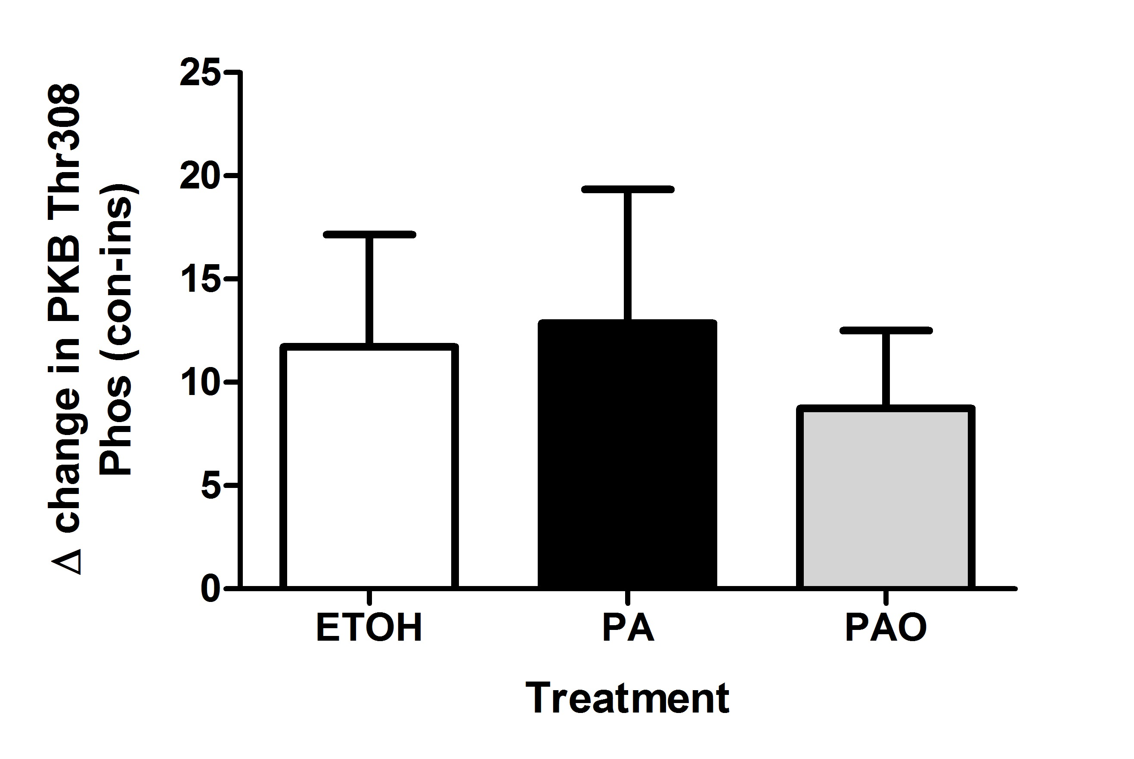
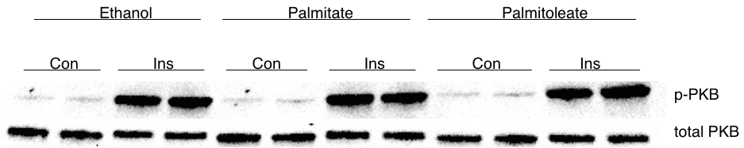
To investigate the effect of fatty acids on the insulin signaling pathway, the cells were blotted for total and phosphorylated PKB^{Thr308}, after 15 minutes stimulation with 100 nM insulin (Figure 6A). Figure 6B shows ∆ change from control to insulin. There are no significant differences in PKB Phosphorylation following any of the fatty acid treatments compared to control (ETHO).
Figure 7. PKB phosphorylation after fatty acid treatment. C₂C₁₂ cells were treated for 16 hours with 750 µM fatty acids or ethanol and stimulated for 15 minutes with 100 nM insulin. A) Cells were lysed and blotted for PKB phosphorylation and total PKB. Western blots are representative of three individual experiments B) Quantification of PKB^{Thr 308} phosphorylation from western blots. ∆ change from control to insulin. ETHO : Control, PA: Palmitate, PAO: Palmitoleate. Values are means ± SD, n=3.
B
A

Global Proteomics
Given that we identified a repression of glucose uptake (figure 6) without and associated repression in PKB (figure 7) we hypothesized that treatment with PA would lead to differential alteration of the global proteomic profile compared with treatment with PAO. These alterations could be validated and explored to determine the mechanism by which PA leads to a repression of glucose uptake. To this end, we carried out a global proteomic screen following fatty acid treatment using an unbiased triple label SILAC approach to compare PA, PAO and ETHO control treatments. We identified 1600 proteins that were present in both independent experiments. Proteins only identified in one experiment were excluded from further analysis. 531 of these were consistently changed in expression compared to control to a similar degree between the 2 independent experiments (data available on request). To further narrow our search for proteins within the data set we set a fold change threshold of 1.2. Figure 8 illustrates the number of proteins up or down regulated in PA, PAO or both above this threshold. This elucidated 11 and 9 upregulated proteins for PA and PAO respectively with 1 common upregulated protein within them. Far more proteins were downregulated with the Fatty acid treatments with 21 for PA and 58 for PAO and 14 in common.
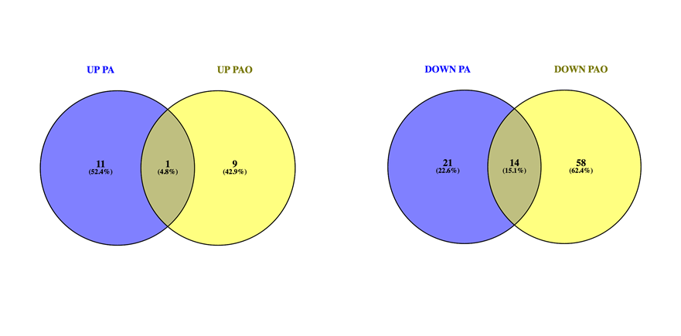
Figure 8: Venn-diagram representing proteins that were up or down regulated in either or both PA and PAO treatment.

Specifically we were interested in protein expression that was differentially regulated between fatty acid treatments. To this end the average fold changes of PAO/CON were subtracted from the average fold changes of PA/CON, and filtered for a delta change of 20%, leaving 47 proteins that were differentially regulated between PA and PAO (Appendix 2 for full list). Table 1 shows a selection of differentially regulated proteins between treatments, grouped based on their role in metabolism and selected others. Of these proteins it was noted that several were primarily localised to the mitochondria (Figure 9). Of the differentially regulated proteins (47) the majority (27) were found to be localised to the cytoplasm while several were found to localised to the mitochondria (6), membrane (6), peroxisome (4) nucleus (3) and the golgi (2).
Table 1. Selection of proteins identified in the proteomic analysis that are involved in Metabolism and selected others.
ID | Gene Name | Protein Name | PA/control | PAO/control

Metabolism associated proteins
O09174 | AMACR | Alpha-methylacyl-CoA racemase | 1.05685 | 0.79761
P40142 | TKT | Transketolase | 1.0878 | 1.35055
Q8K0C9 | GMDS | GDP-mannose4,6  dehydratase | 1.0767 | 1.4285
Q8CAY6 | ACAT2 | Acetyl-CoA acetyltransferase2 | 0.857005 | 1.09795
Q8VCH0 | HADHB | Thiolase 1 | 1.2217 | 0.89098
Q9QUJ7 | ACSL4 | Long-chain-fatty-acid--CoA ligase 4 | 0.910385 | 0.6334

Other
P68181-2 | PRKACA | Protein Kinase A | 1.0801 | 0.831175
P99029-2 | PRDX5 | Peroxiredoxin 5 | 0.87879 | 1.1229

Of these proteins it was noted that several were primarily localised to the mitochondria (Figure 9). Of the differentially regulated proteins (47) the majority (27) were found to be localised to the cytoplasm while several were found to localised to the mitochondria (6), membrane (6), peroxisome (4) nucleus (3) and the golgi (2).

Figure 9: The Subcellular localisation of differentially regulated proteins from proteomic screen. Differentially regulated proteins were grouped based on their known or predicted cellular localisation. Those proteins whose localisation differs depending on activity were represented in both groups.

In an attempt to add clarity to our proteomic data set we employed Ingenuity Pathway Analysis (IPA) software for an overrepresentation analysis. This analysis, based on the 531 differentially regulated proteins in our screen, identifies overrepresented pathways in our data set (data available on request). Overrepresentation however does not indicate whether these pathways are up or downregulated. Table 2 shows selected overrepresented pathways in PA treated cells based on the proteomic screen and the number of proteins up or down regulated within each pathway. A ratio between upregulated proteins versus downregulated proteins within each pathway gives a suggestion as to whether each pathway might be up or downregulated. For comparison the same pathways are represented in the PAO treatment also. It can be seen that Protein Ubiquitination, Mitochondrial Dysfunction, the TCA cycle, Fatty Acid Beta Oxidation, Oxidative Phosphorylation and EIF2 signaling were overrepresented pathways in PA treatment. Both PA and PAO resulted in a decrease of Beta oxidation. Interestingly both PA and PAO also led to a reduction in the TCA cycle (PA 0.1, PAO 0.8) and oxidative phosphorylation (PA Infinity, PAO 0.6) but this is far greater reduced in the PA treatment. Strikingly, with PA treatment, mitochondrial dysfunction and oxidative phosphorylation related proteins are entirely downregulated in PA with UP/DOWN ratios of infinity whilst the same pathways in PAO had ratios of 1.0 and 0.6 respectively. EIF2 signaling was also significantly different between treatments with a 3.0 ratio for PA and 0.25 ratio for PAO treatment which represents the greatest different between the two treatments.
Table 2: Tables showing the Top 6 pathway hits with Palmitate treatment using overrepresentation analysis. The number of proteins up or down regulated within each pathway is given along with the ratio of upregulated to downregulated.
Pathway | Upregulated | Downregulated | UP/DOWN Ratio

PA treated Cells
Protein Ubiquitination | 11 | 18 | 0.6
Mitochondrial Dysfunction | 0 | 20 | Infinity
TCA cycle II | 1 | 8 | 0.1
Fatty acid β-oxidation I | 1 | 3 | 0.3
Oxidative phosphorylation | 0 | 13 | Infinity
EIF2 signalling | 9 | 3 | 3.0

PAO treated Cells
Protein Ubiquitination | 8 | 16 | 0.5
Mitochondrial Dysfunction | 11 | 11 | 1.0
TCA cycle II | 3 | 4 | 0.8
Fatty acid β-oxidation I | 2 | 7 | 0.3
Oxidative phosphorylation | 5 | 9 | 0.6
EIF2 signalling | 4 | 16 | 0.25

Discussion
The present study aimed to assess the differential changes in the proteome as a result of treatment with the SFA Palmitate and the MUFA Palmitoleate. PAO and PA differ only by a double bond at the n-7 position yet have been noted to bring about divergent effects on insulin signalling and glucose uptake (Dimopolous et al 2006). To the authors knowledge this is the first study to utilise a global proteomic approach to address the mechanisms of this differential response. We have shown that PA is capable of reducing basal and insulin stimulated glucose uptake without a corresponding repression in PKB phosphorylation, and that PAO has no effect on glucose uptake, which is contradictory to some of the seminal work in this field (Dimopolous et al, 2006). However, our work showed that the two fatty acids differentially regulate the fatty acid profile and differentially alter glucose uptake in a manner independent of changes in PKB phosphorylation. To try to understand the results we obtained we performed a SILAC based proteomic screen of PA and PAO treated cells to determine changes in the global proteomic profile. This analysis identified more than 40 proteins that are consistently differentially regulated in two independent SILAC runs by PA and PAO. Interestingly our results do not indicate any inhibition or facilitation of the insulin signalling pathway.

Unlike many fatty acid treatment studies we employed FAME analysis to ensure that our fatty acids of interest were accumulating in the cells. These data (figure 3&4) confirmed that the cells were indeed taking up the fatty acids. Interestingly PA accumulated in the cells to a greater extent than PAO with PA making up nearly 50% of total fatty acids compared with around 25% total fatty acids for PAO after treatment with the respective fatty acids. It should be noted however, that the base line content of PA is much greater than PAO and so we see a relatively greater increase in PAO content compared to PA after respective treatments. The greater content PA over PAO in both basal and treatment conditions may be explained by a difference in the oxidation rates of these types of fatty acids. Indeed several cases in the literature point towards an increased oxidation rate of several UFAs over SFAs. One study in rats showed SFAs were oxidised at a slower rate than MUFAs and PUFAs of equal length (Leyton et al, 1985) while another in humans showed a preferential oxidation of Oleate (MUFA) and Linoleate (PUFA) over Stearate (SFA) (Jones et al, 1985). Further De Laney et al (2000) confirmed that carbon number was negatively correlated with oxidation while unsaturation was positively correlated with oxidation. These studies would support the notion that the difference we see in content between PA and PAO is a result of the difference in oxidation of these fatty acids. Given that previous studies have observed different phenotypes using the same concentrations as we have used we felt it was appropriate to continue with these concentrations despite the large disparity in % of the total pool each fatty acid occupies. Regardless it is a potential limitation of this study comparing biological effects of these fatty acids given the large difference in the % of the total Fatty acid pool each occupies.

Given the many starvation, media and treatment paradigms that may be used in cell models we assessed different media and serum starvation protocols to establish a protocol that brings about a stable and least variable glucose uptake response in our cells with PA and PAO. We found that Serum starving for a full 16hr treatment in Phosphate Buffered Saline + 5mM glucose alongside fatty acid treatment brought about the most stable response across all treatments and stimulations (figure 4). After confirming the most effective serum starvation and treatment paradigm for the cells we demonstrated that PA treatment of C₂C₁₂ myotubes brought about a reduction in glucose uptake after 16hr treatment but no reduction in insulin stimulated PKB phosphorylation at Thr 308 despite several studies consistently showing a robust repression in PKB phosphorylation (at both Ser473 and Thr 308) and/or activity assessed via IP kinase assay against recombinant proteins (Newsom et al 2015, Dimopolous et al, 2006, Chavez et al 2003, Basu et al 1998) in several cell lines. It would appear that in our hands neither PA nor PAO have any effect on insulin stimulated PKB phosphorylation. We acknowledge that our findings are in contrast with much of the previous work in this area. However, we would argue that this is more evidence of the caution that should be aired when interpreting data from cell based models as evidently independent groups can elucidate divergent responses in the same cell line, under similar conditions. In the literature there is significant evidence that the repressive effects of PA are mediated through metabolism of PA to ceramide (Powell et al, 2004) and perhaps more debatably DAGs (Macrae et al, 2013). Ceramides have been shown to repress PKB activity via two mechanisms, one via PKC and subsequent sequestration of PKB to CEM regions of the membrane preventing interaction with PIP3 enriched parts of the membrane (Powell et al, 2004) and another via de-phosphorylation of PKB through PP2A (Nardi et al, 2014). Considering that we have confirmed that the cells accumulate substantial amounts of PA it would therefore be interesting to assess if ceramides or DAGs are altered in our model. The role of ceramide synthesis in this process could potentially be assessed by the use of a ceramide synthesis inhibitor. The Serine C-palmitoyltransferase inhibitor myriocin however has been shown to inhibit palmitate induced ceramide, but at the expense of increasing DAGS. As a result there is no improvement in insulin stimulated glucose uptake with palmitate with SPT treatment (Watson et al, 2009).

An alternative mechanism by which fatty acids could influence cell metabolism is through the cell fuel gauge AMP-activated Kinase (AMPK). Several studies in rodent models have shown that high fat feeding can lead to a repression of AMPK activity (Ko et al, 2009). AMPK via the two AMP binding domains on the γ subunit is highly sensitive to the AMP:ATP ratio (Hardie et al, 2012). Binding of AMP to the two domains causes a conformational change in AMPK revealing the catalytic domain on the α-subunit. In times of substrate abundance, such as during the fatty acid treatments, this ratio is likely to be low leading to a lack of AMPK activity (Steinberg and Kemp, 2009). One of AMPKs most important roles is the stimulation of substrate uptake coupled with cellular metabolism to produce more ATP. It could be that Palmitate is driving a repression of AMPK, which leads to the reduction in glucose uptake that we have observed. We propose that if this was the case the lack of a reduction in glucose uptake in PAO treated cells could be explained by the differences we observed in PA and PAO levels before and after treatment (figure 3+4) unfortunately we have not picked up any repression in AMPK expression in our proteomic screen.

PAO did not have any effect on basal or insulin stimulated glucose uptake, or PKB phosphorylation (figures 5&6). This finding is in contrast with several previous works from independent labs who have repeatedly found it to be insulin sensitising in C2c12s and L6 myotubes (Tsuchiya et al 2010, Dimopoulous et al, 2006). However, similar to (Chavez et al, 2003) we found PAO to have no effect on PKB or glucose uptake and so it would appear that the effects of PAO used in different labs is likely very sensitive to minor details in treatment protocols. An additional data set which casts doubt on the characterisation of PAO as a ‘Lipokine’, as it has been previously described (Cao et al, 2008), is the recent work from Jeff Horowitz’s lab. Newsom et al, (2015) demonstrated that the impact of palmitate on PKB signalling was very sensitive to any other physiological mixes of fatty acids and not just PAO. Thus when certain fatty acids are added to cells, there is a very strong influence of the other fatty acids which would be present in plasma in a physiological range. More work is clearly needed to define the effects of PAO but given the recent study in humans (Fabbrini et al, 2011) showing that PAO availability in the plasma was not associated with insulin sensitivity in the liver, skeletal muscle and adipose in lean and obese individuals as might be expected if it were to have a role as a ‘Lipokine’. It would be interesting to assess whether the amount of PAO incorporated into the tissues mentioned above correlates with insulin sensitivity rather than the plasma amount given this study and the excellent review by (Karpe et al, 2011) where the correlation between plasma NEFA and insulin resistance is questioned. Karpe and colleagues highlight that even severe insulin resistance can exist without increased plasma NEFA and conversely elevated levels of NEFA can exist without detriments to insulin sensitivity which questions the role of plasma NEFA in the pathogenesis of insulin resistance. Assuming the same logic with PAO the fabbrini et al study by measuring plasma availability could be missing some important aspects of potential mechanisms of action.

In spite of the differences between our and other lab’s work, we still identified that PA and PAO have divergent effects on cell metabolism. In order to address the potential mechanism of action we employed SILAC based proteomics to address shifts in the global proteome. We hypothesised that differential changes in the global proteome could explain the differential changes in metabolism that we observed. We carried out our proteomic screen following treatment with PA and PAO for 16 hours. It is worth noting and commentating on the fact that this screen was carried out in the basal state i.e. prior to any insulin stimulation despite the major phenotype we and others observe is post insulin stimulation. The rational for carrying out a basal state screen was due to the hypothesis that pre-treatment with the fatty acids leads to a global proteomic shift that acts a dampener or amplifier to response to insulin. With that in mind we wanted to assess the global proteomic shift prior to insulin stimulation to establish if this was the case. Despite not detecting any changes in proteins associated with insulin signalling we have established that these very similar fatty acids have differential effects on 47 proteins (delta change of greater than 20%). It should be noted, from a technical point of view, that differences observed here are despite the treatment buffer containing no exogenous source of amino acids meaning that any changes we observe are due to internal amino acid turnover alone. In hindsight it would have been beneficial to test these treatment buffers with and without amino acid combinations as the presence of supplemented amino acids may amplify the changes we saw and their absence may have left some otherwise detectable changes below the limit of detection. Similarly our proteomics data is based on two independent experiments. We identified several proteins that are differentially regulated but only present in one of the replicates. These data were excluded and this is a limitation of the study. Have a 3rd independent replicate could have provided more confidence on the legitimacy of some of these hits and would have provided a fuller data set in which to study further.
Of the 47 proteins identified there are some involved in fat metabolism such as Thiolase-1 (upregulated in PA) and Long chain fatty acid-CoA ligase 4 (downregulated in PAO), carbohydrate metabolism such as Transketolase (upregulated in PAO) and GDP-mannose4,6 dehydratase (both upregulated in PAO) and Protein Kinase A (PKA, down regulated in PAO). Of particular interest is Acetyl-CoA acetyltransferase 2 (ACAT2) reduced in PA treatment and unaltered in PAO. ACAT2 is involved in the conversion of DAGs to TAGs and could suggest that PA treatment is resulting in the incomplete B oxidation of fatty acids leading to an accumulation of lipid intermediates. Indeed from the literature we do understand that PA treatment does lead to the accumulation of DAGS and ceramides which have been implicated in the insulin resistant phenotype (Macrae et al 2013). Further work to validate this would be interesting as, it would be the first direct mechanistic link, involving the repression of a metabolic enzyme, to how PA treatment leads to accumulation of lipid intermediates.
Several of the differentially regulated proteins that we observed between fatty acid treatments are primarily localised to the peroxisomes and mitochondria, two key sites for fatty acid metabolism indicating that changes in expression at these organelles could be an interesting area to validate in relation to the phenotype we observe. Indeed, obesity and insulin resistance are associated with metabolic inflexibility (Galgani et al, 2008), that is an inability to adapt fuel oxidation to fuel availability and given we have seen PAO upregulate proteins involved in carbohydrate metabolism it could be suggested that PAO prevents metabolic inflexibility in this way.
We undertook pathway overrepresentation analysis with our proteomic dataset to try to understand what pathways may be up or downregulated with PA and PAO (Table 2). Interestingly PA treatment was associated with the downregulation of proteins associated with mitochondrial dysfunction and a link between Palmitate and oxidative stress and mitochondrial dysfunction has been identified in several studies in multiple cell lines and tissues (Yuzefovych et al 2012; Kwon et al 2014). Given this signature for mitochondrial dysfunction it is interesting to note Peroxiredoxin 5 (PRDX5) is downregulated in PA treatment. PRDX5 is part of a family of enzymes responsible for neutralising reactive oxygen species (PRDX1-6). Of these PRDX5 and PRDX6 have been shown to localise to the mitochondria (Kropotov et al 2007, Ma et al 2016). Further PRDX5 expression is strongly correlated with NRF1/2 controlled proteins that are involved in the oxidative stress response at the mitochondria suggesting it may be important in this response as well. (Kropotov et al 2007). Further the Peroxiredoxin family of proteins have been implicated as upstream of the mitochondrial Overexpression of PRDX5 has been previously shown to rescues tendon cell function and prevents apoptosis associated with oxidative stress (Yuan et al 2004). It would be interesting to validate this repression of PRDX5 upon PA treatment and to assess whether overexpression of this protein rescues PA induced phenotypes of mitochondrial function (if validated with further analyses) and glucose uptake.

Future Directions
This work has shown for the first time that PA can reduce the capacity of muscle cells to uptake glucose without an associated repression of PKB. We have also shown that PAO does not, in our hands, enhance either marker of insulin responsiveness. Finally we have identified some metabolic proteins whose expression are differentially regulated between treatments and with pathway analysis identified a possible striking link with mitochondrial dysfunction with PA but not with PAO. In the future it would be interesting to revisit this data set and look more into each fatty acid in isolation to see if there are any interesting hits that are not differentially regulated according to our current parameters. At this stage however, the most critical future work will be to validate an effect on this pathway. Oxidative consumption, ATP synthase activity, mitochondrial membrane potential and mitochondrial protein content could all be assessed. Further in collaboration with the the Muqit and Ganley labs at the University of Dundee the MITO QC system established by Allen et al (2013) is now available in the C2c12 cell line and this could be utilised to assess changes in mitophagy and morphology of the mitochondrial network in response to these fatty acids. Finally with regard to mitochondrial dysfunction we have identified a repression in PRDX5 a member of the Peroxiredoxin antioxidant family of proteins. Members of this family have been implicated as upstream of the mitochondrial quality control pathway mediated by PINK1 and PARKIN (Ma et al 2016). In collaboration with the Muqit laboratory this link could be further explored and validated specifically with PRDX5 identified in this screen. For example the PINK/PARKIN pathway could be probed after treatment with PA. If reduced in PA PRDX5 could be overexpressed or knocked down using RNA or CRISPR mediated methods. It would also be interesting to repeat the fatty acid treatments in C2C12s but also in other commonly used models such as human primaries and L6 myotubes to assess if our proteomic screen results hold true in different models. Our current data set, however, has laid the ground work for further mechanistic studies addressing if some of the hits in our screen could mediate mitochondrial dysfunction and whether mitochondrial dysfunction is responsible for the different phenotypes observed with PA treatment. Finally several studies have combined both fatty acids and found the combination to alleviate PA induced phenotypes. Therefore it would be interesting to combine PA and PAO to add further depth to our dataset.

In conclusion this is the first study of its kind probing the global proteomic profile of PA and PAO treated skeletal muscle models. We have identified several interesting hits in our screen that now require important follow up experiments to validate. These experiments will elucidate novel mechanisms by which PA and PAO treatment affect the metabolism of these cells, particularly at the mitochondria.

References
- Assali et al. Insulin resistance in obesity: body-weight or energy balance? The Journal of Endocrinology 171, 293–8 (2001).
- Bachmann et al. Effects of intravenous and dietary lipid challenge on intramyocellular lipid content and the relation with insulin sensitivity in humans. Diabetes 50, 2579–84 (2001).
- Bajaj, M. et al. Effect of a sustained reduction in plasma free fatty acid concentration on intramuscular long-chain fatty Acyl-CoAs and insulin action in type 2 diabetic patients. Diabetes 54, 3148–53 (2005).
- Basu et al. BAD Enables Ceramide to Signal Apoptosis via Ras and Raf-1. Journal of Biological Chemistry (1998).
- Biddinger, S. & Kahn. From mice to men: insights into the insulin resistance syndromes. Annual review of physiology 68, 123–58 (2006).
- Butler, A. et al. β-Cell Deficit and Increased β-Cell Apoptosis in Humans With Type 2 Diabetes. Diabetes 52, (2003).
- Cantley, L. C. The phosphoinositide 3-kinase pathway. Science 296, 1655–7 (2002).
- Cao, H. et al. Identification of a lipokine, a lipid hormone linking adipose tissue to systemic metabolism. Cell 134, 933–44 (2008).
- Chavez, J. et al. A role for ceramide, but not diacylglycerol, in the antagonism of insulin signal transduction by saturated fatty acids. The Journal of biological chemistry 278, 10297–303 (2003).
- Chen, Q. et al. GARNL1, a major RalGAP α subunit in skeletal muscle, regulates insulin-stimulated RalA activation and GLUT4 trafficking via interaction with 14-3-3 proteins. Cell. Signal. 26, 1636–48 (2014).
- Cohen, P., Alessi, D. R. & Cross, D. A. PDK1, one of the missing links in insulin signal transduction? FEBS Lett. 410, 3–10 (1997).
- DeFronzo, R. & Tripathy, D. Skeletal muscle insulin resistance is the primary defect in type 2 diabetes. Diabetes care 32 Suppl 2, S157–63 (2009).
- DeLany et al. Differential oxidation of individual dietary fatty acids in humans. The American journal of clinical nutrition 72, 905–11 (2000).
- De Luca, C. & Olefsky, J. Inflammation and insulin resistance. FEBS Letters 582, (2007).
- Dimopoulos, N. et al . Differential effects of palmitate and palmitoleate on insulin action and glucose utilization in rat L6 skeletal muscle cells. Biochemical Journal (2006).
- Epps-Fung, V et al. Fatty acid-induced insulin resistance in adipocytes. Endocrinology 138, 4338–45 (1997).
- Fabbrini, E. et al. Insulin sensitivity is not associated with palmitoleate availability in obese humans. Journal of lipid research 52, 808–12 (2011).
- Galgani, J., Moro, C. & Ravussin, E. Metabolic flexibility and insulin resistance. AJP: Endocrinology and Metabolism 295, (2008).
- Folch J et al. A simple method for the isolation and purification of total lipids from animal tissues." J biol Chem 226.1: 497-509. (1957)
- Hajduch et al. Ceramide impairs the insulin-dependent membrane recruitment of Protein Kinase B leading to a loss in downstream signalling in L6 skeletal muscle cells. Diabetologia (2001).
- Hardie, G., Ross, F. & Hawley, S. AMPK: a nutrient and energy sensor that maintains energy homeostasis. Nature Reviews Molecular Cell Biology 13, (2012).
- Hirashima, Y. et al. Insulin down-regulates insulin receptor substrate-2 expression through the phosphatidylinositol 3-kinase/Akt pathway. J. Endocrinol. 179, 253–66 (2003).
- Hunnicutt et al. Saturated fatty acid-induced insulin resistance in rat adipocytes. Diabetes 43, 540–5 (1994).
- Iozzo, P. Viewpoints on the way to the consensus session: where does insulin resistance start? The adipose tissue. Diabetes care 32 Suppl 2, S168–73 (2009).
- Jones, Pencharz & Clandinin. Whole body oxidation of dietary fatty acids: implications for energy utilization. The American journal of clinical nutrition 42, 769–77 (1985).
- Karpe, F., Dickmann, J. & Frayn, K. Fatty Acids, Obesity, and Insulin Resistance: Time for a Reevaluation. Diabetes (2011).
- Kavanos et al. Diabetes expenditure, burden of disease and management in 5 EU countries. London School of Economics http://www.lse.ac.uk/LSEHealthAndSocialCare/research/LSEHealth/MTRG/LSEDiabetesReport26Jan2012.pdf (2012)
- Kim, J.K., et al. Redistribution of substrates to adipose tissue promotes obesity in mice with selective insulin resistance in muscle. Journal of Clinical Investigation. 105(12):1791-7. (2000)
- Ko, H. et al. Nutrient stress activates inflammation and reduces glucose metabolism by suppressing AMP-activated protein kinase in the heart. Diabetes 58, 2536–46 (2009).
- Kropotov et al. Mitochondrial targeting of human peroxiredoxin V protein and regulation of PRDX5 gene expression by nuclear transcription factors controlling biogenesis of mitochondria. FEBS J, 274(22):5804-14 (2007)
- Kwon, B, Lee, HK, Querfurth HW. Oleate prevents palmitate-induced mitochondrial dysfunction, insulin resistance and inflammatory signaling in neuronal cells. Biochem Biophys Acta, 1843, 1402-13.(2014)
- Leyton, Drury & Crawford. Differential oxidation of saturated and unsaturated fatty acids in vivo in the rat. The British journal of nutrition 57, 383–93 (1987).
- Ma et al. Peroxiredoxin 6 Is a Crucial Factor in the Initial Step of Mitochondrial Clearance and Is Upstream of the PINK1-Parkin Pathway. Antioxid Redox Signal. Mar 20;24(9):486-501 (2016).
- Macrae et al. Defining the role of DAG, mitochondrial function and lipid deposition in palmitate-induced proinflammatory signalling and its counter-modulation by palmitoleate. The Journal of Lipid Research 54, 2366–78 (2013).
- Mahfouz, R. et al. Characterising the Inhibitory Actions of Ceramide upon Insulin Signaling in Different Skeletal Muscle Cell Models: A Mechanistic Insight. PLoS ONE 9, (2014).
- Michael et al. Loss of insulin signaling in hepatocytes leads to severe insulin resistance and progressive hepatic dysfunction. Molecular cell 6, 87–97 (2000).
- Myers, M. G. & White, M. F. Insulin signal transduction and the IRS proteins. Annu. Rev. Pharmacol. Toxicol. 36, 615–58 (1996).
- Nardi, F. et al. Enhanced Insulin Sensitivity Associated with Provision of Mono and Polyunsaturated Fatty Acids in Skeletal Muscle Cells Involves Counter Modulation of PP2A. PLoS ONE 9, (2014).
- Neel JV. Diabetes Mellitus: A "Thrifty" Genotype Rendered Detrimental by Progress? Am. J. Hum. Genet. 14 (4): 353–62. (1962)
- Newsom, S. et al. Lipid Mixtures Containing a Very High Proportion of Saturated Fatty Acids Only Modestly Impair Insulin Signaling in Cultured Muscle Cells. PLOS ONE 10, (2015).
- Pagotto, U. Where Does Insulin Resistance Start? The brain. Diabetes Care (2009).
- Perseghin, G. Viewpoints on the Way to a Consensus Session Where does insulin resistance start? The liver. Diabetes Care 32, S164–7 (2009).
- Pirola et al Phosphoinositide 3-Kinase-mediated Reduction of Insulin Receptor Substrate-1/2 Protein Expression via Different Mechanisms Contributes to the Insulin-induced Desensitization of Its Signaling Pathways in L6 Muscle Cells. JBC, 278, 15641-15651.(2003)
- Randle PJ et al. The glucose fatty-acid cycle. Its role in insulin sensitivity and the metabolic disturbances of diabetes mellitus. Lancet. 1(7285): 785–9. (1963)
- Salinas, M, et al. Inhibition of PKB/Akt1 by C2-Ceramide Involves Activation of Ceramide-Activated Protein Phosphatase in PC12 Cells. Molecular and Cellular Neuroscience (2000).
- Saltiel, A. & Kahn, R. Insulin signalling and the regulation of glucose and lipid metabolism. Nature 414, (2001).
- Samuel, V. T. & Shulman, G. I. Mechanisms for insulin resistance: common threads and missing links. Cell 148, 852–71 (2012).
- Sarbassov, D. et al. Phosphorylation and regulation of Akt/PKB by the rictor-mTOR complex. Science 307, 1098–101 (2005).
- Schenk, S., Saberi, M. & Olefsky, J. Insulin sensitivity: modulation by nutrients and inflammation. The Journal of clinical investigation 118, 2992–3002 (2008).
- Schenk, S. & Horowitz, J. Acute exercise increases triglyceride synthesis in skeletal muscle and prevents fatty acid–induced insulin resistance. Journal of Clinical Investigation (2007).
- Schmitz-Peiffer, Craig & Biden. Ceramide Generation Is Sufficient to Account for the Inhibition of the Insulin-stimulated PKB Pathway in C2C12 Skeletal Muscle Cells Pretreated with Palmitate. Journal of Biological Chemistry (1999).
- Schubert, Scheid & Duronio. Ceramide inhibits protein kinase B/Akt by promoting dephosphorylation of serine 473. The Journal of biological chemistry 275, 13330–5 (2000).
- Shanik, M. H. et al. Insulin resistance and hyperinsulinemia: is hyperinsulinemia the cart or the horse? Diabetes Care 31 Suppl 2, S262–8 (2008).
- Shimomura, I. et al. Decreased IRS-2 and Increased SREBP-1c Lead to Mixed Insulin Resistance and Sensitivity in Livers of Lipodystrophic and ob/ob Mice. Molecular Cell 6, 77–86 (2000).
- Steinberg, G. & Kemp, B. AMPK in Health and Disease. Physiological Reviews 89, (2009).
- Taniguchi, C., Emanuelli, B. & Kahn, R. Critical nodes in signalling pathways: insights into insulin action. Nature Reviews Molecular Cell Biology 7, 85–96 (2006)
- Tsuchiya, Y. et al. Palmitate-induced down-regulation of sortilin and impaired GLUT4 trafficking in C2C12 myotubes. The Journal of biological chemistry 285, 34371–81 (2010).
- Vanhaesebroeck, B. & Alessi, D. R. The PI3K-PDK1 connection: more than just a road to PKB. Biochem. J. 346 Pt 3, 561–76 (2000).
- Watson, M., Coghlan, M. & Hundal, H. Modulating serine palmitoyl transferase (SPT) expression and activity unveils a crucial role in lipid-induced insulin resistance in rat skeletal muscle cells. The Biochemical journal 417, 791–801 (2009).
- Yuan J. et al. Overexpression of antioxidant enzyme peroxiredoxin 5 protects human tendon cells against apoptosis and loss of cellular function during oxidative stress. Biochim Biophys Acta BBA - Mol Cell Res 1693: 37–45, (2004).
- Yuzefovych, L.V. et al. Protection from palmitate-induced mitochondrial DNA damage prevents from mitochondrial oxidative stress, mitochondrial dysfunction, apoptosis, and impaired insulin signaling in rat L6 skeletal muscle cells Endocrinology 153(1):92-100. (2012)

Appendices

Appendix 1
B
A
Appendix 1- Protein assay Standard Curves: A) BCA standard curve; B) Bradford standard curve.

Appendix 2
PMID | Name | PA/Eth | PAO/Eth
P84099 | Full=60S ribosomal protein L19 | 1.46155 | 0.876825
O35379 | Multidrug resistance-associated protein 1 | 0.998805 | 0.61701
Q921H8 | 3-ketoacyl-CoA thiolase A, peroxisomal | 1.2217 | 0.89098
P70670 | Nascent polypeptide-associated complex subunit alpha, muscle-specific form | 1.04305 | 0.72537
A2AJI0-2 | MAP7 domain-containing protein 1 | 1.05285 | 0.770905
Q9QUJ7-2 | Long-chain-fatty-acid--CoA ligase 4 | 0.910385 | 0.6334
O09174 | Alpha-methylacyl-CoA racemase | 1.05685 | 0.79761
Q8R1N4 | NudC domain-containing protein 3 | 0.97812 | 0.719065
O88738-3 | Baculoviral IAP repeat-containing protein 6 | 1.11475 | 0.8622
Q91ZU6 | Dystonin | 1.21585 | 0.96352
Q8R010 | Aminoacyl tRNA synthase complex-interacting multifunctional protein 2 | 1.02665 | 0.77609
O70209 | PDZ and LIM domain protein 3 | 0.783205 | 0.533935
P68181-2 | Protein Kinase A | 1.0801 | 0.831175
Q9D5T0 | ATPase family AAA domain-containing protein 1 | 1.1277 | 0.88841
Q9CQN1 | Heat shock protein 75 kDa, mitochondrial | 0.792525 | 0.55684
Q99J99 | 3-mercaptopyruvate sulfurtransferase | 1.1371 | 0.912035
P15116 | Cadherin-2 | 0.84345 | 0.632305
Q9EPR5 | VPS10 domain-containing receptor SorCS2 | 1.2039 | 1.00012
Q9QUM9 | Proteasome subunit alpha type-6 | 0.88216 | 1.0868
Q99M71 | Mammalian ependymin-related protein 1 | 1.028775 | 1.24115
P19157 | Glutathione S-transferase P 1 | 1.08165 | 1.2947
Q9WV91 | Prostaglandin F2 receptor negative regulator | 0.99519 | 1.2228
Q6IRU2 | tropomyosin alpha-4 chain | 1.02346 | 1.2516
P57716 | nicastrin | 0.80156 | 1.031205
P00735 | Prothrombin | 0.407455 | 0.640165
P18872-2 | guanine nucleotide-binding protein G(o) subunit alpha | 0.876005 | 1.1128
Q8CAY6 | acetyl CoA acetyltransferase2 | 0.857005 | 1.09795
P99029-2 | Peroxiredoxin-5, mitochondrial | 0.87879 | 1.1229
P33267 | cytochrome P450 2F2 | 1.3417 | 1.5936
Q99LI8 | hepatocyte growth factor-regulated tyrosine kinase substrate | 0.98639 | 1.2404
Q8BTM8 | Filamin-A | 0.928805 | 1.1899
P40142 | transketolase | 1.0878 | 1.35055
Q08093 | calponin-2 | 0.91493 | 1.178
P16460 | argininosuccinate synthase | 0.91726 | 1.18385
Q91VH6 | protein MEMO1 | 0.907065 | 1.18274
Q810B6 | Rabankyrin-5 | 1.06855 | 1.34855
P97370 | Sodium/potassium-transporting ATPase subunit beta-3 | 0.81681 | 1.0989
Q9WUM3 | Coronin-1B | 0.85644 | 1.1589
P02769 | Serum albumin | 0.069982 | 0.409505
Q8N7N5-2 | DDB1- and CUL4-associated factor 8 | 0.90217 | 1.246
Q8K0C9 | GDP-mannose 4,6 dehydratase | 1.0767 | 1.4285
P23492 | Purine nucleoside phosphorylase | 0.869415 | 1.2761
P50172 | Corticosteroid 11-beta-dehydrogenase isozyme 1 | 0.788985 | 1.21535
O70435 | Proteasome subunit alpha type-3 | 0.997745 | 1.48865
Q29443 | Serotransferrin | 0.16198 | 0.83919
P00761 | Trypsin | 0.14518 | 0.839345
Q64437 | Alcohol dehydrogenase class 4 mu/sigma chain | 1.04569 | 1.9547
Appendix 2- Proteins that were differentially regulated between PA and PAO treatments relative to control

